9B1- Cells and body systems
Question | Answer
What do we call diseases that cannot be passed from person to person e.g. are caused by genes or lifestyle? | Non-communicable
What are some of the consequences of not getting a balanced diet? | Starvation, obesity and deficiency diseases.
Name some examples of lifestyle diseases | Cardiovascular disease, lung cancer, liver disease, type 2 diabetes, obesity
What is the formula for calculating BMI (body mass index)? | BMI = mass/height²
What do we call diseases that are passed from person to person because they are caused by a pathogen? | communicable
What is a microorganism? | A living thing too small to see without a microscope
What are the three types of microorganism? | Bacteria, viruses and fungi
How can we calculate the actual size of a microorganism under the microscope? | Actual size = image size/magnification
Give three examples of diseases caused by microorganisms | Tuberculosis (bacteria), chalara ash dieback (fungus), ebola (virus)
What do we call a microorganism that causes a disease? | Pathogen
What are the human body’s physical and chemical barriers to infection? | Mucus, cilia, skin, lysozyme in tears and hydrochloric acid in stomach
Which body system responds to infection and fights disease? | The immune system
Name the white blood cells that produce antibodies and recognise pathogens. | Lymphocytes
How can we safely become immune to a disease without becoming infected by the pathogen that causes it? | By immunisation with a vaccine

9B2 Exercise and respiration
Define respiration | a chemical reaction that happens in all living cells, including plant cells and animal cells. It is the way that energy is released from glucose so that all the other chemical processes needed for life can happen
State the word equation for respiration | glucose + oxygen Carbon dioxide + water + energy
What is the organelle in which respiration occurs? | Mitochondria
What is the difference between ventilation and respiration? | Ventilation is the movement of gases into and out of the lungs. Respiration is the way we release energy in cells
What is diffusion? | Diffusion is the movement of a substance from an area of high concentration to an area of low concentration. Diffusion happens in liquids and gases because their particles move randomly from place to place
Why does oxygen diffuse across the lining of the alveoli and into the blood? | The concentration of oxygen is lower in the blood supply in the lungs than it is in the alveoli. Because of this the oxygen moves across the membrane into the blood.
Why do we breathe faster during exercise? | During exercise there is a greater rate of respiration in our cells. We use the oxygen in our blood more quickly and this needs to be replaced so our muscles can carry on working. Breathing faster moves more oxygen into our lungs.
What is an oxygen debt? | Anaerobic respiration occurs when there is no oxygen available and so produces an oxygen debt. Increased levels of oxygen are required to break down the lactic acid formed.
What is Anaerobic respiration in humans | Respiration without oxygen. This produces less energy than aerobic respiration  e.g. glucose lactic acid + energy  Lactic acid can build up in your muscles and cause cramp.
What is Anaerobic respiration in microorganisms e.g. yeast | This reaction can be used in fermentation to make ethanol (alcohol).  e.g.  glucose carbon dioxide + ethanol + energy
What is an oxygen debt? | An Oxygen Debt is the amount of extra oxygen needed by muscle tissue to oxidise lactic acid following exercise

9C1 Atoms and the periodic table
What is the proton number of an element? | The total number of protons
What is the mass number of an element? | The total number of protons and neutrons
Why must the number of electrons equal the number of protons? | Atoms are neutrally charged so they must have the same number of positive particles (protons) as negative particles (electrons)
How many bonds will an element with (III) after it form? | 3
How did Mendeleev arrange the elements known at the time into a periodic table? | By using the mass number and the properties of the elements and the properties of their compounds of the elements.
How did Mendeleev use his table? | To predict the existence and properties of some elements that were still to be discovered.
How are elements in the modern periodic table arranged? | In order of increasing atomic number in rows called periods and elements with similar properties are placed in the same vertical columns called groups.
What are the chemical properties of group 1 elements? | Very reactive
How does Group 1 metals reactivity changes down the group? | Increases

9C2 Particles
What is kinetic energy? | The energy of movement.
How are the particles arranged in a gas? | They are very far apart, moving very fast, they have lots of energy and are arranged randomly.  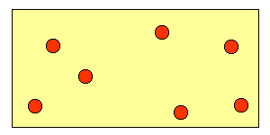
How are the particles arranged in a liquid? | 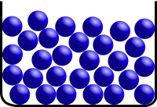  They are close together and touching, they can move past one another and are arranged in an irregular fashion.
How are the particles arranged in a solid? | 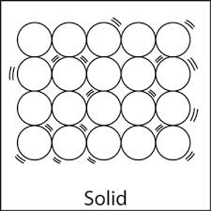  They are close together and touching, they cannot move past one another and are arranged in a regular orderly fashion.
What are the three states of matter | Solids, liquids and gases
Use a simple kinetic theory model to explain solids in terms of movement and arrangement of particles | - Particles vibrate  - Forces of attraction between particles are strong  - Which is why particles do not flow  - Solids keep their shape  - Solids cannot be compressed
Use a simple kinetic theory model to explain liquids in terms of movement and arrangement of particles | - Particles flow  - Particles have moderate forces of attraction  - Liquids take shape of container  - Liquids flow  - Liquids cannot be compressed
Use a simple kinetic theory model to explain gases in terms of movement and arrangement of particles | - Particles move fast  - Particles are far apart  - Gases expand to fill container  - Gases can be compressed
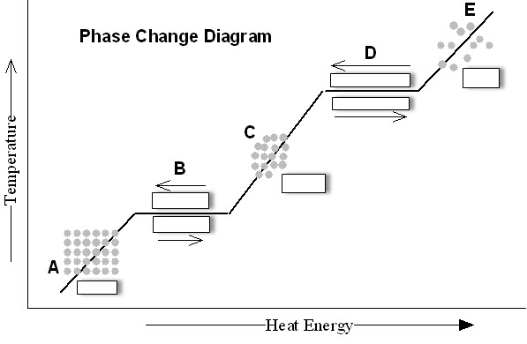  Label A-E | A – Solid  B – Melting/Freezing  C – Liquid  D – Evaporating/Condensing  E – Gas
What happens to the number of particles during a state change? | They stay the same (mass is always conserved)
How is energy stored in substances when they get hotter? | As temperature of the substances increases  They store the thermal energy by transferring it into kinetic energy in the particles  The particles vibrate more
What does a subsstances melting point represent? | The temperature it will change from a solid to a liquid
What does a substances boiling point represent? | The temperature it will change from a liquid to a gas
How does the boiling point change when impurties are present and give a useful example of this? | It increases e.g. salt in water to boil vegetables
How does the melting point change when impurties are present and give a useful example of this ? | It deceases e.g. salt on the road is the temperature if expected to be below 0ºC
How does the solubility of a solute changes as the temperature of the solution increases? | Solubility increases

9p1 Forces and motion
State the units of force. | Newtons
If a system of motion is in equilibrium what can be said of the forces. | They are balanced
What effects does an unbalanced for have on motion of an object? | It will accelerate
What is the name given to a turning force? | A moment
How are moments calculated? | Force x Perpendicular distance
What is a pivot? | The point around which something turns
What instrument can be used to measure force? | Newton meter
What is the unit for moments? | Nm
How can the motion of an object be describes if the forces acting upon it are balanced? | It will either be at rest or moving at a constant speed.
Calculate the net moment in this example?  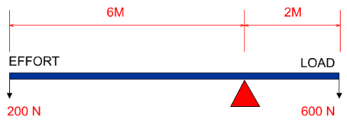 | 0 Nm
How do you use a distance-time graph to find the speed of an object? | In a distance-time graph, the gradient of the line is equal to the speed of the object.
How do you find the gradient of a line? | Select two points on the line and calculate the change in distance and change in time between two points.  Use the formula Gradient= rise/run  (speed = distance/time)
How do you compare the speed of two objects using a distance-time graph? | The greater the gradient (and the steeper the line) the faster the object is moving. The object with a shallower gradient is moving more slowly.
What does a curved line on a distance-time graph mean? | It means that the object’s speed is changing. This is called acceleration or deceleration.
What is a free body diagram? | A diagram that shows the forces acting on an object
What happens if the resultant force on an object is zero? | • a stationary object stays stationary  • a moving object continues to move at the same velocity (at the same speed and in the same direction)
What is Newton’s first law of motion? | An object remains in the same state of motion unless a resultant force acts on it.

9p2 Energy
State the unit of energy | Joules
Name 9 forms of energy | Kinetic, Heat, Light, Gravitational Potential, Chemical, Sound, Electrical, Elastic Potential, Nuclear
How can heat energy be transferred? | Through conduction, convection and radiation.
What is meant by a system? | An object or group of object that have a common function/purpose.
State Hooke’s law | Extension of an elastic material is directly proportional to the load applied.
What is meant by elastic deformation? | A material/object will return to its original shape after experiencing a force that causes its shape to change.
What is meant by plastic deformation? | A material/object will not return to its original shape after experiencing a force that causes its shape to change.
What is conduction? | The transfer of energy between particles through collisions.
What is convection? | The transfer of energy through the movement of substance due to differences in density.
What is radiation? | The transfer of energy in the form of electromagnetic waves.
Which surfaces are the best absorbers/emitters of infrared radiation? | Dark and matt
Which surfaces are the worst absorbers/emitters of infrared radiation? | Light and shiny

