Year 7 Core questions Autumn Term
7B1 Cells and body systems
No. | Question | Answer
 | What is a cell? | The smallest structural unit of living things.
 | Draw and label a typical plant cell. | 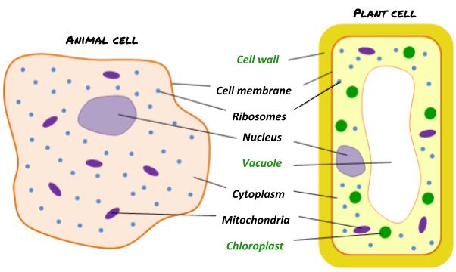
 | Draw and label a typical animal cell.
 | What is the function of the nucleus? | Contains the genetic material, the ‘instructions’ for the cell.
 | What is the function of the cytoplasm? | Where the cell’s chemical reactions happen.
 | What is the function of the cell membrane? | To control what goes in and out of the cell.
 | What is the function of the cell wall in plants? | To protect the cell and give it shape and rigidity.
 | What is the function of the vacuole in plants? | It contains sugar for the cell and gives the cell shape and rigidity
 | What is the function of the chloroplasts in plants? | Where photosynthesis happens.
 | What do we call a cell with adaptations or features that make it good at doing a particular job? | A specialised cell
 | Give three examples of specialised cells you might find in plants or animals | Animal cells: Egg, sperm, red blood cell, white blood cell, neuron  Plant cells: palisade cell, guard cell, root hair cell
 | What is a unicellular organism? | An organism that is made of one single cell
 | What is a metric prefix? | a unit prefix that goes before a basic unit of measurement to show a multiple or fraction of the basic unit
 | What is a microscope? | Instrument for viewing very small objects that cannot be seen with the naked eye e.g. cells
 | What is magnification? | How much bigger something appears compared with its actual size
 | How do you calculate the magnification of a microscope? | Total Magnification = magnification of OBJECTIVE lens x magnification of EYEPIECE lens
 | How do you calculate the magnification of a specimen under the microscope? | magnification = measured size / actual size.
 | What do we call a group of cells of the same type working together? | Tissue
 | What do we call a structure made up of a group of tissues, working together to perform specific functions? | An organ
 | What is an enzyme? | A protein made in cells to help a chemical reaction to happen.

7C1 Atom and the periodic table
What is an atom? | The smallest part of an element that can exist
Describe Dalton’s model of the atom. | Atoms as solid spheres that cannot be divided into smaller parts
What is an element? | A substance made of one type of atom e.g oxygen=O₂, Iron= Fe
What is a molecule? | A particle made of two or more atoms joined together e.g. Oxygen =O₂, Water =H₂O
What is a diatomic molecule? | A molecule that consists of two atoms, often the same. E.g. O₂ , Cl₂
What is a chemical symbol? | A one or two universal letter code of each element
Where are chemical symbols of elements found? | In the periodic table
What is a compound? | A substance made of more than one type of atom chemically joined together. E.g. Water = H₂O, Carbon dioxide = CO₂
What is a chemical formula? | A formula that shows the number and type of atoms present in a molecule.
What do the compound endings:  - ide  - ate  mean? | - ide – a compound of only the named substances  - ate – a compound of the named substances and oxygen
What is a physical change? | Changes of state as no new substances are made.
What is a chemical change (Chemical reaction)? | When atoms rearrange to make new substances
Where do we find metals in the period table? | On the left
Where do we find non-metals on the periodic table? | On the right
Who designed the modern periodic table? | Mendeleev
What are the groups in the periodic table? | Columns
What are the rows called in the periodic table? | Periods
What are the physical properties of most metals? | Good conductors of electricity, good conductors of heat, shiny, high density (heavy for its size), malleable (can be hammered), sonorous (makes a ringing sound when hit ), ductile (can be pulled into wires), high melting points (except mercury), hard
What are the physical properties of non-metals? | Poor conductors of electricity, poor conductors of heat, dull, low density (light for its size), brittle ( breaks easily), non-sonorous ( no ringing sound when hit), low melting points

7P1 Forces and motion
Name 8 forces | Thrust, air resistance, friction, weight/gravity, reaction, upthrust, lift, magnetism
State the unit for force | Newton, N
State an example where friction is useful | Any example of useful friction (e.g. shoes on floor, tyres on road)
What is the motion of the car if all forces are balanced? | Constant speed/stationary
If C is weight/gravity, what is the force A?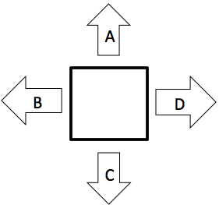 | Reaction
Suggest how you can decrease friction | Using a lubricant such as oil, Vaseline or ball bearings
If force A is 10N and force C is 10N, what is the resultant force acting on this object: | 0N
What is the unit for weight? | Newtons, N
If an object has a resultant force of 0N, describe its motion | It is either stationary or moving at a constant speed
State an example of when friction is not useful | Any example of friction not being useful (e.g. in an engine, axles, motor, machinery)
What two things do the arrows on a force diagram demonstrate? | Size of force  Direction of force
If D is thrust, suggest the name of force B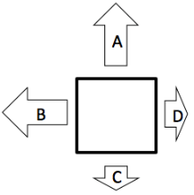 | Friction/drag/air resistance
If D is thrust, describe the motion of the object 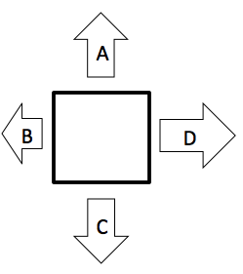 | The object is accelerating in the direction of D

No | Core question | Answer
1 | Name three common speeds | - sound in air 330m/s  - walking pace 1.4m/s  - car in built up area 10.5m/s  - car on motorway 31m/s  - an aeroplane 250 m/s  - light in a vacuum 300,000,000m/s.
2 | What is the equation to calculate speed? | Speed = distance  time
3 | What are the SI units of distance? | Metres (m)
4 | What are the SI units of time? | Seconds (s)
5 | What are the SI units of speed? | Metres per second (m/s)
6 | Draw the equation triangle for speed | d  s  tt
7 | Rearrange the speed equation to make distance the subject (d= ? ) | d = s x t
8 | Rearrange the speed equation to make time the subject (t = ?) | t= d  s
9 | What is a scalar quantity? Give an example | a quantity that has a magnitude only  e.g. speed, mass, temperature
10 | What is a vector quantity? Give an example | a quantity that has both a magnitude and a direction  e.g velocity, acceleration, force

7B2 Gas exchange
What are the characteristic processes of life? | Movement, respiration, sensitivity, nutrition, excretion, reproduction, growth
What are all living and previously living organisms made of? | Cells
What is respiration? | A cellular process that releases energy from food and oxygen
How do molecules move through cytoplasm? | Diffusion
Place the following in size order- molecule, cell and atom | Atom- molecule- cell
How can we describe the cell membrane? | As a semi-permeable membrane (some molecule are able to diffuse through it)
What are the key features of diffusion? | - All particles are in constant motion  - Diffusion involves the movement of particles  - It results from the random motion/collision of particles
What happens when a gas reaches equilibrium? | The particles continue to move but the net movement results in an equal amount of particles on each side of the membrane
What is the relationship between surface area of a membrane and the rate of diffusion? | As surface area increases the rate of diffusion increases too.
How are the alveoli adapted to maximise rates of diffusion? | Alveoli are adapted to provide a very large surface area for diffusion
Label the structure of the respiratory system  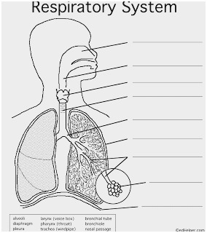 | 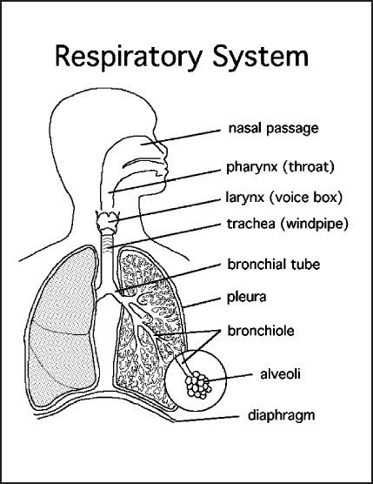
What is the composition of inhaled air? | 78% nitrogen, 21% oxygen, 0.04% carbon dioxide (as well as water vapour, other gases and particulates)
What is the composition of exhaled air? | 78% nitrogen, 17% oxygen, 4% carbon dioxide
How do we breathe in (ventilate)? | Our diaphragm is pulled down, anad the ribs are lifted up increasing the volume of the chest cavity. Air moves in to equalise the pressure.
How do we breathe out? | The muscles pulling on the diaphragm relax and this rises up, the ribs move in and the volume of the chest cavity decreases. Air moves out to balance the pressure.
What is the vital lung capacity? | The maximum amount of air you can breathe in and out

7C2 Particles
What is an atom? | The smallest part of an element, atoms are the building blocks of molecules
What is diffusion? | The movement of one substance through another substance.
How are the particles arranged in a gas? | 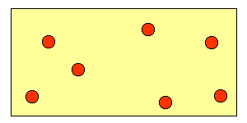  They are very far apart, moving very fast, they have lots of energy and are arranged randomly.
What is kinetic energy? | The energy of movement.
How are the particles arranged in a liquid? | 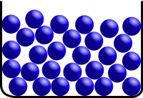  They are close together and touching, they can move past one another and are arranged in an irregular fashion.
What is a molecule? | A molecule is a group of atoms that have been chemically joined together.
What is a particle? | A very small part of a substance, it is sometimes used instead of the word molecule.
How are the particles arranged in a solid? | 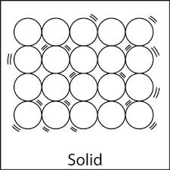  They are close together and touching, they cannot move past one another and are arranged in a regular orderly fashion.
Describe the Dalton model of the atom | Atoms are the smallest part of an element
What are the three states of matter | Solids, liquids and gases
Use a simple kinetic theory model to explain solids in terms of movement and arrangement of particles | - Particles vibrate  - Forces of attraction between particles are strong  - Which is why particles do not flow  - Solids keep their shape  - Solids cannot be compressed
Use a simple kinetic theory model to explain liquids in terms of movement and arrangement of particles | - Particles flow  - Particles have moderate forces of attraction  - Liquids take shape of container  - Liquids flow  - Liquids cannot be compressed
Use a simple kinetic theory model to explain gases in terms of movement and arrangement of particles | - Particles move fast  - Particles are far apart  - Gases expand to fill container  - Gases can be compressed
Describe Brownian motion in gases | - The random motion of particles due to the collisions between themselves
Describe diffusion of particles in gases and liquids | Particles diffuse from high concentration to low concentration
Explain why gases and liquids can diffuse | Forces of attraction between particles are weak enough to allow particles to flow
What causes gas pressure? | Gas particles colliding with the walls of a container
7P2 Energy
Question | Answer
- What is the symbol and unit for energy? | Joule, J
- Name 9 forms of energy | Gravitational potential energy  Chemical  Sound  Electrical  Nuclear  Light  Thermal  Elastic  Kinetic
- Describe what is meant by a system | An observed object or environment. This could be as big as the universe, a room, a car, a beaker or a petri dish.
- Describe what is meant by conservation of energy | The total energy in a closed system remains the same when an energy transfer takes place
- Draw an energy transfer diagram for a car speeding up

- Draw an energy transfer diagram for when a ball falls and lands on the ground

- Draw an energy transfer diagram for stretching a spring

- Draw an energy transfer diagram for when food is used in our bodies

- State 2 common waste energies | Thermal and sound
- Describe what happens to waste energy | It is dissipated to the surroundings

