Name: ………………………………………………………………………………………………
Class: ……………………………………………………………………………………….………
Teacher: ……………………………………………………………………………………………
How to use this book:

h
Section 3 :
These questions require you to apply your topic knowledge to a scientific example.
Section 2 :
These questions test your knowledge from this topic.
Section 1 :
All of these questions are from your core knowledge booklets (year 7,8, or 9!). You can look them up to get a perfect answer.

Y9 Science Homework Booklet

9B1 Homework task 1 Due Date: ………………………………………………..

Section 1: Review of prior knowledge
- What is produced when magnesium burns with oxygen?

- How can we know the number of protons in an atom?

- Recall the equation for pressure

- How are forces represented on diagrams?

- Where does respiration occur in a cell?

- What is ventilation (breathing?)

Section 2: Refreshing current knowledge
- What is the name of the process by which nutrients pass from the lumen into the blood?

- Name three ways that the small intestine is adapted for its function

Section 3: Application of knowledge
Q1.
The photograph shows a model of the small intestine.
Bread, saliva and water were mixed together.
This bread mixture was placed inside a tube made from one leg of a pair of tights.
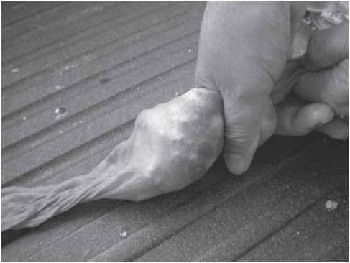
The person squeezed the tube behind the mixture to move the mixture along the tube.
Liquid came through the sides of the tube during the demonstration.
This liquid was collected and the concentration of sugar was measured at the start and after every 30 seconds.
The results are shown in the table.
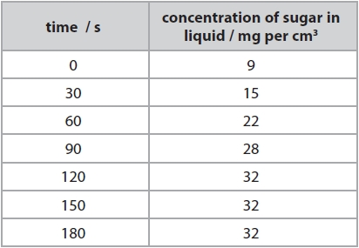
(i) Describe how the concentration of sugar in the liquid changes between 0 and 180 seconds.
(2)
.............................................................................................................................................
.............................................................................................................................................
.............................................................................................................................................
(ii) Explain how the sugar was produced in the bread mixture.
(2)
.............................................................................................................................................
.............................................................................................................................................
.............................................................................................................................................
(iii) Suggest one way that the tube is not a good model of the small intestine.
(1)
.............................................................................................................................................
.............................................................................................................................................

9B1 Homework task 2 Due Date: ………………………………………………..

Section 1: Review of prior knowledge
- What is a genome?

- What is the symbol equation for photosynthesis?

- What is evaporating?

- Which observation always shows that a new chemical reaction has occurred?

- Which equation describes Newton’s second law of motion?

- Name the three types of thermal energy transfer.

Section 2: Refreshing current knowledge
Complete this table:
Large food molecule or substrate | Diagram | Name of Enzyme that breaks it down | Small food molecule or product | Diagram
Carbohydrate (starch)
 |  | Protease
 |  |  | Fatty acids and glycerol

Section 3: Application of knowledge
- Lipase and bile are involved in the digestion of fat.
Give the names of the two products of fat digestion by lipase. (2)
..............................................................................................................................................
..............................................................................................................................................
2.
Type 2 diabetes is associated with being obese.
A high Body Mass Index (BMI) is an indication of obesity.
BMI is calculated using this equation.

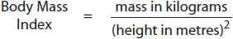

Calculate the BMI for a 90 kg man who is 1.50 metres tall. (2)

9B2 Homework task 1 Due Date: ………………………………………………..

Section 1: Review of prior knowledge
1. What are the characteristic processes of life?

2. What are all living and previously living organisms made of?

3. What is respiration?

4. How do molecules move through cytoplasm?

5. Place the following in size order- molecule, cell and atom

6. How can we describe the cell membrane?

Section 2: Refreshing current knowledge
Q2.
The drawing below shows the human rib cage.
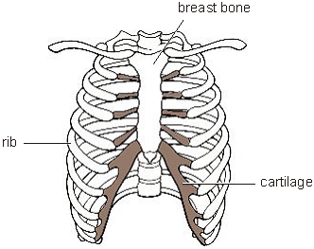
(a) The rib cage protects organs in the chest. Give the names of two organs in the chest.

(b) The ribs are attached to the breast bone by cartilage which bends easily.
This lets the space in the chest get bigger. Why is it important that the space can get bigger?

Section 3: Application of knowledge
Q1.
(b) Some students investigated the effect of temperature on the rate of aerobic respiration in earthworms.
The graph shows the students’ results.
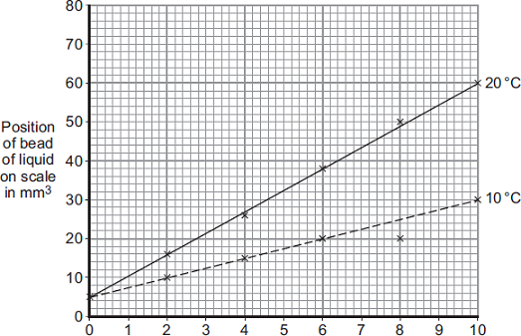
Volume of oxygen used (mm³)
Time in minutes
(i) How much oxygen did the earthworms take in during the 10 minutes at 20°C?

(ii) The earthworms took in this volume of oxygen in 10 minutes.
Use your answer from part (c)(i) to calculate how much oxygen the earthworms took in each minute.

(iii) The earthworms took in less oxygen each minute at 10°C than they took in at 20°C.Explain why.

9B2 Homework task 2 Due Date: ………………………………………………..

Section 1: Review of prior knowledge
1. What are the key features of diffusion?
……………………………………………………………………………………………………………………………………………………………
2. What happens when a gas reaches equilibrium?
……………………………………………………………………………………………………………………………………………………………
3. What is the relationship between surface area of a membrane and the rate of diffusion?
……………………………………………………………………………………………………………………………………………………………
4. How are the alveoli adapted to maximise rates of diffusion?
……………………………………………………………………………………………………………………………………………………………
5. What is the composition of inhaled air?
……………………………………………………………………………………………………………………………………………………………
6. What is the composition of exhaled air?
……………………………………………………………………………………………………………………………………………………………
Section 2: Refreshing current knowledge
Q2. Paula is training for a marathon. When she runs, her heart beats faster than it does when she is resting.
Complete the sentences, using words from the box.
blood breathe carbon dioxide glucose
heat nitrogen oxygen respire
When she is running, Paula‘s muscle activity increases. To do this, her muscle cells............................................. at a faster rate to give her more energy. Her muscles need to be supplied with ........................................... and ............................................................. more quickly. Her heart beats faster to increase the flow of..................................................which carries the products ............................................................................................. and ............................ away from her muscles.

Section 3: Application of knowledge

Q1.
Joanne measured the volume of air she breathed in and out of her lungs. She used the machine shown in the photograph below.
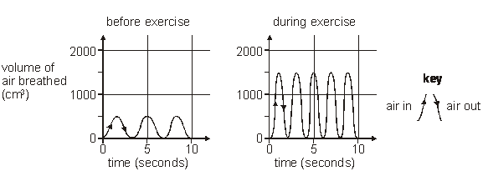
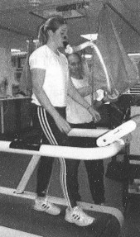

The graphs represent the volume of air Joanne breathed in and out with each breath before and during exercise.
(a) During exercise Joanne breathed more air in and out of her lungs than before exercising.
(i) How much more air did Joanne breathe in with each breath during exercise?
.................... cm³
(ii) Explain fully why Joanne needed to breathe in more air during exercise.

(b) (i) As Joanne exercised, the volume of air she breathed in and out increased.
Give one other way Joanne’s breathing changed during exercise.
.............................................................................................................
.............................................................................................................
(ii) How does the graph show this other change?
.............................................................................................................
.............................................................................................................

9B3 Homework task 1 Due Date: ………………………………………………..

Section 1: Review of prior knowledge
1. What is the process trees use to make their food?

- When plants and animals die and are buried for millions of years, what is formed?

- Give the formulae for oxygen, carbon dioxide and water

- Why are group 1 metals so reactive?

- What is the name given to a turning force?

- What is a pivot?

Section 2: Refreshing current knowledge
The drawings below show three dogs. They all look different.
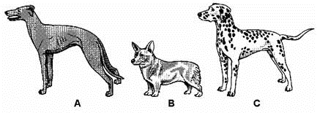
(i) Which word describes the differences between these dogs? Tick the correct box.
adaptation reproduction
vaccination variation
1 mark

(ii) The drawing below shows a puppy. Dog C is the puppy's mother.
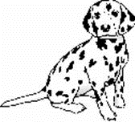
Why does the puppy look like his mother? Tick the correct box.
Information passed from the mother in an egg.
Information passed from the mother in a sperm.
Information passed from the mother in milk.
Information passed from the mother in blood.
1 mark
Section 3: Application of knowledge The drawings show identical twins, Sara and Helen, and their parents.
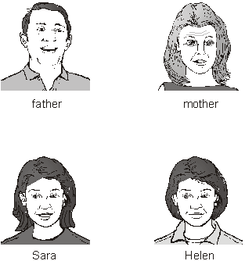
(a) (i) Sara and Helen have blue eyes like their mother. Describe how genetic information is passed on from a parent to a child.
...................................................................................
...................................................................................
2 marks
(ii) Sara and Helen have brown hair like their father and blue eyes like their mother. Why do children have characteristics of both parents?
...................................................................................
1 mark
b) Sara and Helen are identical twins. Why do they have identical characteristics?
.......................................................................................
1 mark
(c) Sara now spends a lot of her time working outdoors in a hot country. Helen now works in an office in England. The table shows information about three human characteristics.
characteristic | Is it identical for  Sara and Helen?
eye colour | yes
skin colour | no
weight | no
Explain why their eye colour is identical but their weight and skin colour are not identical.
............................................................................................
............................................................................................
9B3 Homework task 2 Due Date: ………………………………………………..

Section 1: Review of prior knowledge
- Name 3 types of rock

- List the percentages of the gases in our modern atmosphere.

3. What is an enzyme?

4. What is a microorganism?

5. What instrument can be used to measure force?

- What is the unit for moments?

Section 2: Refreshing current knowledge

1) Label this diagram, if you want use the keywords below.
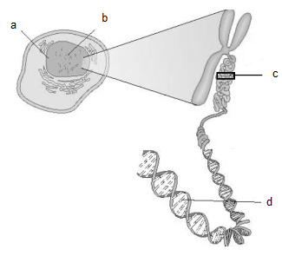

chromosome DNA adenine nucleus gene cell

2) Describe a strand of DNA

3) State the complimentary base pairs

4) What bonds the complementary base pairs together?

Section 3: Application of knowledge

What is continuous variation? Give examples

………………………………………………………………………………………………………………………………………………………………………………………….

What is discontinuous variation? Give examples

………………………………………………………………………………………………………………………………………………………………………………………….

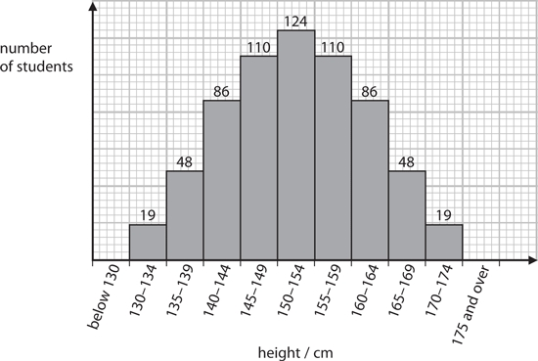
(i) Complete the sentence by putting a cross () in the box next to your answer.
The range in heights of the students is due to
(1)
A environmental influences only
B genetic influences only
C environmental and genetic influences
D neither environmental nor genetic influences
(ii) Describe the variation in height of these students, as shown in the graph.
(3)
..............................................................................................................................................
..............................................................................................................................................
..............................................................................................................................................

9B3 Homework task 3 Due Date: ………………………………………………..

Section 1: Review of prior knowledge
- What is gas exchange?

- Where does respiration occur in a cell?

- What is distillation?

4. What type of substances are separated by filtration?

5. What happens to potential difference in series circuits?

- What are compasses used for?

Section 2: Refreshing current knowledge
There are two forms of cell division: mitosis and meiosis. The table below contains statements about cell division. For each statement, place one tick in the appropriate row.
statement | mitosis only | meiosis only | both mitosis and meiosis
occurs only in
reproductive organs
replaces worn out
body cells
DNA or genetic information is copied before cell division
number of chromosomes
in a cell is halved

4 marks
Section 3: Application of knowledge
1) A female with the genotype ee has attached earlobes and a male with the genotype Ee has detached earlobes.
(ii) Complete the Punnett square to show the gametes and genotypes of the offspring for this female and male. (2)
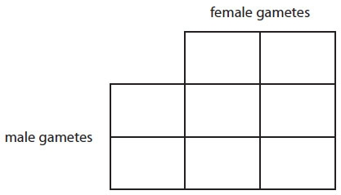

(iii) State the probability of the offspring having detached earlobes.
(1)
..............................................................................................................................................
(iv) What is the percentage probability of a mother with the dominant genotype EE and a father with the recessive genotype ee producing a child with attached earlobes?

Put a cross () in the box next to your answer.
(1)
A 0%
B 25%
C 75%
D 100%

2) Some students extracted DNA from strawberries. The diagram shows the method used.
Suggest the purpose of stages 1 and 3 in the DNA extraction. (2)
……………………………………………………………………………………………………………………………………………………………………………………….…………………………………………………………………………………………………………………………………………………………………………………………….………………………………………………………………………………………………………………………………………………………………………………………….
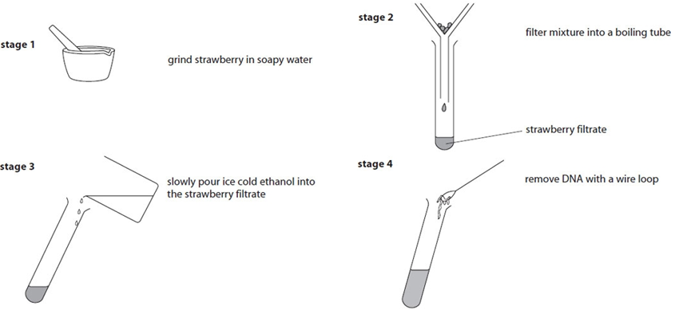
9C1 Homework Task 1 Due date ………………………………………………

Section 1: Review of prior knowledge
- What is biomass?

- What chemical is used to test for starch?

- Which greenhouse gas is responsible for recent climate change?

- Which gas is responsible for Acid Rain?

- Why do objects cool down?

- In which states of matter can convection take place?

Section 2: Refreshing current knowledge
A How does the diagram show that air is a mixture?
B How many different substances are shown in the diagram?
C How many of them are not molecules?
D How many oxygen molecules are shown?
E Name the three elements shown. F How many different compounds are shown?
G Name them.
H How many different molecules are there?
I Name them

Section 3: Application of knowledge
The table shows some information about four metals.
metal | atomic number | electronic configuration
lithium | 3 | 2.1
sodium | 11
magnesium | 12 | 2.8.2
calcium | 20 | 2.8.8.2
(a) State the electronic configuration of sodium. (1)
..............................................................................................................................................
(b) Magnesium and calcium are in the same group of the periodic table.
Explain why they are both in the same group. (2)
..............................................................................................................................................
..............................................................................................................................................
..............................................................................................................................................
(c) Complete the sentence by putting a cross () in the box next to your answer.
The atomic number of an element is equal to the number of (1)
A neutrons in the nucleus of its atom
B electrons in the nucleus of its atom
C protons in the nucleus of its atom
D protons and neutrons in the nucleus of its atom
(d) Which of these statements is correct about the particles in atoms?
Put a cross () in the box next to your answer. (1)
A a proton has the same mass as an electron
B an electron is heavier than a proton
C a neutron is lighter than an electron
D a neutron has the same mass as a proton

9C2 Homework Task 1 Due date ………………………………………………

Section 1: Review of prior knowledge
- What do we call diseases that cannot be passed from person to person e.g. are caused by genes or lifestyle?

- Give two ways that we can easily represent really big measurements or really small measurements.

- What is a molecule?

- Give the formulae for oxygen, carbon dioxide and water.

- What effects does an unbalanced force have on motion of an object?

- How can the motion of an object be describes if the forces acting upon it are balanced?

Section 2: Refreshing current knowledge

- What is causing the temperature of a pan of cold water on the hob to rise?

- Why doesn’t a pan of boiling water get any hotter?

- On a sunny day, my drink with ice in stays at 0°C until all the ice has melted. Why?

Section 3: Application of knowledge
The apparatus for a simple distillation is shown in Figure 1.
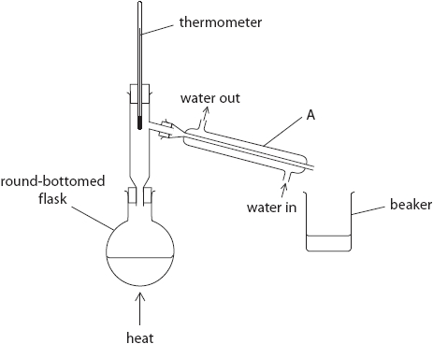
Figure 1
(i) Use words from the box to complete the sentences.
You may use each word once, more than once, or not at all.
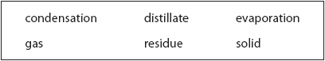
(3)
Simple distillation is used to separate a liquid from a .......................................................... .
In the apparatus labelled A, vapour is cooled to form liquid.
This process is called .......................................................... .
The liquid collected in the beaker is known as the .......................................................... .
(ii) Pure water collects in the beaker.
Explain how the apparatus will show that the liquid collected is pure water. (2)
.............................................................................................................................................
.............................................................................................................................................
.............................................................................................................................................

9P1 Homework Task 1 Due date ………………………………………………

Section 1: Review of prior knowledge
- Give two reasons why cells need food.

2. Name the unicellular organisms that live in the human digestive system and keep it healthy.

- Where on the periodic table are the halogens found?

- What is the maximum number of electrons found in the first energy level?

- Define friction

- Recall the equation for pressure

Section 2: Refreshing current knowledge
Fill in the gaps in these sentences using words below. You do not need to use all of the words:
When a car is travelling at a constant speed, the forces on it are __________________. The forwards force from the __________________ is exactly balanced by the forces of air __________________ and _________________.

Balanced forces do not change the __________________ of something. A car with balanced __________________ on it will carry on moving at the same speed.
__________________ forces make objects __________________ or slow down.

Moving objects do not need __________________ to keep moving. A space probe orbiting the Sun has no forces of __________________ to slow it down. It will carry on __________________ the Sun.

balanced balanced do do not engine forces forces friction friction orbiting resistance speed speed up unbalanced unbalanced

Section 3: Application of knowledge
Figure 7 shows two boxes on a plank.
The plank is balanced on a pivot.
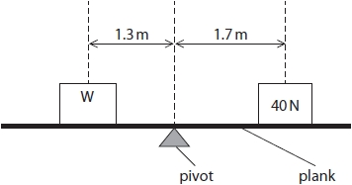
One box has a weight of 40 N.
(i) Calculate the moment of the 40 N weight about the pivot.
State the unit.
Use the equation
moment = force × perpendicular distance
(3)
moment = ...........................................................
unit ...........................................................
(ii) Calculate the weight, W, needed to balance the plank in Figure 7.
(3)
W = ........................................................... N

(Total for question = 6 marks)

9P2 Homework Task 1 Due date ………………………………………………

Section 1: Review of prior knowledge
- What is the difference between ventilation and respiration?

- What is diffusion?

- What element do all acids contain?

- What happens to the particles in a substance in a chemical reaction?

- Describe 2 characteristics of a sound wave

- Describe 2 characteristics of a light wave.

Section 2: Refreshing current knowledge

1 )Calculate the force needed to accelerate a 22 kg cheetah at 15 m/s².

2) Calculate the force needed to accelerate a 15 kg gazelle at 10 m/s².

Section 3: Application of knowledge
Figure 1 shows a speed/time graph for a car.
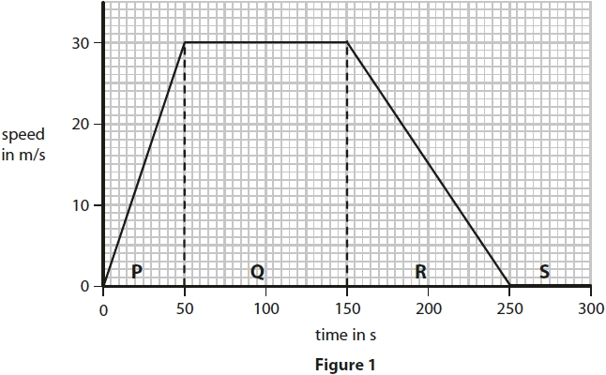
(i) The graph in Figure 1 is divided into four parts, P, Q, R and S.
Draw a line from the letter for each part to the correct description of the motion during that part.
One line has been drawn for you.
(2)
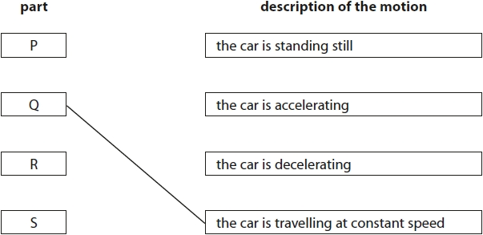
(ii) In two parts of the graph in Figure 1 the forces are balanced.
State the letters of the two parts of the graph where the horizontal forces acting on the car are balanced.
(2)
part ............................................................ and part ............................................................
(iii) Calculate the distance travelled by the car in part Q.
Use the equation
distance travelled = average speed × time
(2)
distance travelled = ........................................................... m
Homework title | Score for section 1 | Score for section 2 | Score fpr section 3 | What did I do well? | What do I need to improve next time?

