Year 7 Homework Booklet
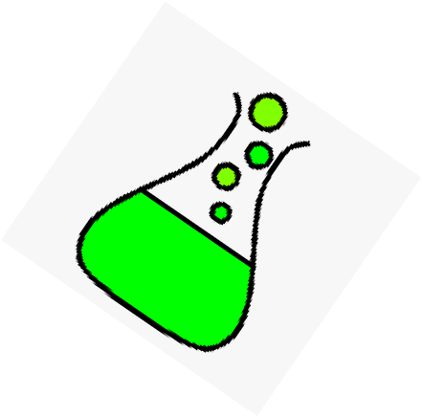
Name : ………………………………………………………………………………………………………………

Class & Teacher : ……………………………………………………………………………………….………

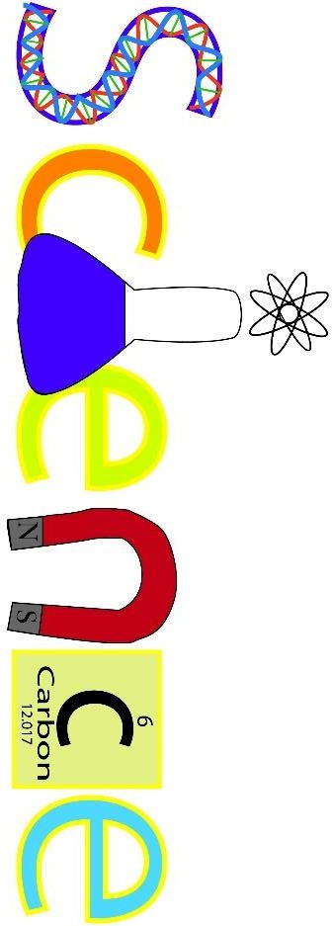

How to use this booklet:
- Section 1 contains core knowledge questions. You can use your core knowledge booklet or class workbooklet to get a perfect answer.
- Section 2 reviews your knowledge of this topic from the work you have done in class.
- Section 3 contains exam style questions for this topic.
Homework number | Date set | Date to be handed in | Completed?

Year 7 Homework support
The following QR codes will guide you to information which may help you to complete each homework.
Homework 1 – 7B1 | Homework 2 – 7B2
Homework 3 – 7B3 | Homework 4 – 7B4
Homework 5 – 7C1 | Homework 6 – 7C2
Homework 7 – 7C3 | Homework 8 – 7CP4
Homework 9 – 7C5 | Homework 10 – 7P1
Homework 11 – 7P2 | Homework 12 – 7P3
Homework 13 – 7 P4

Homework task 1 - 7B1 Cells and Body Systems

Section 1: Review of prior knowledge
- What is a cell?
………………………………………………………………………………………………………………………………………………………………………
……………….……………………………………………………………………………………………………………………………………………………

- Name 3 things you’d find in all plant and animal cells.
………………………………………………………………………………………………………………………………………………………………………
……………….……………………………………………………………………………………………………………………………………………………

- What is the function of the nucleus?
………………………………………………………………………………………………………………………………………………………………………
……………….……………………………………………………………………………………………………………………………………………………

- What is the function of the cytoplasm?

………………………………………………………………………………………………………………………………………………………………………
……………….……………………………………………………………………………………………………………………………………………………

- What is the function of the cell membrane?
………………………………………………………………………………………………………………………………………………………………………
……………….……………………………………………………………………………………………………………………………………………………

- What is the function of the chloroplasts in plants?
………………………………………………………………………………………………………………………………………………………………………
……………….……………………………………………………………………………………………………………………………………………………

Section 2: Refreshing current knowledge
1) Label these cells

4) What is the job of the mitochondria in cells?

………………………………………………………………………………………………………………………………………………………………………
……………….……………………………………………………………………………………………………………………………………………………
……………………………………….……………………………………………………………………………………………………………………………

Section 3: Application of knowledge

Draw lines to match up the cell, its job and the adaptation.

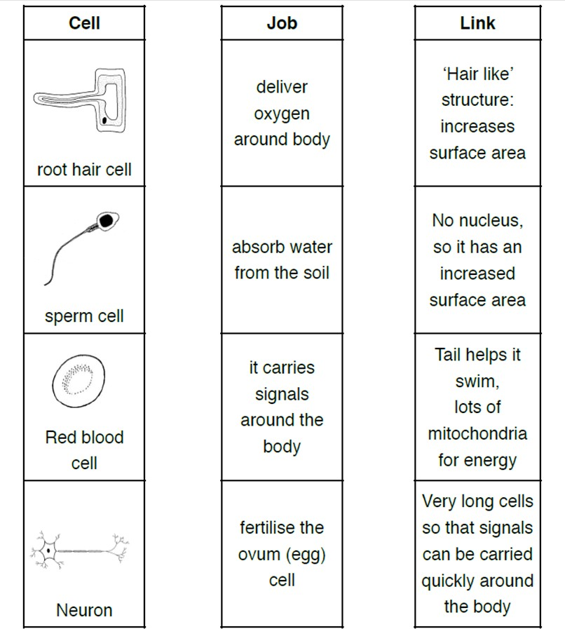

Homework task 2 - 7B2 Respiration

Section 1: Review of prior knowledge
- What are the key features of diffusion?
………………………………………………………………………………………………………………………………………………………………………
………………………………………………………………………………………………………………………………………………………………………
- What happens when a gas reaches equilibrium?
………………………………………………………………………………………………………………………………………………………………………
………………………………………………………………………………………………………………………………………………………………………
- What is the relationship between surface area of a membrane and the rate of diffusion?
………………………………………………………………………………………………………………………………………………………………………
………………………………………………………………………………………………………………………………………………………………………
- How are the alveoli adapted to maximise rates of diffusion?
………………………………………………………………………………………………………………………………………………………………………
………………………………………………………………………………………………………………………………………………………………………
- What is the composition of inhaled air?
………………………………………………………………………………………………………………………………………………………………………
………………………………………………………………………………………………………………………………………………………………………
- What is the composition of exhaled air?
………………………………………………………………………………………………………………………………………………………………………
………………………………………………………………………………………………………………………………………………………………………

Section 2: Refreshing current knowledge
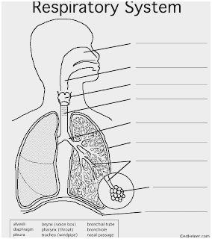
- Label the diagram of the respiratory system

- Air entering the lungs would pass through the following structures in the order:
A trachea to bronchus to air sac to alveolus
B trachea to bronchus to alveolus to air sac
C alveolus to trachea to bronchus to air sac
D bronchus to trachea to air sac to alveolus
- How is oxygen transported around the body?
  - carried on red blood cells
  - as a gas
  - carried on white blood cells
  - attached to glucose
- The air we breathe in contains:
A more oxygen and more water vapour than the air we breathe out.
B more oxygen and less carbon dioxide than the air we breathe out. C more carbon dioxide and less oxygen than the air we breathe out.
D more carbon dioxide and less water vapour than the air we breathe out.
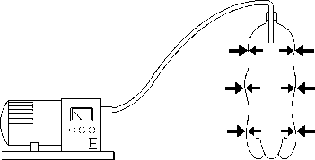
- The air is being sucked out of this bottle. Why is it collapsing?
A There is more air pressure inside than outside.
B There is more air pressure outside than inside. C There are more particles inside it.
D Air particles are sticking to the walls and pulling them in.

Section 3: Application of knowledge
- People who have emphysema have damaged air sacs in their lungs. The diagrams show a section through a normal air sac and a section through a damaged air sac.

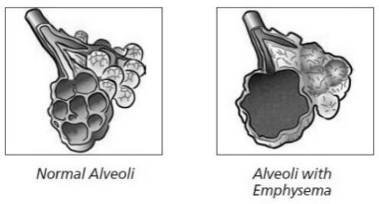
Gas exchange takes place at the inside surface of the air sac when a person breathes.

  - Which two gases are exchanged at this surface of the air sac?

............................................. and (1)

  - The amount of gas exchanged is smaller in a damaged air sac. Explain why.

........................................................................................................................................................... (1)

- Diagram 2 below shows one alveolus and its blood supply.

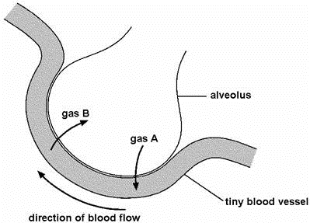
  - Look at diagram 2, above.
Gas A enters the blood from the alveolus.
Gas B leaves the blood and enters the alveolus. What are the names of gases A and B?

gas A .....................................................

gas B (1)

  - Give one reason why it is easy for gases to pass across the wall of an alveolus:
..................................................................................................................................................... (1)

Homework task 3 – 7B3 Genetics

Section 1: Review of prior knowledge
- What is a genome?

- What are gametes?

- What causes the physical changes that take place at puberty?

- How long does pregnancy last in humans?

- How often does a woman release an egg cell and when does ovulation usually happen?

- How do food, water and oxygen reach the growing baby?

Section 2: Refreshing current knowledge
Draw lines to link each term with its definition.

Terms |  | Definitions
ovulation |  | when the unfertilised egg and part of the uterus lining are shed from the body
fertilisation |  | when an egg is released from an ovary
menstruation |  | prevention of pregnancy
contraception |  | when a sperm cell fuses with an egg

Section 3: Application of knowledge

- The graph below shows how the mass of a human foetus increases during the 40 weeks of pregnancy.
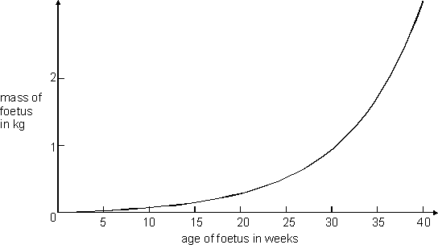

  - In which five-week period on the graph does the mass of the foetus increase most rapidly?

……………………………………………………………………………………………………………………………………………………………
……………

  - Describe the relationship between the age of the foetus and the mass of the foetus.

………………………………………………………………………………………………………………………………………………………………………
…………….………………………………………………………………………………………………………………………………………………………
…………………………………….………………………………………………………………………………………………………………………………
……………………………………………………….……………………………………………………………………………………………………………
……………………………………………………………
- The foetus needs oxygen but cannot breathe while it is in the uterus. Describe how oxygen gets from the air to the cells of the foetus.

………………………………………………………………………………………………………………………………………………………………………
……………….……………………………………………………………………………………………………………………………………………………
……………………………………….……………………………………………………………………………………………………………………………
………………………………………………………….…………………………………………………………………………………………………………

Homework task 4 – 7B4 Ecosystems

Section 1: Review of prior knowledge

What is an ecosystem?

Define community

Define population

What is biodiversity?

Where in the plant does photosynthesis take place?

How do plants get water?

Section 2: Refreshing current knowledge

Section 2: Refreshing current knowledge
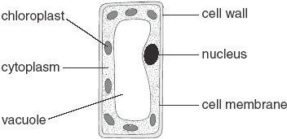
The diagram below shows a plant cell.
  - In which part of a plant would you find this type of cell? (1)
……………………………………………………………………………
  - (i) Give the function of the nucleus. (1)
…………………………………………………………………………………………………………………………………………………
- Give the function of the chloroplasts. (1)
…………………………………………………………………………………………………………………………………………………
- Give the function of the cell wall. (1)
…………………………………………………………………………………………………………………………………………………

- Give the names of two labelled parts that are not present in animal cells. (2)
…………………………………………………………………………………………………………………………………………………

…………………………………………………………………………………………………………………………………………………

statement | photosynthesis | respiration
carbon dioxide is produced
light is needed
it occurs in plants and animals
oxygen is produced
- Tick one box in each row to show whether the statement is true for photosynthesis or for respiration:

2 marks
Section 3: Application of knowledge
In the seventeenth century a Belgian scientist, Van Helmont, planted a young willow tree in a tub of dry soil.
During the next five years he watered the plant with rain water but he did not add anything else to the tub.
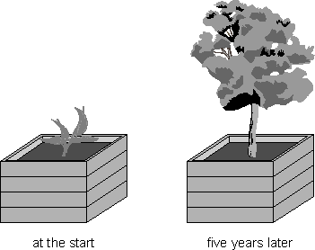 | 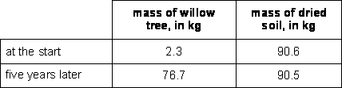
After five years Van Helmont removed the willow tree from the tub and weighed the tree. He also dried and weighed the soil. Results from Van Helmont’s experiment are shown in the table.
- Van Helmont concluded that the increase in the mass of the willow tree was due only to a gain in water.
(i) What two pieces of evidence did Van Helmont use to reach his conclusion? (2)
…………………………………………………………………………………………………………………………………………………
…………………………………………………………………………………………………………………………………………………
(ii) We now know that Van Helmont’s conclusion is not correct.
Explain why the mass of the willow tree increased by such a large amount. (2)
…………………………………………………………………………………………………………………………………………………
…………………………………………………………………………………………………………………………………………………
- Van Helmont believed that a plant would always grow faster if it was given more water. We now know that this is not true.
Give two environmental conditions which can slow down the growth of a plant, even when it has plenty of water. (2)
…………………………………………………………………………………………………………………………………………………
…………………………………………………………………………………………………………………………………………………

Homework Task 5 – 7C1 Atoms and the Periodic Table

Section 1: Review of prior knowledge

- What is an atom?

- What is an element?

- Where do we find metals on the period table?

- What are the columns of the periodic table called?

- What are the rows of the periodic table called?

- Who designed the modern periodic table?

Section 2: Refreshing current knowledge
Write the formula for each of these particle drawings

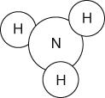
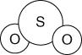
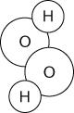
a b c

ammonia

d
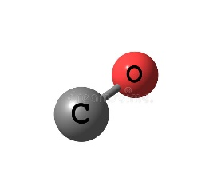

carbon monoxide
sulfur dioxide

e
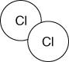

chlorine
hydrogen peroxide

f
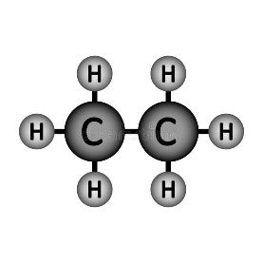

ethane

Section 3: Application of knowledge

Tick the correct boxes to classify each substance shown in the particle drawings below.

1  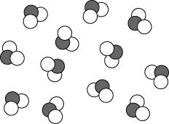 | - pure  - mixture  - element  - compound | 2  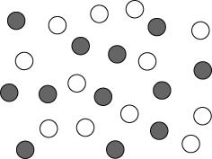 | - pure  - mixture  - element  - compound
3  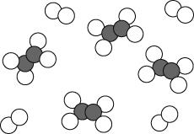 | - pure  - mixture  - element  - compound | 4  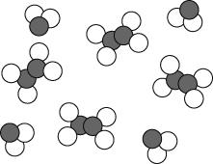 | - pure  - mixture  - element  - compound

- Read the following passage then answer the questions which follow.
‘When the shiny lithium metal is heated and lowered into a container of green chlorine gas, a chemical reaction occurs. The lithium appears to burn and a white solid forms on the sides of the container. The white solid is lithium chloride.’
  - Name the elements and the compound described in the above passage.

Elements:

Compound:
  - Describe one difference in property between the elements and the compound they form.

  - What evidence is there for a chemical reaction occurring?

- What is the difference between a mixture of elements and a compound?

- What elements are in the compound copper oxide?

Homework task 6 – 7C2 Particles

Section 1: Review of prior knowledge
- How are the particles arranged in a gas?

- How are the particles arranged in a liquid?

- How are the particles arranged in a solid?

- Describe Brownian motion in gases

- What do we call the process of forming a solid from a liquid?

- What do we call the process of forming a liquid from a solid?

Section 2: Refreshing current knowledge

Q1. (a) Methane can be a gas, a liquid or a solid. In the diagram below, arrows P, Q, R and S represent changes of state. The boxes on the right show the arrangement of particles of methane in the three different physical states.
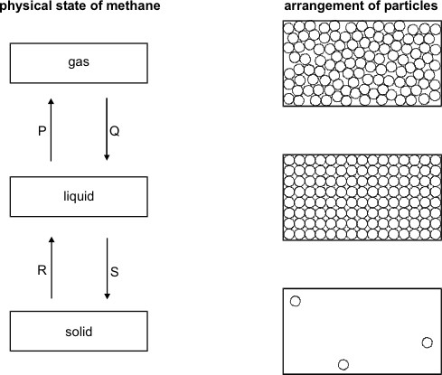
Each circle represents a particle of methane.

- Draw a line from each physical state of methane to the arrangement of particles in that physical state.
Draw only three lines.

- Arrows P, Q, R and S represent changes of state. Which arrow represents:

evaporation? ............................................................

melting? ...................................................................

Q2. Solids, liquids and gases have different properties and different uses. Some of these are described in the table.
Tick either one or two boxes in each row to show whether a solid, liquid or gas matches the description in that row.

property or use | solid | liquid | gas
it is used to build rigid or stiff structures
it flows easily through a pipe or tube
it can be squeezed into a much smaller volume

Q3. Ice from a freezer is put in a glass of water at room temperature. The ice floats in the water.

  - What does this show about the density of the ice compared to that of water? Tick the correct box.

Ice is more dense than water.

Ice and water have the same density. Ice is less dense than water.
Ice has a density of zero.
1 mark

  - The fact that ice floats in water tells us something about the distances between the molecules.
Tick the box by the correct statement.

The molecules are further apart in ice than in water.

The molecules are the same distance apart in ice and in water.

The molecules are closer together in ice than in water.

Section 3: Application of knowledge
Q1. Brownian Motion: This image shows smoke particles moving in an erratic way. This is caused by Brownian motion

- What states can Brownian motion occur in?

1 mark
Maximum 5 marks

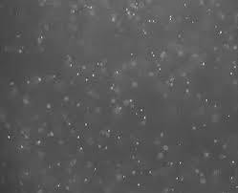
(2 marks)

- The bright dots represent smoke particles. What causes them to move in an erratic way? (2 marks)

- What would happen to the speed of the movements if you heated the smoke cell up? ( 1 mark)

Homework task 7 – 7C3 Chemical Reactions

Section 1: Review of prior knowledge

- What change takes place when atoms rearrange to make a new substance?

- What happens to the mass in a chemical reaction?

- What do we call the starting materials in a chemical reaction?

- What do we call the end materials in a chemical reaction?

- What do we call A solution with a pH less than 7 that produces hydrogen when dissolved in water?

- What do we call a solution with a pH greater than 7 that produces hydroxide ions when dissolved in water?

Section 2: Refreshing current knowledge
- What must go in the middle of a chemical word equation?
 A an arrow pointing right (→).
 B an arrow pointing left (←).
 C an equals sign.
 D the phrase ‘atoms get rearranged’.

- What are the chemicals on the left-hand side of a chemical word equation called?
 A solutes
 B solvents
 C reactants
 D products

- What are the chemicals on the right-hand side of a chemical word equation called?:
 A solutes
 B solvents
 C reactants
 D products

- What can be written after the name of a chemical in an equation to show that it was dissolved in water?
 A (s)
 B (l)
 C (g)
 D (aq)

- State the law of conservation of mass:
............................................................................................................................................................................

............................................................................................................................................................................

............................................................................................................................................................................

Section 3: Application of knowledge

  - Henrietta measures the mass of a piece of solid magnesium metal. She slowly heats the magnesium in the air and observes that it changes colour from a solid silver ribbon to a crumbly white solid. She records the mass again. Her results are shown in the table below.

Mass of magnesium at the start (g) | 1.52
Mass of magnesium substance at the end (g) | 2.53

    - Calculate the change in mass

…………… g

    - Suggest why the change in mass occurred
…………………………………………………………………………………………………………………………………………………
…………………………….………………………………………………………………………………………..…………………………
………………………………………….……………………………..…………………………………………………………………….

    - What signs were there that a chemical reaction occurred?

…………………………………………………………………………………………………………………………………………………

    - Henrietta correctly figured out that she no longer had pure magnesium at the end of the reaction.
Suggest a name for the new substance that had been made during the reaction

…………………………………………………………………………………………………………………………………………………

    - Suggest a word equation, including state symbols, for the chemical reaction that took place.

…………………………………………………………………………………………………………………………………………………

Homework task 8 - 7CP4 Earth and space

Section 1: Review of prior knowledge

Define weight

Define Mass

Describe what would happen to your mass if you were to visit the moon

How did the first oceans form?

How much oxygen was in the atmosphere when it first formed?

How was the Earth’s first atmosphere formed?

Section 2: Refreshing current knowledge
1 (a) Complete the sentence by putting a cross next to your answer. The Earth's earliest atmosphere is thought to have been formed by
  - animals breathing
  - photosynthesis in plants
  - the oceans cooling
  - gases from volcanoes
(b) (i) Complete the sentence by putting a cross next to your answer.
The Earth's earliest atmosphere contained large amounts of carbon dioxide.
The percentage of carbon dioxide in the Earth's atmosphere today is
- less than 1%
- 5%
- 21%
- 78%

- Write the formula of a molecule of carbon dioxide....................................................................
The percentage of carbon dioxide in the atmosphere has decreased since the Earth's earliest atmosphere. Explain what has caused the amount of carbon dioxide in the atmosphere to decrease.
…………………………………………………………………………………………………………………………………………………………
2. Define the following terms: The Universe
.................................................................................................................................................................
Galaxy
.................................................................................................................................................................
Solar System
.......................................................................................................................................................
What is our sun an example of? ………………………………………………………………………………………………….

Section 3: Application of knowledge
Draw a postcard designed to be from one of the planets in our solar system.
You must include the following information on the front of the postcard:
Its day length, Its temperature (this may be a range), Its year length, Its distance from the sun, At least 3 fun facts about the planet, An image of the planet

Homework task 9 – 7C5 Metals

Section 1: Review of prior knowledge

What gas is formed when a metal reacts with an acid?

What is the new chemical that is made during a chemical reaction knowns as?

Where are non-metals found on the periodic table?

Where are metals found on the periodic table?

What type of salt is produced from nitric acid?

What type of salt is produced from sulfuric acid?

Q1. (a) Ruth put a piece of a different metal in each of four test tubes. She poured 10 cm³ of hydrochloric acid onto each metal.
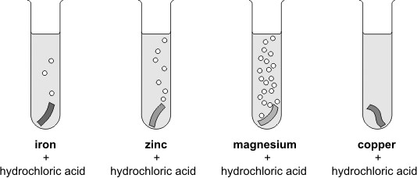

Look at the diagrams above. (i) How do these show if a metal reacts with the acid?
………………………………………………………………………………………………………………………………………………………………………

(ii) On the lines below, put the four metals in the order of how strongly they react with the acid.

most reactive ..................................

..................................

..................................

least reactive ..................................

Section 3: Application of knowledge

- Lithium, sodium and potassium are reactive metals in group 1 of the periodic table.
In an experiment equal-sized pieces of lithium, sodium and potassium are added to separate samples of water.
- A flame is produced only with potassium because potassium
  - is the softest metal
  - has the lowest melting point
  - is the most reactive
  - is the only flammable metal

* (ii) A teacher demonstrated this experiment.
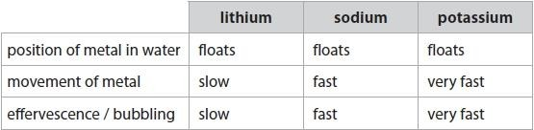
The results are shown in Figure 14.

Figure 14
Describe, in detail, how the teacher would demonstrate this experiment safely, showing how the results give the order of reactivity of the metals.

………………………………………………………………………………………………………………………………………………………………………
………………………………………………………………………………………………………………………………………………………………………
………………………………………………………………………………………………………………………………………………………………………
………………………………………………………………………………………………………………………………………………………………………
………………………………………………………………………………………………………………………………………………………………………
………………………………………………………………………………………………………………………………………………………………………
………………………………………………………………………………………………………………………………………………………………………
………………………………………………………………………………………………………………………………………………………………………
………………………………………………………………………………………………………………………………………………………………………

- Magnesium reacts very slowly with cold water but it reacts faster with steam, H2O, to form magnesium oxide, MgO, and hydrogen.
Write the balanced equation for the reaction between magnesium and steam.

………………………………………………………………………………………………………………………………………………………………………
………………………………………………………………………………………………………………………………………………………………………

Homework Task 10 – 7P1 Forces and Motion

Section 1: Review of prior knowledge

Name 8 forces

State the unit for force

What is the motion of the car if all forces are balanced?

What is the motion of the car if the forces are unbalanced?

What is the unit for weight?

What two things do the arrows on a force diagram demonstrate?

Section 2: Refreshing current knowledge

- What is the equation to calculate speed?

- A bicycle travelled at 6 m/s. What was distance measured in?

- A ferry travels at 18m/s. Which units were used to measure time?

- A commuter train travels at 55m/s for 300 seconds. What distance has it travelled in this time?

Section 3: Application of knowledge

Q1) The diagram below shows Jo hanging on a trapeze (swing) in a circus.
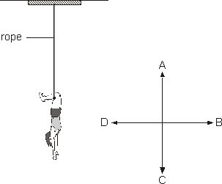

  - (i) Which arrow, A, B, C or D, shows the direction of Jo’s weight?

..............

- Which arrow, A, B, C or D, shows the direction of the force of the rope on Jo?

..............

Sally pulls a sledge in the snow.
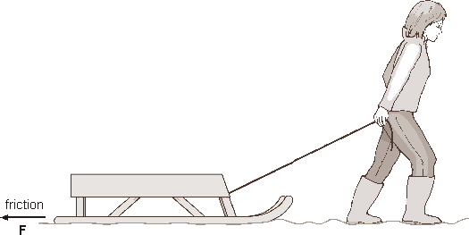

  - (i) Draw an arrow on the rope to show the direction of the force of the rope on the sledge

Label the arrow R. (ii) Draw an arrow on the diagram to show the direction of the force of gravity on the sledge.

Label the arrow G.

Homework task 11 – 7P2 Energy

Section 1: Review of prior knowledge

- What is the symbol and unit for energy?

- Draw an energy transfer diagram for when food is used in our bodies

- Describe what is meant by a system

- Describe what is meant by conservation of energy

- Name at least two pathways through which energy can be transferred

- Describe what happens to waste energy

Section 2: Refreshing current knowledge
Q1) Name the 9 stores of energy
1.
2.
3
4.
5.
6.
7.
8.
9.

Q2) Draw an energy transfer diagram for a battery powered torch.

Q3) Explain what is meant by waste energy
………………………………………………………………………………………………………………………………………………………………………
……………….……………………………………………………………………………………………………………………………………………………

………………………………………………………………………………………………………………………………………………………………………
……………….……………………………………………………………………………………………………………………………………………………

Section 3: Application of knowledge

A motor in a remote controlled car transfers 300J of energy into the car’s energy stores. 225 J are
transferred to the car’s kinetic energy stores. Kinetic energy is related to the motion of the car and is a useful energy.

Q1) Calculate how much of the input energy is wasted to thermal energy (due to friction):
………………………………………………………………………………………………………………………………………………………………………
……………….……………………………………………………………………………………………………………………………………………………
……………………………………………………………………………………………………………………………………………………………………

Q2) Describe a method that could be used to reduce the amount of energy lost due to friction.
………………………………………………………………………………………………………………………………………………………………………
……………….……………………………………………………………………………………………………………………………………………………
……………………………………………………………………………………………………………………………………………………………………

Q3) Explain why it is important for that people try to reduce the amount of energy lost as waste.
………………………………………………………………………………………………………………………………………………………………………
……………….……………………………………………………………………………………………………………………………………………………
……………………………………………………………………………………………………………………………………………………………………

………………………………………………………………………………………………………………………………………………………………………
……………….……………………………………………………………………………………………………………………………………………………
………………………………………………………………………………………………………………………………………………………………………

Homework task 12 – 7P3 Waves

Section 1: Review of prior knowledge

Define echo

State the speed of light

State the speed of sound

Define transparent

Define translucent

Define opaque

Section 2: Refreshing current knowledge
  - What is a wave?
………………………………………………………………………………………………………………………………………………………………………
……………….……………………………………………………………………………………………………………………………………………………

  - Name the two types of wave motion. Give an example of each.
………………………………………………………………………………………………………………………………………………………………………
……………….……………………………………………………………………………………………………………………………………………………

  - Explain how all waves are similar.
………………………………………………………………………………………………………………………………………………………………………
….……………………………………………………………………………………………………………………………………………………

Section 3: Application of knowledge

    - Correctly identify the types of wave motion shown below.

For each statement, decide whether it refers to water waves, sound waves, or both

Example: Particles move at right angles to the way the wave is moving (water only)

- Can be reflected

- Particles move in the same direction as the wave is moving

- Can involve solids, liquids or gases

- Transverse wave

- Spreads out from source in all directions

- Amplitude of wave decreases with distance from source

- Transfers energy

- Transfers matter

- Longitudinal wave

Homework task 13 – 7P4 Electricity

Section 1: Review of prior knowledge

Describe the structure of an atom

What subatomic particles are found in the nucleus?

What is the charge and mass of the three subatomic particles?

How do unlike charges interact?

Describe how static electricity is generated

Define current

Section 2: Refreshing current knowledge
- Most atoms contain electrons, protons and neutrons. Describe the positions of these particles in atoms.
............................................................................................................................................................................
............................................................................................................................................................................
............................................................................................................................................................................
............................................................................................................................................................................
- Draw a diagram to illustrate the structure of metals

Section 3: Application of knowledge
- Describe the structure of a metal
............................................................................................................................................................................
............................................................................................................................................................................
............................................................................................................................................................................
............................................................................................................................................................................
- Explain why metals can conduct electricity
............................................................................................................................................................................
............................................................................................................................................................................
............................................................................................................................................................................
............................................................................................................................................................................
- A student charges two balloons and hangs them side by side.
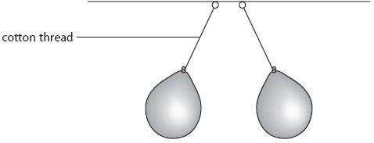
- Explain why the cotton threads are not vertical.
............................................................................................................................................................................
............................................................................................................................................................................
............................................................................................................................................................................
............................................................................................................................................................................
The student rubs another balloon with a cloth. This balloon becomes negatively charged.
- Explain why the balloon became negatively charged when it was rubbed with the cloth.
............................................................................................................................................................................
............................................................................................................................................................................
............................................................................................................................................................................
..............................................................................................................................................................................

