
Aylsham High School:
Food Preparation and Nutrition GCSE

PRACTICALS – September - June

Contents | Page
GCSE Food Preparation & Nutrition | 2-4
Health & Safety | 5-8
Skills Groups & Techniques | 9-12
Recipes, Evaluations, Questions & Tasks
PRACTICAL LESSONS:
PRACTICAL 1: Choux Pastry | 13-15
PRACTICAL 2: Meatballs | 16-18
PRACTICAL 3: Chicken Kiev | 19-23
PRACTICAL 4: Rough Puff Pastry Chicken Pie | 24-27
PRACTICAL 5: Pannacotta & Shortbread | 28-31
PRACTICAL 6: Poached Fish & Dauphinoise | 32-35
PRACTICAL 7: Souffle | 36-38
PRACTICAL 8: Alternative Proteins | 39-42
PRACTICAL 9: Scotch Egg & Health and Safety | 43-47
PRACTICAL 10: Lasagne & Garlic Bread | 48-51

This booklet contains the recipes for all the dishes you will make during the course and is where you record and evaluate the skills and techniques you use and evaluate the dishes you make.

You will need to become proficient at using the Nutrition Program website to cost, evaluate and analyse the nutritional content of the food you make.

Website | www.nutritionprogram.co.uk | www.illuminate.digital/eduqasfood
User Name | SB1A  ..................................................................... Lastname initial Firstname initial  (that’s your first name and last name)  Followed by group. | SAYL4
Password | gcse (lower case) | STUDENT4

GCSE Food Preparation and Nutrition

Aims of the course
The Eduqas Food and Nutrition equips learners with
- the knowledge, understanding and skills required to cook and apply the principles of food science, nutrition and healthy eating.
- encourages learners to cook
- enables them to make informed decisions about food and nutrition and
- allows them to acquire knowledge in order to be able to feed themselves and others affordably and nutritiously, now and later in life.

Assessment
The GCSE course in Food Preparation and Nutrition is assessed by examination and through the completing of two Non-Examination Assessments.

The Exam
The 1 hour 45-minute written exam will be in early June, and is worth 50% of the qualification, or 100 marks. This is on the following 6 areas of content:
  - Food commodities
  - Principles of nutrition
  - Diet and good health
  - The science of food
  - Where food comes from
  - Cooking and food preparation

The Non-Examination Assessments
There are 2 non-examined assessments (NEAs) which you have to complete as part of your GCSE.
1. Non-Examination Assessment 1 (NEA1): The Food Investigation Assessment
Worth 15% of the qualification or 30 marks.
This is a scientific investigation into an area of food. All that means is that you investigate the different methods or ingredients used to make particular food. You so this by planning experiments, making a prediction about what you think will happen, conducting the experiments, drawing some conclusions about what happened and evaluating your method and prediction.

Some of the tasks set recently were to investigate chemical raising agents in scones, fats in shortcrust pastry and sugars in fairy cakes.

- Non-Examination Assessment 2 (NEA2): The Food Preparation Assessment
Worth 35% of the qualification or 70 marks.
The NEA2 is the food preparation assessment and represents 35% of the qualification. In this assignment you will be given a choice of two tasks. Once you have chosen your task you will need to investigate and plan the task, selecting a final menu which showcases your skills and a plan as to how you will cook it on the assessment day.

- Section A (worth 15 / 70 marks) is where you interpret and investigate the task. You will research, trial and select your dishes and write a plan for your practical session.
- Section B (worth 45 / 70 marks) is where you have a 3-hour session to showcase your technical skills. Demonstrate a wide range of technical skills and health and safety procedures when preparing, cooking and presenting your chosen dishes. Photographic evidence of the completed dishes is essential. You need to get all your washing up done too!
- Section C (worth 10 / 70 marks) is where you evaluate your assignment, you’ll need to explain how well you selected, prepared, cooked and presented your final dishes.

The task might be about a special dietary need, a lifestyle choice or a special event. Some of the tasks set recently asked students to plan a celebratory Valentine’s day hotel meal, a menu to serve at an event where street food is served and some lacto-vegetarian dishes to include on a restaurant menu.

We hope that you’ve chosen to do this course because you love cooking and eating food (we all do!) To help develop your interest in food and support your progress on the course there are some things you could do which are useful:
- Cooking, especially chopping vegetables – if you can’t remember the methods we used this video is a pretty good guide - https://www.youtube.com/watch?v=G-Fg7l7G1zw ,
- Washing up and helping keep the kitchen clean and tidy (getting really good at this will help your NEA2 go super-smooth),
- Helping plan the family meals – websites like BBC Good Food are great, but so are the supermarkets’ websites,
- Watching TV cookery programs,
- Following cooks and chefs on social media platforms like Twitter, YouTube and Instagram,
- Reading cookery books (some of them are as well written as a good novel),
- Looking at food magazines and restaurant menus (online and in the flesh)
- Thinking about ingredients and how they are used in recipes,
- Going food shopping with the family,
- Talking to butchers, fishmongers and other people involved in food,
- Finally, we normally encourage students to visit farmers markets, food festivals, and, if possible, restaurants. Sadly, none of these are not possible at the moment.

Health and Safety

Hazards in the Kitchen
There are many hazards in the kitchen. You need to think about these when you are planning to cook and whilst you are cooking. In your NEA2 you will need to list all the health and safety points you need to consider whilst cooking.
- Hot surfaces: cookers, burners, hobs, grills
- Hot equipment: pans, trays, kettle
- Sharp equipment: knives and blades
- Water: slips and trips – let me know
- Electricity, gas and water
- Chemicals: anti-bac, washing-up liquid
- Debris: slips and trips
- People: noise, collision, distraction, unsafe behaviours
- Flames: gas cookers, fires, etc.
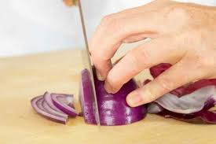
- Bacteria: people, food, dirt, pests, bags.

Knife Safety
With good skills a chef will be safe, quick, efficient and produce good quality food.
- Never grab a falling knife
- Always cut away from yourself – never towards –using the whole of the knife’s blade
- When you have a knife in hand, keep your eyes on the blade
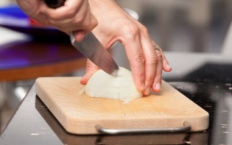
- Carry a knife properly, pointed straight down
- Never put a knife in a sink full of water
- Clean knives safely with a brush in hot soapy water
- Only cut on a chopping board
- A sharp knife is a safe knife.
- To prevent cuts and grazes whilst cutting food always use the claw grip and the bridge hold.

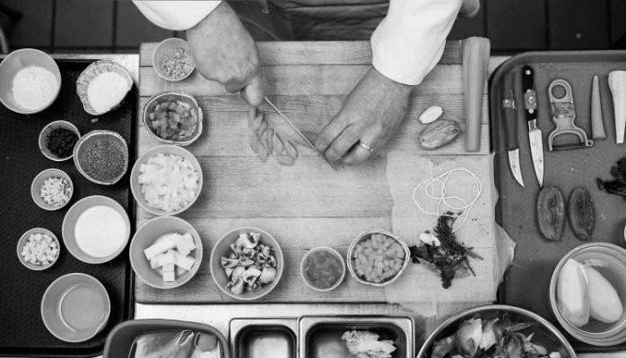
Mise en place
(MEEZ ahn plahs) is a French term for getting your ingredients and equipment ready before you start cook. It is a technique chefs use to assemble meals so quickly and effortlessly.
This means:
- READ THE RECIPE AT LEAST Twice.
- Making sure that you and your workspace are clean and ready to cook – that you have followed all the personal hygiene recommendations.
- Having all your ingredients measured, cut, peeled, sliced, grated, etc.
- Pans are prepared.
- Mixing bowls, tools and equipment set out.

The 4 C’s of Food Safety

Clean

Cook

Chill

Cross Contamination
Personal hygiene
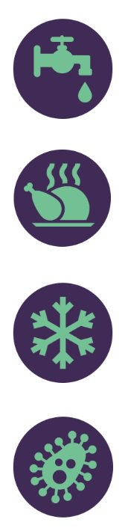
- Blue waterproof plasters in food areas.
- Hands and nails kept clean at all times – frequent washing.
- No jewellery as it harbours dirt and bacteria.
- No nail varnish - it chips and falls off and hides dirty nails.
- Clean apron or uniform.
- Should not be handling food with a heavy cold or flu. Always say if you have a cold or sore throat, boils, spots or septic wounds; diarrhoea, nausea or vomiting
- Hair should be tied back or covered.

HACCP
All food businesses have in place a HACCP (Hazard Analysis Critical Control Point) assessment to make sure that food is safe to eat. Every aspect of food hygiene and safety is monitored for hazards. You need to make sure that you and your workspace are
Hazards can be:
- Physical hazards (hair, jewelry, finger nails, flies, plasters, griot, bone, metal machinery parts) can cause choking, broken teeth, internal cuts and bruising.
- Chemical hazards (cleaning products and pesticides) can cause liver and nerve damage and internal burns.
- Biological hazards (bacteria, viruses, mould, fungi) can all cause food poisoning.

In your practical assessment you have just 3 hours to prepare, cook, wash up and present your 3 dishes. For all the recipes you cook this year you should think about how you can make them as quickly and efficiently as possible. Thinking carefully about what you do for your preparation / mise en place and make sure you clear and clean your workspace as you go.



Food poisoning
Common causes of food poisoning
- Food is prepared too far in advance
- Cooked food is cross contaminated by raw food
- Food is cooled too slowly
- Food is undercooked
- Food isn’t reheated enough to kill all the bacteria in it.
- Hot food is kept at a temperature of less than 63˚C.
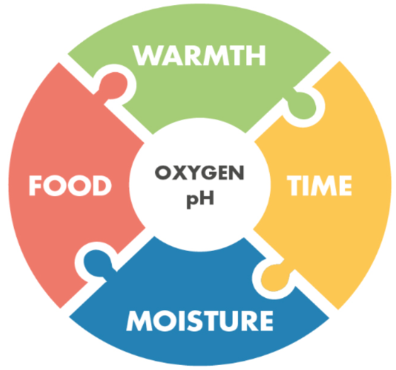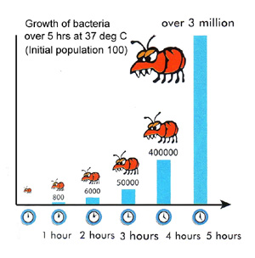
Fig 2. In the right conditions bacteria reproduce very quickly.
Fig 1.
Bacteria need warmth, time, moisture and food to grow. Some also need oxygen and a specific pH.

High Risk Foods
High risk foods are foods high in protein and moist. At 75ºC, most bacteria will die. We need to temperature probe the meat to ensure its hot enough.

The Danger Zone
This is the name for the range of temperatures best suited for bacterial growth, 5ºC to 63ºC.
The longer food is kept in the danger zone, the greater the opportunity for bacteria to grow and the greater the possibility of food poisoning.

Reheating Food at Home
Your dishes will be refrigerated within an hour of you making them. They can be reheated at home, but only once. Food can be reheated in a microwave (transfer it to a microwavable dish first) until steaming hot, or in the oven at 190oC for 15 to 20 minutes. Check it’s piping hot, with a temperature probe if you have one - you will be looking for a temperature of 75oC or above in the centre of the food.

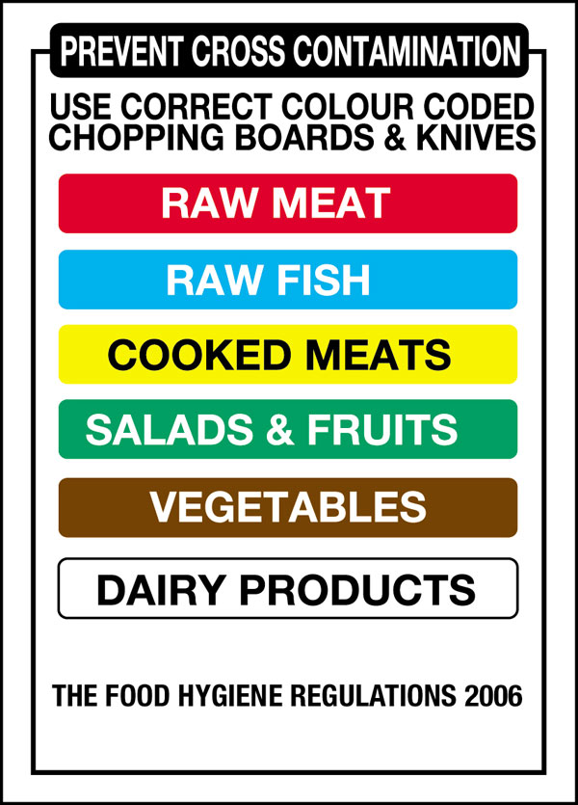
Preparation and Cooking
- To prevent cross contamination, make sure to use the correct colour chopping board.
- Check ingredients are in date and fit for use
- Wash fruit and vegetables before use.
- To kill food poisoning bacteria food must be cooked at the right temperature for the right amount of time.
- Fully defrost frozen foods before cooking.
- Always check the core temperature.
- Clean and sanitise before and after use.
- High risk foods must be at least 75˚C in the middle to be safe.
- Stir often to avoid cool spots or split large amounts of liquid into smaller pans.

Cooling
- Cool rapidly so that the food is in the danger zone for the least amount of time.
- DO NOT put into the fridge to cool down.

Washing Up
To prevent bacteria and mould growing on wet and dirty surfaces it is important to keep food preparation areas clean and dry. This means:
- sanitising surfaces before cooking,
- washing up and drying equipment thoroughly before putting it away and
- keeping surfaces wiped down.

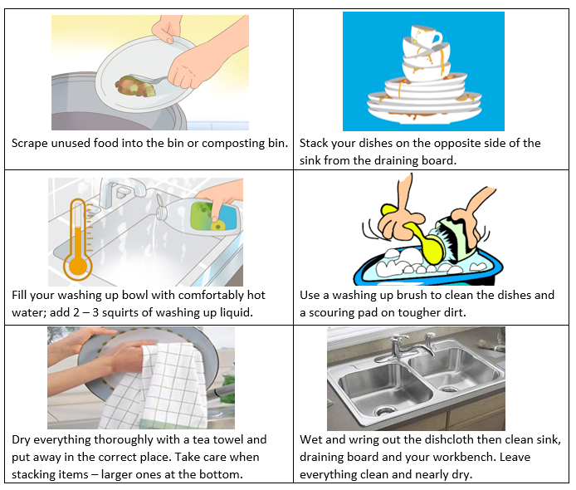
Skills Groups and Techniques Table

The next 4 pages list all the skills and techniques you will be using on the course. You can maximise the number of marks you get in your NEA2 practical by using as many as you possibly can (as long as you can execute them well).

Skill | Food prep skills | Techniques | Examples of where I used these techniques
S1 | Knife Skills | Be able to demonstrate the following techniques for fruits and vegetables and, where appropriate, also those that relate to meat and fish or their alternatives:  • meat, fish and alternatives - fillet a chicken breast, portion a chicken, remove fat and rind, fillet fish, slice raw and cooked meat and fish or alternatives (such as tofu and halloumi) evenly and accurately  • fruits and vegetables - bridge hold, claw grip, peel, slice, dice and cut into even size pieces (i.e. batons, julienne) | ..................................................................  ..................................................................  ..................................................................  ..................................................................  ..................................................................  ..................................................................  ..................................................................  ..................................................................  ..................................................................  ..................................................................  ..................................................................  ..................................................................
S2 | Prepare fruits and vegetables | Be able to demonstrate the following techniques:  • mash, shred, scissor snip, scoop, crush, grate, peel, segment, de-skin, de-seed, blanch, shape, pipe, blend, juice and prepare garnishes whilst demonstrating the technical skills of controlling enzymic browning and spoilage and preventing food poisoning (wash and dry where appropriate) | ..................................................................  ..................................................................  ..................................................................  ..................................................................  ..................................................................  ..................................................................  ..................................................................  ..................................................................
S3 | Prepare, combine and shape | Be able to demonstrate the following techniques:  • roll, wrap, skewer, mix, coat, layer meat, fish and alternatives, and shape and bind wet mixtures (such as falafels, fish cakes or meatballs) whilst demonstrating the technical skill of preventing cross contamination and handle high risk foods correctly | ..................................................................  ..................................................................  ..................................................................  ..................................................................  ..................................................................  ..................................................................

Skill | Food prep skills | Techniques | Examples of where I used these techniques
S4 | Tenderise and marinate | Be able to demonstrate how acids denature protein and marinades add flavour and moisture when preparing vegetables, meat, fish, and alternatives | .......................................................................  .......................................................................  .......................................................................  .......................................................................
S5 | Select and adjust a cooking process | Be able to demonstrate the following techniques:  • select and adjust the cooking process and length of time to suit the ingredient, for example to match the cut of meat, fish and alternatives | .......................................................................  .......................................................................  .......................................................................  .......................................................................  .......................................................................
S6 | Weigh and measure | Be able to demonstrate accurate measurement of liquids and solids | .......................................................................
S7 | Preparation of ingredients and equipment | Be able to demonstrate the following techniques:  • grease/oil, line, flour, evenly and with attention to finished product | .......................................................................  .......................................................................  .......................................................................
S8 | Use of equipment | Be able to demonstrate the following techniques:  • use a blender, food processor, mixer, and microwave | .......................................................................  .......................................................................  .......................................................................
S9 | Water based methods using the hob | Be able to demonstrate the following techniques:  • steaming  • boiling and simmering  • blanching  • poaching | .......................................................................  .......................................................................  .......................................................................  .......................................................................
S10 | Dry heat and fat based methods using the hob | Be able to demonstrate the following techniques:  • dry frying  • pan (shallow frying)  • stir frying | .......................................................................  .......................................................................  .......................................................................
S11 | Using the grill | Be able to demonstrate the following techniques with a range of foods, such as vegetables, meat, fish or alternatives such as halloumi, seeds and nuts:  - char  - grill or toast | .......................................................................  .......................................................................  .......................................................................  .......................................................................  .......................................................................

Skill | Food prep skills | Techniques | Examples of where I used these techniques
S12 | Using the oven | Be able to demonstrate the following techniques:  - baking  - roasting  - casseroles and/or tagines  - braising | ....................................................................  ....................................................................  ....................................................................  ....................................................................
S13 | Make sauces | Be able to demonstrate the following techniques:  • make a blended white sauce (starch gelatinisation) such as a roux and all in one blended sauce, infused sauce, velouté, béchamel, to demonstrate understanding of how liquid/starch ratios affect the viscosity and how conduction and convection work to cook the sauce and the need for agitation  • make a reduction sauce such as pasta sauce, curry sauce, gravy, meat sauce (including meat alternatives such as myco-protein and textured vegetable protein) to demonstrate how evaporation concentrates flavour and changes the viscosity of the sauce  • make an emulsion sauce such as a salad dressing, mayonnaise, hollandaise to demonstrate the technical skill of how to make a stabilised emulsion | ....................................................................  ....................................................................  ....................................................................  ....................................................................  ....................................................................  ....................................................................  ....................................................................  ....................................................................  ....................................................................  ....................................................................  ....................................................................  ....................................................................  ....................................................................  ....................................................................  ....................................................................  ....................................................................  ....................................................................  ....................................................................  ....................................................................  ....................................................................  ....................................................................
S14 | Set a mixture - removal of heat (gelation) | Be able to demonstrate the following techniques:  • use starch to set a mixture on chilling for layered desserts such as custard or cheesecake | ....................................................................  ....................................................................  ....................................................................
S15 | Set a mixture - heating (coagulation) | Be able to demonstrate the following techniques:  • use protein to set a mixture on heating such as denatured protein in eggs for quiche, choux pastry | ....................................................................  ....................................................................  ....................................................................

Skill | Food prep skills | Techniques | Examples of where I used these techniques
S16 | Use of raising agents | Be able to demonstrate the following techniques:  • use egg (colloid foam) as a raising agent - create a gas-in air foam - whisking egg whites, whisked sponge  • use chemical raising agents - self raising flour, baking powder, bicarbonate of soda  • use steam in a mixture (choux pastry, batter) | .................................................................  .................................................................  .................................................................  .................................................................  .................................................................  .................................................................  .................................................................
S17 | Make a dough | Be able to demonstrate the following techniques:  • use the technical skills of shortening, gluten formation, fermentation (proving) for bread, pastry, pasta | .................................................................  .................................................................  .................................................................  .................................................................
S18 | Shaping and finishing a dough | Be able to demonstrate the following techniques:  • roll out pastry, use a pasta machine, line a flan ring, create layers (palmier), proving/resting  • glazing and finishing such as pipe choux pastry, bread rolls, pasta, flat breads, pinwheels, pizza, calzone | .................................................................  .................................................................  .................................................................  .................................................................  .................................................................  .................................................................
S19 | Test for readiness | Be able to demonstrate the following techniques:  • use a temperature probe, knife/skewer, finger or ‘poke’ test, ‘bite’, visual colour check or sound to establish whether an ingredient or recipe is ready | .................................................................  .................................................................  .................................................................  .................................................................
S20 | Judge and manipulate sensory properties | Be able to demonstrate the following techniques:  • how to taste and season during the cooking process  • change the taste and aroma through the use of infusions, herbs and spices, paste, jus, reduction  • how to change texture and flavour, use browning (dextrinisation) and glazing, add crust, crisp and crumbs  • presentation and food styling – use garnishes and decorative techniques to improve the aesthetic qualities, demonstrate portioning and presenting | .................................................................  .................................................................  .................................................................  .................................................................  .................................................................  .................................................................  .................................................................  .................................................................  .................................................................  .................................................................  .................................................................

PRACTICAL 1: Choux Pastry:
Ingredients:
Method:
- Preheat the oven to 200ºC, gas mark 6.
- Sift the flour onto a piece of greaseproof paper.
- Cut the butter into small pieces, place into a medium sized pan and cover with water. Heat on a medium hob stirring with a white spoon. As soon as the butter has melted and the water has come to a boil turn off the heat.
- Tip in all the flour and mix thoroughly with the white spoon to make a roux. Beat the mixture vigorously with the spoon until you have a smooth ball of paste which leaves the sides of the saucepan clean.
- Thoroughly beat the eggs and add to the mixture about a tablespoon at a time. Continue adding egg beating until you have a smooth glossy paste (like shiny mashed potato). You don’t have to use all the egg.
- Put the piping nozzle into a piping bag, roll down the sides of the piping bag and sit in a clean jug and fill with the mixture.
- Dot a baking tray with butter to make the greaseproof paper stick to the tray.
- Sprinkle the baking paper with cold water.
- For profiteroles:
- Pipe small balls onto the tray and smooth the tops down with a wet finger.
- Bake for 15 – 20 minutes.
- Make a small slit in the side.
- Cool on a baking rack and then fill with whipped cream and drizzle chocolate sauce over the top.
- For eclairs:
- Pipe the mixture into sausage shapes, bake for 15 minutes and then turn the temperature down to gas mark 5 or 190ºC and cook for a further 10 minutes.
- Make a slit along the length of the éclair. Scrape any uncooked dough out of the middle of the éclair.
- Cool on a baking rack and then fill with whipped cream and dip the tops into the chocolate sauce.
55g butter (or marge)
150g water (weigh out)
75g plain flour, sifted
2 eggs (beaten)
Pinch salt (add to beaten egg)
Pinch caster sugar (add to beaten egg)
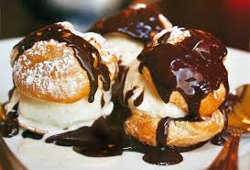

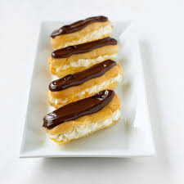
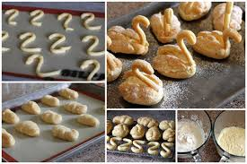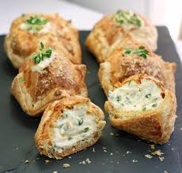

To cover (share between your table of 4)
Heat all the ingredients in a glass bowl over a pan of steaming water, stirring until it melts then beat until smooth.
Drizzle over your choux buns, but remember it’s to share!
150ml double cream
50g butter (margarine)
25g brown sugar
75g dark chocolate
Using an electric whisk, whisk the cream on a medium power until trails start to appear in the cream (the soft plop stage). Add the icing sugar and vanilla paste. Continue to beat on medium until the cream is forming soft peaks. Then turn the whisk down to low power and whisk until the peaks are firmer. Do not overbeat, as the cream will separate.
To fill (share between your table of 4)
300ml whipping cream, whipped with 50g icing sugar and a cap of vanilla extract or
half vanilla pod/ 1 g vanilla paste.

Name: |  | Food Class: Date:
Name of dish:
Key skills and techniques |  |  | Insert a picture of the dish here:
1.
2.
3.
4.
Evaluation
C | colour/ contrasts of colours
A | aroma/smell
A | aroma/smell |  | Success Criteria (what I'm looking for in the finished dish)  1.  2.  3.
T | texture/ ‘mouth feel’
FL | flavours
A | appearance/shapes/contrasts
A | appearance/shapes/contrasts |  | Food science involved:  1.  2.  3.
P | portioning/ position on plate |  | Food science involved:  1.  2.  3.
S | suggested improvements |  | Food science involved:  1.  2.  3.
I followed good personal hygiene rules by:  1.  2.  3. |  |  | I followed good food safety rules by:  1.  2.  3.

Sensory Evaluations |  |  |  |  |  | 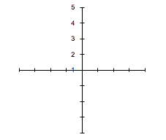  A.  D.  B  C.
Gather feedback from one or two others in class or at home. Focus on four descriptors relating to CATFLAPS and record in the box below, then complete the star diagram to the right.
Descriptor |  | Hedonic rating (out of 5)
 |  | You | Taster
A.
B.
C.
D.
Your sensory evaluation of the dish:
1.
2.
3.
Nutritional analysis (use ww.nutritionprogram.co.uk  Print out traffic lights (show 8) and insert here. |  |  |  |  |  | What did others say about your dish?  It was good because ……..  It could have been better if ……..
Healthy Eating Guidelines |  |  |  |  |  | Special diets
I could modify the recipe to improve the nutritional content to meet HEGs by: |  |  |  |  |  | I could modify the recipe to meet the following special diets by:
Element | Modification |  |  |  |  | Special Diet | Modification
Fibre |  |  |  |  |  | Diabetic
Salt |  |  |  |  |  | Obesity
Vitamins |  |  |  |  |  | Dental caries
Iron |  |  |  |  |  | Cardio vascular disease (CVD)
Calcium |  |  |  |  |  | Coeliac disease
Protein |  |  |  |  |  | Other allergies / intolerances
Saturated Fat |  |  |  |  |  | Vegans
 |  |  |  |  |  | Specific religions
Event or occasion this dish would be suitable for: |  |  |  |  |  | Specific religions
 | GCSE PRACTICAL 2 |  |  | Meatballs with Peppers and Tomatoes
 | FOOD PREPARATION & NUTRITION
INGREDIENTS  For meatballs:  -115g minced beef  -65g sausage meat  -¼ green pepper, deseeded & finely chopped  -1/2 egg, beaten  -1/2 small onion, finely diced or minced  -1 clove garlic, crushed  -1 tsp parsley, chopped  -1 tbsp bread crumbs  -1 tsp tomato paste  -flour for coating  -pepper & salt  -oil for frying  For the sauce:  -200g tinned or fresh tomatoes  -½ small onion, finely chopped  -1 clove garlic, crushed  -1/4 green pepper, seeded & finely chopped  -A few basil leaves |  | EQUIPMENT  -weighing scales  -large bowl  -chopping board  -chopping knife  -frying pan  -wooden spoon  -teaspoon  -tablespoon  -plate  -small bowl  -casserole dish  -baking tray | 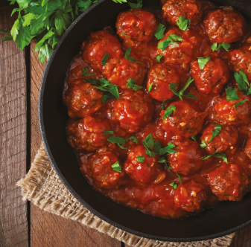
METHOD  Mise en place :  Look at the ingredients above & method below, what could you prepare for your mise en place?  Order of work:  1. Preheat oven to 190°C / Gas mark 5.  2. Place all the ingredients for the meatballs in large bowl and mix together throughly.  3. Take out a tablespoon of the mixture and roll into a small round, repeat with all the mixture. Making approximately 8-9.  4. Place flour on a plate and season. Coat all the meatballs with seasoned flour.  5. Heat oil in frying pan and brown the meatballs evenly. Place in casserole dish/foil tray .  6. For the sauce: In the juices remaining in the pan, gently fry the onions, peppers and garlic until soft, approximately 5 mins.  7. Add the basil and tomatoes and simmer for a few minutes, add seasoning then pour over the meatballs.  8. Cover with a lid and cook in the oven for about 30 minutes, then remove the lid and cook for a further 10 minutes.  9. Serve with noodles or rice. |  |  |  |  | Health and safety points  Use correct colour chopping boards.  Use knife holds correctly.  Make sure fat hot but not smoking.  Use oven gloves when placing in and taking out of the oven.  Wash up in hot soapy water. Dry thoroughly with tea towel before putting away.

Name: |  |  | Food Class: Date:
Name of dish:
Key skills and techniques |  |  |  | Insert a picture of the dish here:
1.
2.
3.
4.
Evaluation
C | colour/ contrasts of colours
A | aroma/smell
A |  |  |  | Success Criteria (what I'm looking for in the finished dish)  1.  2.  3.
T | texture/ ‘mouth feel’
FL | flavours
A | appearance/shapes/contrasts
A |  |  |  | Food science involved:  1.  2.  3.
P | portioning/ position on plate |  |  | Food science involved:  1.  2.  3.
S | suggested improvements |  |  | Food science involved:  1.  2.  3.
I followed good personal hygiene rules by:  1.  2.  3. |  |  |  | I followed good food safety rules by:  1.  2.  3.

Sensory Evaluations |  |  |  |  |  | A.  D.  B  C.
Gather feedback from one or two others in class or at home. Focus on four descriptors relating to CATFLAPS and record in the box below, then complete the star diagram to the right.
Descriptor |  | Hedonic rating (out of 5)
 |  | You | Taster
A.
B.
C.
D.
Your sensory evaluation of the dish:
1.
2.
3.
Nutritional analysis (use ww.nutritionprogram.co.uk  Print out traffic lights (show 8) and insert here. |  |  |  |  |  | What did others say about your dish?  It was good because ……..  It could have been better if ……..
Healthy Eating Guidelines |  |  |  |  |  | Special diets
I could modify the recipe to improve the nutritional content to meet HEGs by: |  |  |  |  |  | I could modify the recipe to meet the following special diets by:
Element | Modification |  |  |  |  | Special Diet | Modification
Fibre |  |  |  |  |  | Diabetic
Iron |  |  |  |  |  | Cardio vascular disease (CVD)
Protein |  |  |  |  |  | Other allergies / intolerances
Saturated Fat |  |  |  |  |  | Vegans
 |  |  |  |  |  | Specific religions

 | GCSE PRACTICAL 3 |  | CHICKEN KIEV
 | FOOD PREPARATION & NUTRITION
INGREDIENTS  - 4 skinless, boned chicken breasts  - 150g dried breadcrumbs  - 3 eggs  - 75g plain flour  - Pinch of paprika  - Salt and pepper  For the garlic butter  - 2 garlic cloves  - 1 tbsp parsley  - 1 tbsp lemon juice, from a ½ lemon or bottle of juice  - 100g butter  - Salt and black pepper |  | 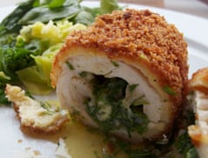
Method |  |  |  | H & S points
Mise en place  - Preheat the oven to 180ºC.  - Mince the garlic cloves  - Wash and finely chop the parsley  - Soften the butter in a small bowl  - Juice the lemon  - Mash together the butter, garlic and herbs, lemon juice and season.  - Divide the mixture between you.  - Shape the butter into a sausages using cling film to help you shape it, then tightly wrap and chill in the fridge until needed.  - Prepare three bowls for the pannéing:  - Weigh the flour into the first, add the paprika, seasoning and mix;  - Crack the eggs into the second;  - Weigh the breadcrumbs into the third.  Order of work  - Butterfly each chicken breast by opening it out using a knife, put it between 2 sheets of cling film and bash with a rolling pin.  - Put the sausage of butter near one edge of the chicken and begin rolling the meat up around it, tucking in the ends as you go, using some egg and flour as glue.  - Roll into a tight sausage using the cling film and chill until needed.  - Roll the Kiev in the three bowls – flour, eggs, then breadcrumbs, then repeat the egg and breadcrumb layers to give the Kiev a double coating. Remember to keep one hand dry.  - Heat the vegetable oil in a large pan until a crumb of bread turns golden in about 15 seconds, then gently lower the first Kiev in. Fry it for 2 – 3 minutes, then transfer to a baking tray and cook for 20 – 25 minutes until cooked through. |  |  |  | Take care with sharp knives  Wash your hands after cracking the egg.  Wash your hands before and after handling raw meat.  Carefully control the temperature, do not allow the hot oil to spit.  Use oven gloves when transferring food into and out of the oven.

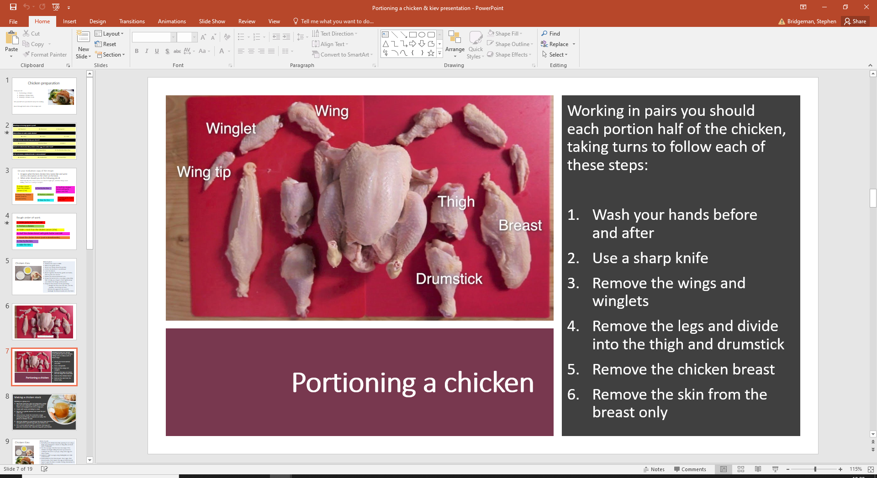

CHICKEN AND KIEV:

WHAT DOES THE WORD PANNEING MEAN?
………………………………………………………………………………………………………………………………………………………………………………
………………………………………………………………………………………………………………………………………………………………………………
………………………………………………………………………………………………………………………………………………………………………………
………………………………………………………………………………………………………………………………………………………………………………
………………………………………………………………………………………………………………………………………………………………………………

NAME THE PARTS OF THE CHICKEN YOU TOOK OFF TODAY? (How would you cook them differently?)
………………………………………………………………………………………………………………………………………………………………………………
………………………………………………………………………………………………………………………………………………………………………………
………………………………………………………………………………………………………………………………………………………………………………
………………………………………………………………………………………………………………………………………………………………………………

CAN YOU NAME 5 OTHER TYPES OF POULTRY?

……………………………………………………………… , ………..……………………………………… , …………………………………………………….

…………………………………………. & …………………………………………………….

GIVE A DEFINITION AS TO WHAT THE WORD ‘POULTRY’ MEANS?

………………………………………………………………………………………………………………………………………………………………………………
………………………………………………………………………………………………………………………………………………………………………………

IDENTIFY 3 VEHICLES THAT CAN RESULT IN CROSS – CONTAMINATION IN OUR DISH TODAY?

…………………………………………………….. , ……………………………………………. & …………………………………………………………….

WHAT IS IMPORTANT ABOUT THESE TEMPERATURES?

75C .............................................................................................................................................................................

5C – 63C ....................................................................................................................................................................

-18c ..............................................................................................................................................................................

SKILLS USED (Use the Skills Group and Techniques Table to list the skills and techniques you used today)
………………………………………………………………………………………………………………………………………………………………………………
………………………………………………………………………………………………………………………………………………………………………………
………………………………………………………………………………………………………………………………………………………………………………
………………………………………………………………………………………………………………………………………………………………………………

EVALUATION OF THE DISH
Decide what sensory qualities you want your dish to have and write them in here. Complete the evaluation when you eat the dish.
Sensory quality descriptor  with suggestions for characteristics to describe – colour etc  (make them in depth and accurate) |  | Score / 5 | Star Chart
C | 1 – colour /contrast of colours
A | 2 – aroma
T | 3 – texture / mouthfeel
FL | 4 – flavour
A | 5 – appearance / shapes / contrast
P | 6 - portioning
S | Suggested improvements
What I liked about the dish

Sensory Evaluations |  |  |  |  |  | A.  D.  B  C.
Gather feedback from one or two others in class or at home. Focus on four descriptors relating to CATFLAPS and record in the box below, then complete the star diagram to the right.
Descriptor |  | Hedonic rating (out of 5)
 |  | You | Taster
A.
B.
C.
D.
Your sensory evaluation of the dish:
1.
2.
3.
Nutritional analysis (use ww.nutritionprogram.co.uk  Print out traffic lights (show 8) and insert here. |  |  |  |  |  | What did others say about your dish?  It was good because ……..  It could have been better if ……..
Healthy Eating Guidelines |  |  |  |  |  | Special diets
I could modify the recipe to improve the nutritional content to meet HEGs by: |  |  |  |  |  | I could modify the recipe to meet the following special diets by:
Element | Modification |  |  |  |  | Special Diet | Modification
Fibre |  |  |  |  |  | Diabetic
Salt |  |  |  |  |  | Obesity
Sugar |  |  |  |  |  | Anaemia
Vitamins |  |  |  |  |  | Dental caries
Iron |  |  |  |  |  | Cardio vascular disease (CVD)
Calcium |  |  |  |  |  | Coeliac disease
Protein |  |  |  |  |  | Other allergies / intolerances
Saturated Fat |  |  |  |  |  | Vegans
 |  |  |  |  |  | Specific religions
Event or occasion this dish would be suitable for: |  |  |  |  |  | Specific religions
GCSE PRACTICAL 4: Flaky Pastry Chicken Pie
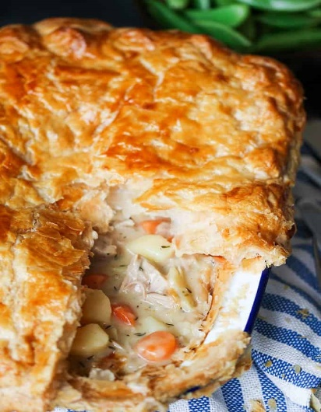
Ingredients for one small pie dish:
Flaky pastry
chicken meat
½ onion
½ tablespoon olive oil
½ tablespoon plain flour
50g mixed vegetables
Pinch of salt
Salt and pepper
100ml chicken stock
milk to glaze
Ingredients Flaky pastry:

200g strong plain flour
150g fat
(75g Marg / 75g White Fat)
6 tblsp cold water
1 tsp lemon juice

Method for filling
Preheat oven to 200º / gas mark 7.

Finely dice ½ an onion and the mixed vegetables sweat off in oil until soft.

Add ½ tablespoon of plain flour to make a roux and cook for about 30 seconds until it swells up but does not dry out.

Add the chicken stock a little at a time, cooking and stirring all the time until the sauce is thick.

Add the chicken to the sauce and mix. Taste and season, then set aside.

Roll out your pastry so that you have enough to line your pie tin and leave some for a lid. Lift the pastry on your rolling pin and line the tin, using a floured ball of pastry to gently push it into the corners. Fill the pie with the filling and then put on your pastry lid.

Crimp the top and bottom pastry pieces and rim at the very edge of the pastry case and, using a pastry brush, was the surface with a little milk.

You may cut some decorations to adorn the lid of your pie. Wash these with a little milk too.

Bake in the oven for 30minutes or until the crust is golden brown.

Method for pastry

Weigh ingredients carefully
Cut all the fat into small pieces about the size of a sugar lump. Add the flour.
Add the liquid. Using a palette knife, bind together into a soft dough.
Roll the dough to a rectangular shape. Fold the rectangle into three. Seal the edges with a rolling pin.
Place the pastry in fridge to relax for 15 mins.
Turn the pastry through 90° and roll and fold as before. Repeat once more.
Edges of pastry should be trimmed with a sharp knife.
Bake pastry at 220° - 230°C, Gas 7.

Name: |  |  | Food Class: Date:
Name of dish:
Key skills and techniques |  |  |  | Insert a picture of the dish here:
1.
2.
3.
4.
Evaluation
C | colour/ contrasts of colours
A | aroma/smell
A |  |  |  | Success Criteria (what I'm looking for in the finished dish)  1.  2.  3.
T | texture/ ‘mouth feel’
FL | flavours
A | appearance/shapes/contrasts
A |  |  |  | Food science involved:  1.  2.  3.
P | portioning/ position on plate |  |  | Food science involved:  1.  2.  3.
S | suggested improvements |  |  | Food science involved:  1.  2.  3.
I followed good personal hygiene rules by:  1.  2.  3. |  |  |  | I followed good food safety rules by:  1.  2.  3.

Sensory Evaluations |  |  |  |  |  | A.  D.  B  C.
Gather feedback from one or two others in class or at home. Focus on four descriptors relating to CATFLAPS and record in the box below, then complete the star diagram to the right.
Descriptor |  | Hedonic rating (out of 5)
 |  | You | Taster
A.
B.
C.
D.
Your sensory evaluation of the dish:
1.
2.
3.
Healthy Eating Guidelines |  |  |  |  |  | Special diets
I could modify the recipe to improve the nutritional content to meet HEGs by: |  |  |  |  |  | I could modify the recipe to meet the following special diets by:
Element | Modification |  |  |  |  | Special Diet | Modification
Fibre |  |  |  |  |  | Diabetic
Salt |  |  |  |  |  | Obesity
Sugar |  |  |  |  |  | Anaemia
Vitamins |  |  |  |  |  | Dental caries
Iron |  |  |  |  |  | Cardio vascular disease (CVD)
Calcium |  |  |  |  |  | Coeliac disease
Protein |  |  |  |  |  | Other allergies / intolerances
Saturated Fat |  |  |  |  |  | Vegans
 |  |  |  |  |  | Specific religions
Event or occasion this dish would be suitable for: |  |  |  |  |  | Specific religions

 | GCSE PRACTICAL 5 | Pannacotta & Fruit Coulé
 | FOOD PREPARATION & NUTRITION | Pannacotta & Fruit Coulé
INGREDIENTS:  Pannacotta:  1½ gelatine leaves  125ml milk  125ml double cream  ½ vanilla pod  25g caster sugar  Coule:  100g fresh raspberries, mixed berries or stewed fruit  50g icing sugar  Mine leaves optional | Equipment:  -Scales  -Measuring jug  -Veg knife  -Ramekins/pots  -Medium Saucepan  -White spoon  -Sieve |  | 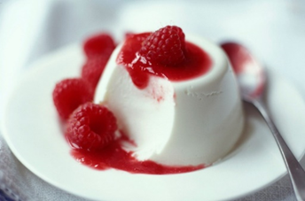
METHOD
Mise en place
- Prepare dishes
- Weight out milk and cream
- Weigh out sugar
- Split vanilla pod
- Weigh out coulé ingredients.

Order of work
- To make panna cotta soak the gelatine leaves in cold water until soft.
- Pour the cream and double cream into a saucepan. Split the vanilla pod in half and scrape out the seeds and add to the pan. Add the sugar.
- Heat the mixture slowly, stirring all the time until the sugar has dissolved. Bring just to a simmer.
- Remove the cream from the heat. Remove the gelatine from the water and squeeze well. Add to the saucepan and stir well until dissolved.
- Pour the mixture into four ramekins, small cups or cleaned plastic yogurt pots. Chill for at least 4 hours.
- To turn out dip each dish briefly in boiling water and invert onto plates.
For Coulé:
- Place raspberries/fruit into a saucepan with sugar. Set over a medium heat, crushing with the back of a fork until the sugar has dissolved and the berries have become saucy. Taste and add a little more sugar if the berries are particularly sharp.
- Strain through a sieve, then chill until ready to serve.
- To serve: scatter the fresh raspberries/fruit over and around and then sprinkle lightly with icing sugar. Decorate with mint leaves and/or fresh fruit.
Skills used:  - Weighing and measuring  - Fruit preparation  - Testing for readiness  - Setting with gelatine.  - Making a coulé |  | Food Quality Points:  - Smooth, moulded texture  - Creamy taste  - Set but also wobbly

Shortbread for Pannacotta
Ingredients  75g plain flour  50g margarine or butter  25g caster sugar |  | Equipment  15cm (6”) pastry cutter* baking tray  1 white tray palette knife  mixing bowl mixing spoon  cooling tray flour dredger  rolling pin
Time | Order  Prepare for practical.  Collect equipment, weigh out ingredients accurately.  Pre-heat the oven to 175°C/Gas 4.  Sieve the flour into the mixing bowl.  Add the margarine and rub into the flour until the mixture looks like breadcrumbs.  Stir the sugar into the mixture. Using your hands work the mixture into a dough.  Roll out the dough to an even thickness of a 50p piece. Cut the dough into biscuit rounds using the cutter.  Place the biscuits onto a greased baking tray. Prick with a fork and bake for 7 minutes until the biscuits are just beginning to turn golden brown.  Cool on a cooling tray.  Wash up and clear away. |  | Special Points  Why?  Why do you need to pre-heat the oven?  Why?  Why does the dough have to be an even thickness?  REMEMBER: the biscuits do not go crisp until they cool.

Name: |  |  | Food Class: Date:
Name of dish:
Key skills and techniques |  |  |  | Insert a picture of the dish here:
1.
2.
3.
4.
Evaluation
C | colour/ contrasts of colours
A | aroma/smell
A |  |  |  | Success Criteria (what I'm looking for in the finished dish)  1.  2.  3.
T | texture/ ‘mouth feel’
FL | flavours
A | appearance/shapes/contrasts
A |  |  |  | Food science involved:  1.  2.  3.
P | portioning/ position on plate |  |  | Food science involved:  1.  2.  3.
S | suggested improvements |  |  | Food science involved:  1.  2.  3.
I followed good personal hygiene rules by:  1.  2.  3. |  |  |  | I followed good food safety rules by:  1.  2.  3.
Sensory Evaluations |  |  |  |  |  | A.  D.  B  C.
Gather feedback from one or two others in class or at home. Focus on four descriptors relating to CATFLAPS and record in the box below, then complete the star diagram to the right.
Descriptor |  | Hedonic rating (out of 5)
 |  | You | Taster
A.
B.
C.
D.
Your sensory evaluation of the dish:
1.
2.
3.
Nutritional analysis (use ww.nutritionprogram.co.uk  Print out traffic lights (show 8) and insert here. |  |  |  |  |  | What did others say about your dish?  It was good because ……..  It could have been better if ……..
Healthy Eating Guidelines |  |  |  |  |  | Special diets
I could modify the recipe to improve the nutritional content to meet HEGs by: |  |  |  |  |  | I could modify the recipe to meet the following special diets by:
Element | Modification |  |  |  |  | Special Diet | Modification
Fibre |  |  |  |  |  | Diabetic
Salt |  |  |  |  |  | Obesity
Sugar |  |  |  |  |  | Anaemia
Vitamins |  |  |  |  |  | Dental caries
Iron |  |  |  |  |  | Cardio vascular disease (CVD)
Calcium |  |  |  |  |  | Coeliac disease
Protein |  |  |  |  |  | Other allergies / intolerances
Event or occasion this dish would be suitable for:

 | GCSE PRACTICAL 6 |  |  | Poached Fish with a Parsley Sauce
 | FOOD PREPARATION & NUTRITION
INGREDIENTS  A fillet of fish with skin on, cod, mackerel, haddock, trout.  Cold water  1 slice onion  ¼ carrot  Bouquet garni: bay leaf, thyme, parsley  Parsley Sauce  50ml Fish stock  50ml milk  15g butter  15g flour  10g Chopped Parsley |  | EQUIPMENT  2 Saucepans  Slotted spoon  White/wooden spoon  Sharp knife  Chopping board fish & veg.  Tablespoon  Teaspoon  Fish slice  Scales | 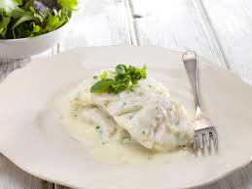
Mise en place:  What will you need to get ready for your mise en place? List below.  METHOD  For fish & fish stock:  - Fillet fish keeping skin on and place in fridge.  - For the stock place the fish bones in a saucepan and cover with cold water. Add peppercorns and bring up to boil. Then add vegetables and bouquet garni. Simmer for 20mins.  - Strain and set aside for poaching and parsley sauce.  For Parsley Sauce  - Melt the butter and add the flour to make a roux, cook gentle heat until cooked.  - Mix the liquids together and slowly add to roux to make sauce. Stir in parsley and bring to boil to thicken. Add a little more liquid to get required consistency.  - To ‘hold’ place greaseproof paper on sauce to prevent skin forming.  Poaching:  - In a saucepan put enough stock to cover fillet if fish and bring to boil.  - Place fillet carefully in stock and turn down to simmer until cooked, approx. 4-8 mins.  Serve:  - Plate the fillet on a warm plate, coat with warmed sauce, garnish and prepared vegetables. |  |  |  |  | Health and safety points  Use correct holds when peeling and chopping vegetables to prevent cuts.  Ensure refrigerator at 0c-5c.  Be careful with boiling water, not to splash and pan handle not sticking out.  Make sure fish cooked, flake easily.

 | GCSE PRACTICAL 6 |  |  | Dauphinoise Potatoes
 | FOOD PREPARATION & NUTRITION
INGREDIENTS  - knob butter , for greasing  - 1 large waxy potato , such as Desirée  - 80 ml milk  - 50ml double cream  - 1 garlic clove , peeled and halved  - Pepper & Salt  - Sprig fresh thyme (or half teaspoon of thyme leaves)  - pinch freshly ground nutmeg  - 1 tablespoon parmesan , (freshly grated) |  | EQUIPMENT  Small saucepan  White spoon  Sieve  Sharp knife  Chopping board veg.  Tablespoon  Measuring jug  Vegetable peeler  Garlic crusher  Scales | 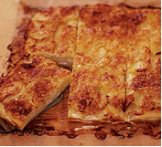
Mise en place:  What will you need to get ready for your mise en place? List below.  METHOD  1. Heat oven to 160C/fan 140C/gas 4. Grease a foil dish with a little of the butter.  2. Pour the milk and cream into a pan, then add the garlic and thyme. Heat to ‘just’ boiling point, cool a little and strain into a jug. Sprinkle with nutmeg and keep warm. You can prepare this in advance and reheat.  3. Peel and slice the potatoes to the width of a £1 coin.  4. Layer half the potatoes in the tin, overlapping the slices, sprinkling each layer with a little salt and pepper. Pour over half the liquid and finish layering, then add the rest of the liquid and scatter over the cheese. Bake for 45-60mins until the potatoes are tender and the top is golden. Leave to stand for 5 mins, then cut into 6 portions and serve. |  |  |  |  | Health and safety points  Use correct holds when peeling and chopping vegetables to prevent cuts.  Use oven gloves when placing and taking out dishes from the oven.

Name: |  |  | Food Class: Date:
Name of dish:
Key skills and techniques |  |  |  | Insert a picture of the dish here:
1.
2.
3.
4.
Evaluation
C | colour/ contrasts of colours
A | aroma/smell
A |  |  |  | Success Criteria (what I'm looking for in the finished dish)  1.  2.  3.
T | texture/ ‘mouth feel’
FL | flavours
A | appearance/shapes/contrasts
A |  |  |  | Food science involved:  1.  2.  3.
P | portioning/ position on plate |  |  | Food science involved:  1.  2.  3.
S | suggested improvements |  |  | Food science involved:  1.  2.  3.
I followed good personal hygiene rules by:  1.  2.  3. |  |  |  | I followed good food safety rules by:  1.  2.  3.

Sensory Evaluations |  |  |  |  |  | A.  D.  B  C.
Gather feedback from one or two others in class or at home. Focus on four descriptors relating to CATFLAPS and record in the box below, then complete the star diagram to the right.
Descriptor |  | Hedonic rating (out of 5)
 |  | You | Taster
A.
B.
C.
D.
Your sensory evaluation of the dish:
1.
2.
3.
Nutritional analysis (use ww.nutritionprogram.co.uk  Print out traffic lights (show 8) and insert here. |  |  |  |  |  | What did others say about your dish?  It was good because ……..  It could have been better if ……..
Healthy Eating Guidelines |  |  |  |  |  | Special diets
I could modify the recipe to improve the nutritional content to meet HEGs by: |  |  |  |  |  | I could modify the recipe to meet the following special diets by:
Element | Modification |  |  |  |  | Special Diet | Modification
Fibre |  |  |  |  |  | Diabetic
Salt |  |  |  |  |  | Obesity
Sugar |  |  |  |  |  | Anaemia
Iron |  |  |  |  |  | Cardio vascular disease (CVD)
Calcium |  |  |  |  |  | Coeliac disease
Protein |  |  |  |  |  | Other allergies / intolerances
Saturated Fat |  |  |  |  |  | Vegans
 |  |  |  |  |  | Specific religions

Name: |  |  | Food Class: Date:
Name of dish:
Key skills and techniques |  |  |  | Insert a picture of the dish here:
1.
2.
3.
4.
Evaluation
C | colour/ contrasts of colours
A | aroma/smell
A |  |  |  | Success Criteria (what I'm looking for in the finished dish)  1.  2.  3.
T | texture/ ‘mouth feel’
FL | flavours
A | appearance/shapes/contrasts
A |  |  |  | Food science involved:  1.  2.  3.
P | portioning/ position on plate |  |  | Food science involved:  1.  2.  3.
S | suggested improvements |  |  | Food science involved:  1.  2.  3.
I followed good personal hygiene rules by:  1.  2.  3. |  |  |  | I followed good food safety rules by:  1.  2.  3.

Sensory Evaluations |  |  |  |  |  | A.  D.  B  C.
Gather feedback from one or two others in class or at home. Focus on four descriptors relating to CATFLAPS and record in the box below, then complete the star diagram to the right.
Descriptor |  | Hedonic rating (out of 5)
 |  | You | Taster
A.
B.
C.
D.
Your sensory evaluation of the dish:
1.
2.
3.
Nutritional analysis (use ww.nutritionprogram.co.uk  Print out traffic lights (show 8) and insert here. |  |  |  |  |  | What did others say about your dish?  It was good because ……..  It could have been better if ……..
Healthy Eating Guidelines |  |  |  |  |  | Special diets
I could modify the recipe to improve the nutritional content to meet HEGs by: |  |  |  |  |  | I could modify the recipe to meet the following special diets by:
Element | Modification |  |  |  |  | Special Diet | Modification
Fibre |  |  |  |  |  | Diabetic
Salt |  |  |  |  |  | Obesity
Sugar |  |  |  |  |  | Anaemia
Iron |  |  |  |  |  | Cardio vascular disease (CVD)
Calcium |  |  |  |  |  | Coeliac disease
Protein |  |  |  |  |  | Other allergies / intolerances
Saturated Fat |  |  |  |  |  | Vegans
 |  |  |  |  |  | Specific religions

GCSE PRACTICAL 8: Alternative Protein Dishes

- Each bench is going to make a different alternative protein dish.
- You will all taste and evaluate each dish.
- Read through all sections of your recipe card. List the things you will do to prepare your mise en place. What could go wrong and what can you do to prevent it?
- You may use any fresh herbs and spices which are available to season (carefully) your dish.
- Present your dish, using any of the ingredients in the room as a garnish.

What are the dishes?

- Cheesy Beanburgers
- Quinoa, Feta and Roast Vegetable Salad
- Soya Spaghetti Bolognese
- Thai Quorn Curry
- Tofu Noodles

Dish | Hedonic Testing Marks out of 5 |  |  |  |  |  | Cost per portion | Nutritional analysis
Dish | Colour | Aroma | Texture | Flavour | Appearance | Marks  / 25 | Cost per portion | Nutritional analysis
Cheesy bean burger
Quinoa, feta and roast
vegetable salad
Soya spaghetti Bolognese
Thai Quorn curry
Tofu noodles
Say which you think was the most successful dish and explain why

Dish | Line colour
Cheesy beanburger
Quinoa, feta and roast vegetable salad
Soya spaghetti Bolognese
Thai Quorn curry
Tofu noodles

Questions on alternative proteins

- What are “alternative proteins” an alternative to?

- Why would someone choose to eat alternative proteins rather than ones from more traditional sources? (Try to think of and explain three good reasons.)

 | GCSE PRACTICAL 9 | Scotch Egg
 | FOOD PREPARATION & NUTRITION | Scotch Egg
INGREDIENTS: For one Scotch Egg.  1 egg  75g sausage meat  50g fresh white breadcrumbs  cooking oil  20g plain flour  egg for panne | Equipment:  -saucepan  -bowl  -fork  -knife  -kitchen paper  -weighing scales  -draining spoon  -deep fat fryer
METHOD
Mise en place

Order of work
- Place One egg in a saucepan, cover with cold water and bring to the boil.
- Boil for 5–8 minutes then plunge into cold water.
- Turn on deep fat fryer, set at 170°C.
- Cool and shell egg.
- Beat the raw egg in a bowl and halve the sausage meat. Flatten each piece using
floured hands.
- Coat each egg evenly with sausage meat making sure there are no gaps.
- Brush the egg with your beaten egg and roll in breadcrumbs, shaking off any excess crumbs.
- Gently lower the eggs into the fryer and cook for up to 8 minutes until golden
brown, turning occasionally.
- Drain on kitchen paper and cut into halves or quarters before serving.
Skills used:  - Weighing and measuring  - Boiling eggs  - Coating with egg and breadcrumbs  - Frying  - Testing for readiness |  | Food Quality Points:  - Eggs boiled without any dark  discolouration between yolk and white  - Even thickness of sausage meat  - Evenly browned appearance

Name of dish:
Key skills and techniques |  |  |  | Insert a picture of the dish here:
1.
2.
3.
4.
Evaluation
C | colour/ contrasts of colours
A | aroma/smell
A |  |  |  | Success Criteria (what I'm looking for in the finished dish)  1.  2.  3.
T | texture/ ‘mouth feel’
FL | flavours
A | appearance/shapes/contrasts
A |  |  |  | Food science involved:  1.  2.  3.
P | portioning/ position on plate |  |  | Food science involved:  1.  2.  3.
S | suggested improvements |  |  | Food science involved:  1.  2.  3.
I followed good personal hygiene rules by:  1.  2.  3. |  |  |  | I followed good food safety rules by:  1.  2.  3.
Sensory Evaluations |  |  |  |  |  | A.  D.  B  C.
Gather feedback from one or two others in class or at home. Focus on four descriptors relating to CATFLAPS and record in the box below, then complete the star diagram to the right.
Descriptor |  | Hedonic rating (out of 5)
 |  | You | Taster
A.
B.
C.
D.
Your sensory evaluation of the dish:
1.
2.
3.
Nutritional analysis (use ww.nutritionprogram.co.uk  Print out traffic lights (show 8) and insert here. |  |  |  |  |  | What did others say about your dish?  It was good because ……..  It could have been better if ……..
Healthy Eating Guidelines |  |  |  |  |  | Special diets
I could modify the recipe to improve the nutritional content to meet HEGs by: |  |  |  |  |  | I could modify the recipe to meet the following special diets by:
Element | Modification |  |  |  |  | Special Diet | Modification
Fibre |  |  |  |  |  | Diabetic
Salt |  |  |  |  |  | Obesity
Sugar |  |  |  |  |  | Anaemia
Vitamins |  |  |  |  |  | Dental caries
Iron |  |  |  |  |  | Cardio vascular disease (CVD)
Calcium |  |  |  |  |  | Coeliac disease
Protein |  |  |  |  |  | Other allergies / intolerances
Saturated Fat |  |  |  |  |  | Vegans
 |  |  |  |  |  | Specific religions

Examination Questions on Health and Safety

1. Studies show that many kitchens contain the most germs in the home. [6 marks]
For each of the following, list 2 rules to help prevent the spread of germs.
(a) Personal hygiene [2]
(i) .....................................................................................................................................................
.....................................................................................................................................................
(ii) .....................................................................................................................................................
.....................................................................................................................................................
(b) Kitchen hygiene [2]
(i) .....................................................................................................................................................
.....................................................................................................................................................
(ii) .....................................................................................................................................................
.....................................................................................................................................................
(c) Storage of foods [2]
(i) .....................................................................................................................................................
.....................................................................................................................................................
(ii) .....................................................................................................................................................
.....................................................................................................................................................

2. Bacteria in food can cause food poisoning. [5 marks]
For each of the following, list 2 rules to help prevent the spread of germs.
(a) Name 2 high risk foods [2]
(i) .....................................................................................................................................................
(ii) .....................................................................................................................................................
(b) Explain the importance of using colour coded equipment when handling and preparing food. [3]
................................................................................................................................................................
................................................................................................................................................................
................................................................................................................................................................
................................................................................................................................................................
................................................................................................................................................................
................................................................................................................................................................
................................................................................................................................................................
................................................................................................................................................................
................................................................................................................................................................
3. The following foods are to be served at a buffet.
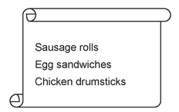

Discuss how to keep these foods safe to eat when preparing, cooking and serving the buffet. [9]

................................................................................................................................................................
................................................................................................................................................................
................................................................................................................................................................
................................................................................................................................................................
................................................................................................................................................................
................................................................................................................................................................
................................................................................................................................................................
................................................................................................................................................................
................................................................................................................................................................
................................................................................................................................................................
................................................................................................................................................................
................................................................................................................................................................
................................................................................................................................................................
................................................................................................................................................................
................................................................................................................................................................
................................................................................................................................................................
................................................................................................................................................................
................................................................................................................................................................
................................................................................................................................................................
..............................................................................................................................................................

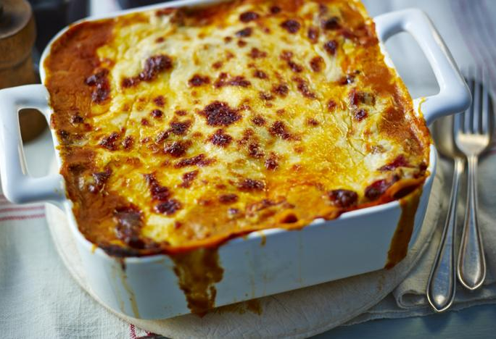
GCSE PRACTICAL 10: Lasagna and Garlic Bread
For fresh pasta
- 100g strong flour
- 1 egg
- 10ml olive oil
- Pinch salt

Lasagne

For the ragu
- 1 tbsp olive oil
- 100g beef mince
- ½ onion, roughly chopped
- 1 garlic clove, crushed
- 1 level tbsp plain flour
- 75ml beef stock
- ½ tsp caster sugar
- 1 tbsp tomato purée
- 1 tsp chopped thyme
- ½ x 400g can chopped tomatoes

For the white sauce
- 25g butter
- 25g plain flour
- 300ml infused milk (bayleaf, black peppercorn, clove studded onion)
- 25g cheese, finely grated
- salt and freshly ground black pepper
- Pinch mustard

Preheat Oven to 180c/325f/Gas 4
•For the lasagne, put one third of the meat sauce in the base of a shallow ovenproof dish. Spoon one third of the white sauce on top. Arrange one layer of lasagne sheets on top. Season. Spoon half of the remaining meat sauce on top and then half of the white sauce. Put another layer of lasagne sheets on top, then the remaining meat sauce and remaining white sauce. Sprinkle over the cheddar cheese.
• Cook in the middle of the oven for about 25 minutes- or until golden brown on top, bubbling around the edges and the pasta is soft.
Method for Pasta:
•Sieve the flour and salt into a bowl and shape into a well. Beat the egg and pour into the flour well. Mix together and only add oil to adjust the required consistency. Once bound together place on a clean flat surface and pull/knead the dough until it is of a smooth, elastic consistency. Cover the dough with a dampened cloth and allow to rest in a cool place for 30 minutes.
•Roll out the dough on a well floured surface to a thickness of ½ a mm or use a pasta rolling machine.
•Trim the edges and cut the dough as required or if using a pasta machine once thinned and run through the machine again using the cutting tool attachment.
•For the white sauce, melt the butter in a saucepan. Add the flour and cook over the heat for one minute. Gradually stir in the hot infused milk, stirring until thickened. Add the mustard and cheese and season well with salt and pepper.
•For the ragu, heat a large frying pan until hot and add the oil. Cook the mince until browned all over. Remove from the heat and transfer to a plate. Add the onion and garlic to the pan and cook until softened. Return the meat to the pan and stir in the flour. Add the stock and bring to the boil. Add the sugar, tomato purée and thyme, then stir well.
•Stir in the canned tomatoes. Bring to the boil again, cover and simmer in the oven for approximately 30mins, or until the beef is tender.

Nutrition: Each serving provides 861 kcal, 50g protein, 56g carbohydrates (of which 17g sugars), 47g fat (of which 23g saturates), 5.5g fibre and 1.4g salt.

Name: |  |  | Food Class: Date:
Name of dish:
Key skills and techniques |  |  |  | Insert a picture of the dish here:
1.
2.
3.
4.
Evaluation
C | colour/ contrasts of colours
A | aroma/smell
A |  |  |  | Success Criteria (what I'm looking for in the finished dish)  1.  2.  3.
T | texture/ ‘mouth feel’
FL | flavours
A | appearance/shapes/contrasts
A |  |  |  | Food science involved:  1.  2.  3.
P | portioning/ position on plate |  |  | Food science involved:  1.  2.  3.
S | suggested improvements |  |  | Food science involved:  1.  2.  3.
I followed good personal hygiene rules by:  1.  2.  3. |  |  |  | I followed good food safety rules by:  1.  2.  3.
Sensory Evaluations |  |  |  |  |  | A.  D.  B  C.
Gather feedback from one or two others in class or at home. Focus on four descriptors relating to CATFLAPS and record in the box below, then complete the star diagram to the right.
Descriptor |  | Hedonic rating (out of 5)
 |  | You | Taster
A.
B.
C.
D.
Your sensory evaluation of the dish:
1.
2.
3.
Nutritional analysis (use ww.nutritionprogram.co.uk  Print out traffic lights (show 8) and insert here. |  |  |  |  |  | What did others say about your dish?  It was good because ……..  It could have been better if ……..
Healthy Eating Guidelines |  |  |  |  |  | Special diets
I could modify the recipe to improve the nutritional content to meet HEGs by: |  |  |  |  |  | I could modify the recipe to meet the following special diets by:
Element | Modification |  |  |  |  | Special Diet | Modification
Fibre |  |  |  |  |  | Diabetic
Salt |  |  |  |  |  | Obesity
Sugar |  |  |  |  |  | Anaemia
Vitamins |  |  |  |  |  | Dental caries
Iron |  |  |  |  |  | Cardio vascular disease (CVD)
Calcium |  |  |  |  |  | Coeliac disease
Protein |  |  |  |  |  | Other allergies / intolerances
Saturated Fat |  |  |  |  |  | Vegans
 |  |  |  |  |  | Specific religions

