Aylsham High School:

Food Preparation and Nutrition GCSE

THEORY September-June

Contents | Page
Cornell Notes Reference Sheet | 2
THEORY LESSONS:
THEORY 1: Meat Theory | 3-5
THEORY 2: Cooking Processes | 6-16
THEORY 3: Poultry | 17-21
THEORY 4: Cereals | 22-24
THEORY 5: Fish | 25-27
THEORY 6: Eggs | 28-31
THEORY 7: Alternative Proteins | 32-34
THEORY 8: Fruit and Vegetables | 35-37
THEORY 9: Time Planning | 38-44
THEORY 10: Balanced Diets & Energy Requirements | 45-49
THEORY 11: Food Provenance & Packaging | 50-52
THEORY 12: Factors Affecting Food Choice | 53-55
THEORY 13: Baking Methods & Problem Solving | 56-57
APPENDICES
APPENDIX 1: Quick/Revision Question Pages | 58-66
APPENDIX 2: Using the Nutrition Program | 67-68
APPENDIX 4: Seasonality Charts | 69-70
APPENDIX 5: The Eatwell Guide | 71

Cornell Notes Reference Sheet
We take notes on readings and in class in order to remember the information that is covered long after we read or hear it. Cornell Notes is a process that helps you organize your notes as well as learn the information you wrote down. The process you should take while writing your Cornell Notes is below:

- Set-up – draw two columns (left is smaller than the right), write the title of the reading and the date
- Record – write down facts and ideas in phrases, define important words
- Reduce – group and summarize those facts and ideas in key concepts
- Recite – cover up the notes and questions, use the key words to recite the fact or idea recorded in the notes
- Review – re-read all your notes and think about what you have learned
- Reflect – consider your notes as a whole, write a summary connecting all the concepts in your notes
- Recapitulate – summarize the main ideas studied from your notes without looking at them

These steps will help you go beyond just writing down the information. They will allow you to learn the information. The following is another description of the Cornell Notes set-up and process.
Step 1
Set-up
Date
Title of the Reading/Assignment

Key Concepts:  Step 3 Reduce  - After you have read and taken notes in the left column, summarize the main ideas of the notes into a word or statement.  - Try to use less than 5 words to summarize the each main idea.  - When the topic of the reading changes, write a new “key concept” | Notes and Questions:  - As you read, write down important information in your own words. Here are some ideas about what to write down:  Step 2 Record  - Important facts or information  - Phrases that summarize the major ideas – IN YOUR OWN WORDS  - Define important words  - Define words that you do not know  - As you read, you should be asking questions. Write down those questions as they come up. Try to make your questions require higher order thinking skills. Here are some ideas for ways to start to higher order questions:  - When you are done with your notes, cover up the “Notes and Questions” section. Try to restate the information you wrote down based on the “Key Concepts.”  - After you recite, uncover the “Notes and Questions” section, re-read all of the notes, and think about what you have learned.  Step 4&5 Recite & Review
Summary:

- Think about everything that you have read/heard. Write a summary of the information. Connect all of the concepts in the reading to each other and to what you are learning in class.
Step 6 Reflect
- Try to summarize all of the main ideas from your notes without looking at them. This will show that you have learned the information.
Step 7 Recapitulate
Theory 1: Meat

TITLE: Meat Theory |  | DATE:
KEY WORDS: | NOTES:  .................................................................................................................................................  .................................................................................................................................................  .................................................................................................................................................  .................................................................................................................................................  ................................................................................................................................................  ................................................................................................................................................  ................................................................................................................................................  ................................................................................................................................................  ................................................................................................................................................  ................................................................................................................................................  ................................................................................................................................................  ................................................................................................................................................  ................................................................................................................................................  ................................................................................................................................................  ................................................................................................................................................  ................................................................................................................................................  ................................................................................................................................................  ................................................................................................................................................  ................................................................................................................................................  ................................................................................................................................................  ................................................................................................................................................  ................................................................................................................................................  .................................................................................................................................................  .................................................................................................................................................  .................................................................................................................................................  .................................................................................................................................................  .................................................................................................................................................  .................................................................................................................................................  .................................................................................................................................................  .................................................................................................................................................
SUMMARY:

TITLE: Meat Theory Cont. |  | DATE:
KEY WORDS: | NOTES:  .................................................................................................................................................  .................................................................................................................................................  .................................................................................................................................................  .................................................................................................................................................  ................................................................................................................................................  ................................................................................................................................................  ................................................................................................................................................  ................................................................................................................................................  ................................................................................................................................................  ................................................................................................................................................  ................................................................................................................................................  ................................................................................................................................................  ................................................................................................................................................  ................................................................................................................................................  ................................................................................................................................................  ................................................................................................................................................  ................................................................................................................................................  ................................................................................................................................................  ................................................................................................................................................  ................................................................................................................................................  ................................................................................................................................................  ................................................................................................................................................  .................................................................................................................................................  .................................................................................................................................................  .................................................................................................................................................  .................................................................................................................................................  .................................................................................................................................................  .................................................................................................................................................  .................................................................................................................................................  .................................................................................................................................................
SUMMARY:

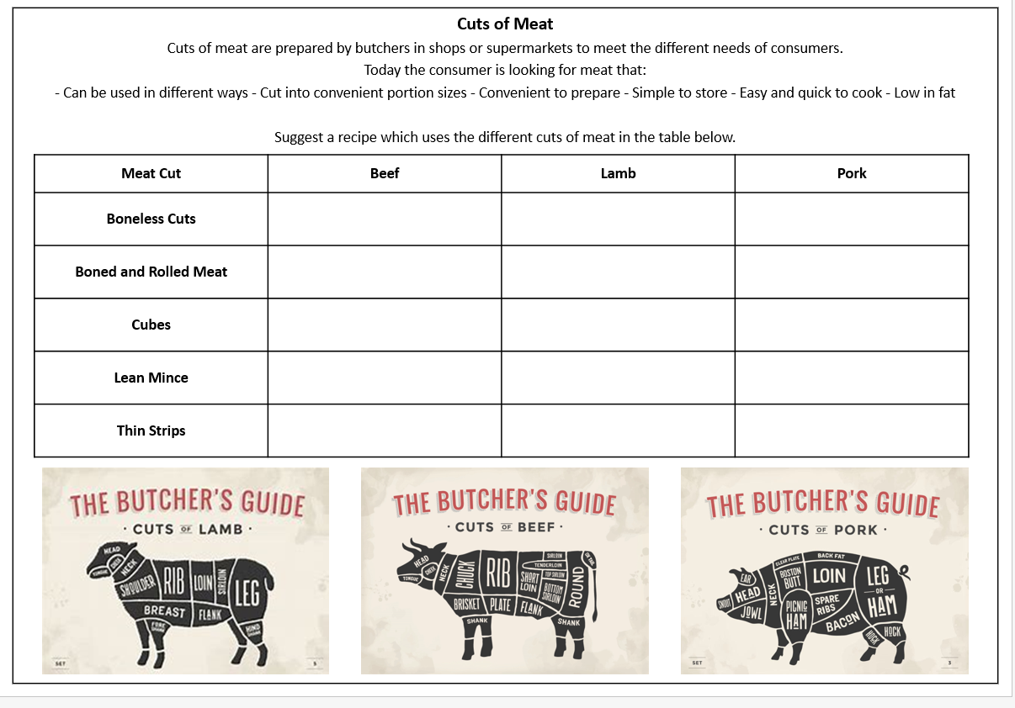
THEORY 2: Cooking Processes:
Part A. How and why we cook food
1. Why do we cook food?
 | Reason for cooking | Examples
1. | To kill pathogenic bacteria and destroy toxins, making food safe to eat.
2. | To soften the food making it easier to chew and swallow.
3. | To make the food more digestible.
4. | It improves and intensifies the flavour of food.
5. | The food looks more attractive and appealing.
6. | It reduces the bulk of the food.
7. | Provides variety to meals.
8. | To keep warm in cold weather.
9. | To enable some ingredients to perform their function.

2. When we cook food we have to transfer heat from the oven to the food. Name the 3 types of heat transfer, describe how it works and give examples food cooked using each method.
Type of heat transfer |  |  | Description / how it works | Examples
 |  | 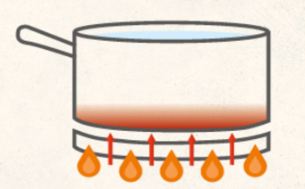SAUCEPAN
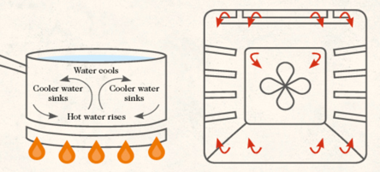
SAUCEPAN OVEN
 | Infra  -red radiant heat | 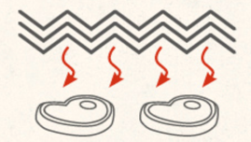IN A GRILL
 | Microwave | 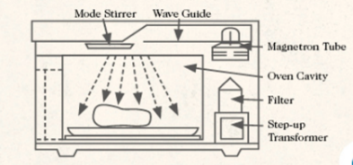
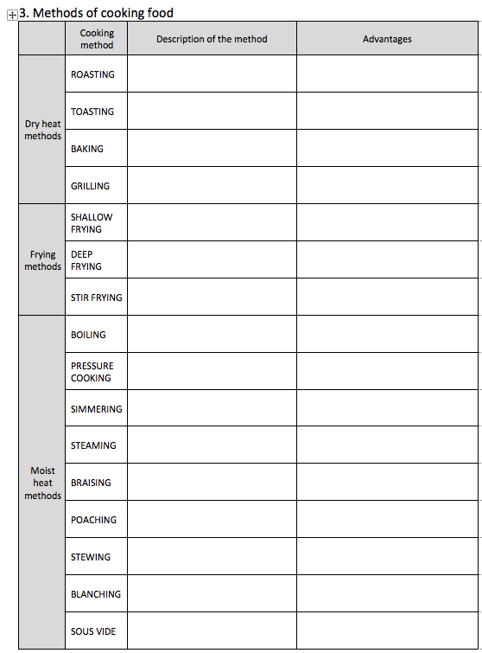

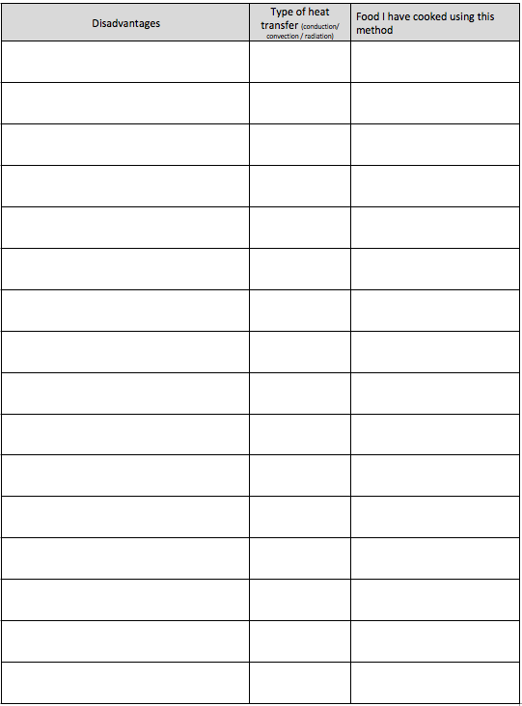

4. Can you suggest some lifestyle factors or other reasons why you might choose one method rather than another, suitable method of cooking?
- …………………………………………………………………………………………………………………..…………………………..…..;
- ……………………………………………………………………………………………………………..……………………………………. ;
- …………..……………………………………………………………………………………………..……………………………………….. ;
- ……………………………………………………………………………………………………..………………………………………..….. ;
- …………………………………………………………………………………………………..………………………………………………. .

5. Suggest which cooking method you would chose to cook the following and say why.
a) A tough piece of meat, like an oxtail.
………………………………………………………………………………………………………………..………………………………………
b) Chips.
………………………………………………………………………………………………………………..………………………………………
c) Sausages.
………………………………………………………………………………………………………………..………………………………………
d) Pasta.
………………………………………………………………………………………………………………..………………………………………
e) Vegetables which you want to retain as many of their vitamins and minerals as possible.
………………………………………………………………………………………………………………..………………………………………
f) A whole joint of good quality meat.
………………………………………………………………………………………………………………..………………………………………
g) A cake.
………………………………………………………………………………………………………………..………………………………………

Part B. The effects of heat on food

Proteins
Proteins are large molecules made of individual units called ……………. ……..………. . They are so large they are often folded up and the different parts joined by ……………………… bonds. When we cook proteins we can break these bonds – this is called ……………………….…………. and can be caused by ………………………….., ………………………….. and ………………………….. ……………………. The denatured proteins join together in a new structure – this is ………………..………………. . Air and ………………. can be trapped in pockets between the proteins. This feature is used in cooking to hold other ingredients together, like: ……………………………………………………………………………………….……………………………….. .
- Why do overcooked proteins become rubbery and sometimes watery? ……………………………………………………………………………………………………………………………………………………………….
- Why are some meats tough?
………………………………………………………………………………………………………………………………………………………….………
- How can tough meat be tenderized?
………………………………………………………………………………………………………………………………………………………….………
- How should we cook tough cuts of meat?
……………………………………………………………………………………………………………………………………………………………….…
- Why are some meat cuts tender?
……………………………………………………………………………………………………………………………………………………………….…
- How can more tender meats be cooked?
……………………………………………………………………………………………………………………………………………………………….…
- When the proteins and carbohydrates in some foods, like meat, are heated with a dry heat a ………………..……….. reaction occurs. This makes steaks …………………….……………………………………………. .
- When you make a meringue what does whisking do to the egg white?
……………………………………………………………………………………………………………………………………………………………….…
9. What does adding sugar and then baking do to the meringue?
……………………………………………………………………………………………………………………………………………………………….…

Fats
1. What happens to fats as they are heated? ………………………………………………………………………………………….……
2. What do you need to know about a fats when deciding which to use in a recipe?
……………………………………………………………………………………………………………………………………………………………….……

Carbohydrates
When we heat carbohydrates their flavour, colour and texture are changed and they release aromas.
When dry heat is applied to starch it turns ….....…. – this is ………………………….. .
When sugar is cooked it turns …………………… and the flavor ……..………..; this is called ………………………………...

Thickening a sauce with starch
When we heat starch in a liquid:
- How do we make a roux sauce (like the cheese sauce in a lasagna)? …………………………………………….………
……………………………………………………………………………………………………...……...…………………………………………………….
- What happens at around 60ºC? ………………………………………………………………………………………………………………
- What effect does this have on a sauce? ……………………………………………………………………….………………………………..……
- Why must you keep stirring a starch thickened sauce? ………….…………………………………………………………………………………………………………………………………………….…….
……………………………………………………………………………………………………...……...…………………………………………………….
- What happens at around 80ºC? …………………………………………………………………………….……………………………………………………………..…………………
- What happens when the sauce starts to boil? ……………………………………………………………………….…………………………………………………………………………….……….

Water
As foods containing a lot of water are heated the water will turn into a gas, _ _ _ _ _ and _ _ _ _ _ _ _ _ _ . When this happens the food will reduce in _ _ _ _ _ _ and become _ _ _.
Part C. Other factors affecting food
The effect of pH on food
How can reducing the pH (making a food more acidic) be used in cooking?
- …………………………………………………………………………………………………...……...……………………………………………………
- ……………………………………………………………………………………………………...……...…………………………………………………
- ……………………………………………………………………………………………………...……...………………………………………………..
The effect of oxygen on food
When some fruit and vegetables are sliced (e.g. apples, potatoes and parsnips) they go brown. This is because when the plant cells are broken open enzymes in the plant cells react with oxygen (oxidation) to turn the flesh brown. This is enzymic browning. How can we prevent enzymic browning in:
- Chipped potatoes ……………………………………………………………………….……………….
- Freshly cut apple to go into a fruit salad ……………………………………………………………………….……………….
When fresh meat is exposed to air the myoglobin in the meat goes brown due to the OX_ _ _ _ _ _ _ of enzymes in the meat.
When fats or oils are exposed to oxygen in the air they will start to smell or taste unpleasant. To prevent foods containing fat or oil turning R _ _ _ _ _ they should be stored correctly so that exposure to _ _ _ _ _ _ is reduced.
Raising Agents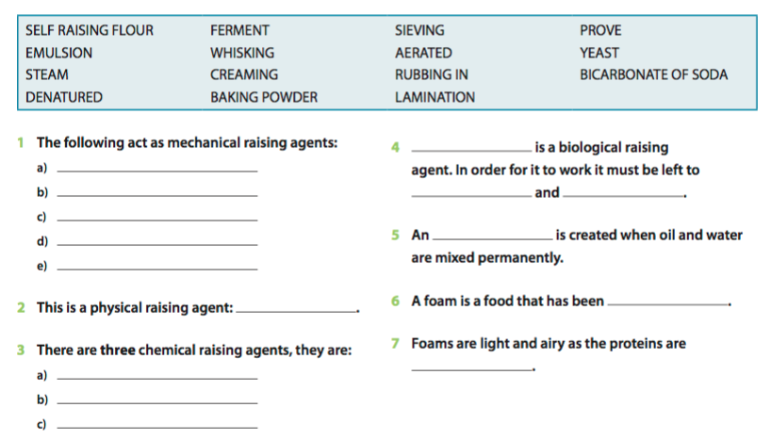
- Name the raising agent which added to bicarbonate of soda to make baking powder to improve the taste.
__________________________ .
CREAM OF TARTAR

Gluten - Explain how gluten is formed, the differences between strong and soft (regular plain) flour and say why we use each in different recipes.
_______________________________________________________________________________________
_______________________________________________________________________________________
_______________________________________________________________________________________
_______________________________________________________________________________________
_______________________________________________________________________________________
_______________________________________________________________________________________
_______________________________________________________________________________________
Emulsions - Explain what an emulsion is and why we use emulsifiers like egg yolk.
_______________________________________________________________________________________
_______________________________________________________________________________________
_______________________________________________________________________________________
_______________________________________________________________________________________
_______________________________________________________________________________________
_______________________________________________________________________________________
Foams - Explain what a foam is, how they are made and what can go wrong with them.
_______________________________________________________________________________________
_______________________________________________________________________________________
_______________________________________________________________________________________
_______________________________________________________________________________________
_______________________________________________________________________________________
______________________________________________________________________________________

Chemical and functional properties of food
The chemical properties of a food are the chemical changes foods undergo during preparation and cooking.
The functional properties of a food are the functions (or jobs) it performs in a recipe.

What are the working characteristics of flour?
What are the working characteristics of fat?
What are the working characteristics of eggs?
What are the working characteristics of sugar?
What are the working characteristics of baking powder?
What are the working characteristics of yeast?

Accurate measuring
1. What equipment would you use to measure the following amounts accurately
a) 5ml .....................................................................
b) 15ml .....................................................................
c) 250ml ....................................................................
2. Use what you know about the science of cooking food to try to explain why the following disasters could happen (has too much or too little of an ingredient been used?);
- A quiche does not set. _______________________________________________________________
- A cake surface cracks. _______________________________________________________________
- A sauce is runny or a cake lacks bulk or volume. ____________________________________________
- A loaf of bread has a dense, close texture and has not risen. __________________________________
- A cake is too dense and tastes like an omelette. ____________________________________________
- A cake is too brown, sweet, brittle and burns quickly. _______________________________________
- A cookie is greasy and too crunchy. ______________________________________________________
- A cake is dry and a little flavourless. _____________________________________________________

Exam questions
1. We are being encouraged to reduce the amount of energy we use when cooking meals. Discuss how this can be done in the home. [4]
_______________________________________________________________________________________
_______________________________________________________________________________________
_______________________________________________________________________________________
_______________________________________________________________________________________
_______________________________________________________________________________________
_______________________________________________________________________________________
2. Describe five ways to cook potatoes and explain the effect that each way has on the product. [10]
(1) _____________________________________________________________________________________
_______________________________________________________________________________________
_______________________________________________________________________________________
(2) ___________________________________________________________________________________-_
_______________________________________________________________________________________
_______________________________________________________________________________________
(3) _____________________________________________________________________________________
_______________________________________________________________________________________
_______________________________________________________________________________________
(4) _____________________________________________________________________________________
_______________________________________________________________________________________
_______________________________________________________________________________________
(5) _____________________________________________________________________________________
_______________________________________________________________________________________
______________________________________________________________________________________
Theory 3: Poultry
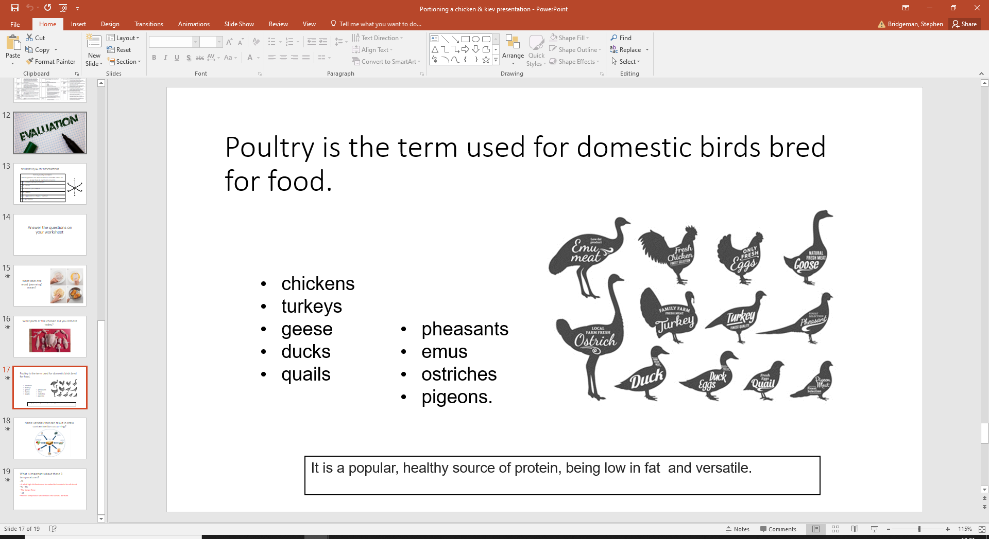

- Rules for handling poultry

1.
2.
3.
4.
5.
6.
7.
8.
9.
10.

- What does the term poultry mean?

……………………………………………………………………………………………………………………………………………..……………….…

……………………………………………………………………………………………………………………………………………………….…………

……………………………………………………………………………………………………………………………………………..……………….…

……………………………………………………………………………………………………………………………………………………….…………

- What is the value of poultry in the diet?

……………………………………………………………………………………………………………………………………………..……………….…

……………………………………………………………………………………………………………………………………………………….…………

……………………………………………………………………………………………………………………………………………..……………….…

…….……….…………………………………………………………………………………………………………………………………………………

4. Use the textbook to list some examples of poultry and make notes on their dietary, and culinary value.
Examples of poultry | Notes


5. Rearing and labelling – match the term with its definition (do it in pencil first)
Extensive indoor |  | Birds have been reared to the RSPCA’s welfare standards (RSPCA = Royal Society for the Prevention of Cruelty to Animals).
Free range |  | AKA Barn reared -birds are kept inside.
Organic |  | To label a bird this it must have been born, reared and slaughtered in the UK.
Corn-fed |  | A quality mark which guarantees the health of the birds and that they have been fed and reared to a set standard.
British label |  | Birds have easy access to vegetated land outdoors. Fed on organic foods.
Red Tractor symbol |  | A bird which has been fed on a diet containing at least 50% of this grain.
RSPCA Assured |  | Birds must have access to an outside run for at least half their lives.

Past Paper Questions
- Give consumer advice on the following topics:
- Handling raw chicken [2 marks]
……………………………………………………………………………………………………………………………………………..…

……………………………………………………………………………………………………………………………………………………

……………………………………………………………………………………………………………………………………………..……

……………………………………………………………………………………………………………………………………………………

…………………………………………………………………………………………………………………….………………………………
- Storing raw chicken [2 marks]
……………………………………………………………………………………………………………………………………………..……

……………………………………………………………………………………………………………………………………………………

……………………………………………………………………………………………………………………………………………..……

……………………………………………………………………………………………………………………………………………………

…………………………………………………………………………………………………………………….………………………………

- Cooking chicken [2 marks]
……………………………………………………………………………………………………………………………………………..……

……………………………………………………………………………………………………………………………………………………

……………………………………………………………………………………………………………………………………………..……

……………………………………………………………………………………………………………………………………………………

…………………………………………………………………………………………………………………….………………………………

- Evaluate the impact on health of handling and consuming raw chicken. [6 marks]
……………………………………………………………………………………………………………………………………………..………

………………………………………………………………………………………………………………………………………………………

…………………………………………………………………………………………………………………….………………………………

…………...…………………………………………………………………………………………………………………………………………

………………………………………………………………………………………………………………………………………………………

…………………………………………………………………………………………………………………….………………………………

…………...…………………………………………………………………………………………………………………………………………

………………………………………………………………………………………………………………………………………………………

…………………………………………………………………………………………………………………….………………………………

…………...…………………………………………………………………………………………………………………………………………

………………………………………………………………………………………………………………………………………………………

.……………………………………………………………………………………………………………………………………………………

………………………………………………………………………………………………………………………………………………………

…………………………………………………………………………………………………………………….………………………………

THEORY 4: Cereals

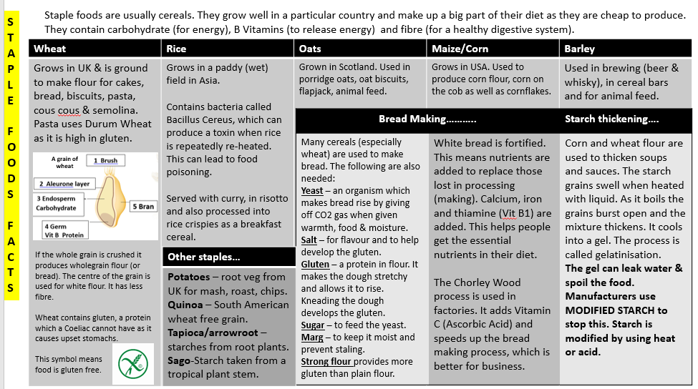
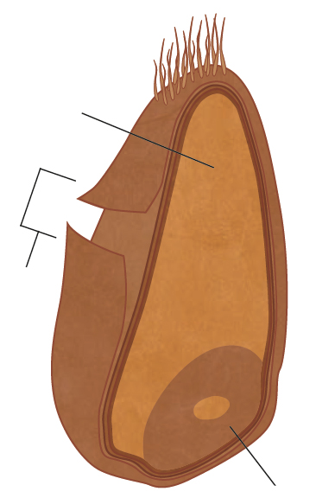
TITLE: Cereals |  | DATE:
KEY WORDS: | NOTES:  .................................................................................................................................................  .................................................................................................................................................  .................................................................................................................................................  .................................................................................................................................................  ................................................................................................................................................  ................................................................................................................................................  ................................................................................................................................................  ................................................................................................................................................  ................................................................................................................................................  ................................................................................................................................................  ................................................................................................................................................  ................................................................................................................................................  ................................................................................................................................................  ................................................................................................................................................  ................................................................................................................................................  ................................................................................................................................................  ................................................................................................................................................  ................................................................................................................................................  ................................................................................................................................................  ................................................................................................................................................  ................................................................................................................................................  ................................................................................................................................................  .................................................................................................................................................  .................................................................................................................................................  .................................................................................................................................................  .................................................................................................................................................  .................................................................................................................................................  .................................................................................................................................................  .................................................................................................................................................  .................................................................................................................................................
SUMMARY:

TITLE: Cereals Cont. |  | DATE:
KEY WORDS: | NOTES:  .................................................................................................................................................  .................................................................................................................................................  .................................................................................................................................................  .................................................................................................................................................  ................................................................................................................................................  ................................................................................................................................................  ................................................................................................................................................  ................................................................................................................................................  ................................................................................................................................................  ................................................................................................................................................  ................................................................................................................................................  ................................................................................................................................................  ................................................................................................................................................  ................................................................................................................................................  ................................................................................................................................................  ................................................................................................................................................  ................................................................................................................................................  ................................................................................................................................................  ................................................................................................................................................  ................................................................................................................................................  ................................................................................................................................................  ................................................................................................................................................  .................................................................................................................................................  .................................................................................................................................................  .................................................................................................................................................  .................................................................................................................................................  .................................................................................................................................................  .................................................................................................................................................  .................................................................................................................................................  .................................................................................................................................................
SUMMARY:

THEORY 5: Fish

Buying Fresh Fish – Draw on the fish, areas where you can tell it is fresh!

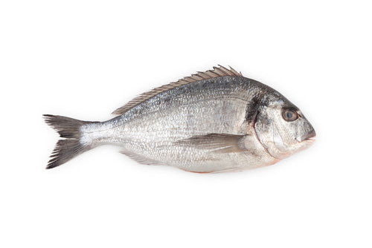

What are the 3 types of fish?

TITLE: Fish |  | DATE:
KEY WORDS: | NOTES:  .................................................................................................................................................  .................................................................................................................................................  .................................................................................................................................................  .................................................................................................................................................  ................................................................................................................................................  ................................................................................................................................................  ................................................................................................................................................  ................................................................................................................................................  ................................................................................................................................................  ................................................................................................................................................  ................................................................................................................................................  ................................................................................................................................................  ................................................................................................................................................  ................................................................................................................................................  ................................................................................................................................................  ................................................................................................................................................  ................................................................................................................................................  ................................................................................................................................................  ................................................................................................................................................  ................................................................................................................................................  ................................................................................................................................................  ................................................................................................................................................  .................................................................................................................................................  .................................................................................................................................................  .................................................................................................................................................  .................................................................................................................................................  .................................................................................................................................................  .................................................................................................................................................  .................................................................................................................................................  .................................................................................................................................................  ................................................................................................................................................  .................................................................................................................................................
SUMMARY:

TITLE: Fish Cont. |  | DATE:
KEY WORDS: | NOTES:  .................................................................................................................................................  .................................................................................................................................................  .................................................................................................................................................  .................................................................................................................................................  ................................................................................................................................................  ................................................................................................................................................  ................................................................................................................................................  ................................................................................................................................................  ................................................................................................................................................  ................................................................................................................................................  ................................................................................................................................................  ................................................................................................................................................  ................................................................................................................................................  ................................................................................................................................................  ................................................................................................................................................  ................................................................................................................................................  ................................................................................................................................................  ................................................................................................................................................  ................................................................................................................................................  ................................................................................................................................................  ................................................................................................................................................  ................................................................................................................................................  .................................................................................................................................................  .................................................................................................................................................  .................................................................................................................................................  .................................................................................................................................................  .................................................................................................................................................  .................................................................................................................................................  .................................................................................................................................................  .................................................................................................................................................
SUMMARY:

THEORY 6: Eggs

TITLE: Eggs |  | DATE:
KEY WORDS: | NOTES:  .................................................................................................................................................  .................................................................................................................................................  .................................................................................................................................................  .................................................................................................................................................  ................................................................................................................................................  ................................................................................................................................................  ................................................................................................................................................  ................................................................................................................................................  ................................................................................................................................................  ................................................................................................................................................  ................................................................................................................................................  ................................................................................................................................................  ................................................................................................................................................  ................................................................................................................................................  ................................................................................................................................................  ................................................................................................................................................  ................................................................................................................................................  ................................................................................................................................................  ................................................................................................................................................  ................................................................................................................................................  ................................................................................................................................................  ................................................................................................................................................  .................................................................................................................................................  .................................................................................................................................................  .................................................................................................................................................  .................................................................................................................................................  .................................................................................................................................................  .................................................................................................................................................  .................................................................................................................................................  .................................................................................................................................................
SUMMARY:

- Why are eggs important in nutrition?

............................................................................................................................................................................

……………………………………………………………………………………………………………………………………………………………………..
- List the ways eggs can be cooked on their own:

............................................................................................................................................................................

……………………………………………………………………………………………………………………………………………………………………..

Function of Eggs
Eggs are very versatile and have many different uses in cooking. Complete the table below:
Function | Description | Example
Aeration

Binding

Coating

Glazing

Emulsifying

Thickening

Enriching

- Complete the paragraph

Eggs contain nearly ……….. the nutrients the body needs. They are particularly useful because they contain all the ……………………………………… amino acids. The ………………….. contains slightly more protein than the ………………………. . Eggs are low in unhealthier …………………………………… fats and higher in healthier ……………………………..…………. and ……..……………………………………….. fats. They also contain the essential fatty acid ………………………………………………. . Eating eggs, unless they are ………………………… in ……………….. does not have a negative effect on the body’s ……………………………………… levels. Eggs are a good source of vitamins ………… , ……………. , ……………… and a number of other B vitamins, including folate. Eggs are rich in minerals, particularly ……………………..…………. , ……………………………………… , …………………………………….. , ………………..……………. and ………………………………………. . Egg yolk contains a lot of iron, but research suggests this is not easily absorbed, although eating eggs with a food rich in vitamin ………. might help.
7
20
19
18
17
16
15
14
13
12
11
10
9
8
6
5
4
3
2

. 5. Draw arrows matching the terms on the left with a definitions / statements on the right:
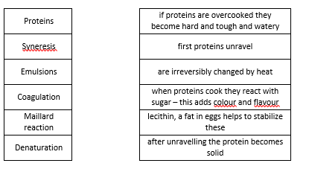

6. Complete the table:

Type of egg | Price per egg | dvantages / why you might chose to buy them | Disadvantages/ why you might chose not to buy them
Battery / caged
Barn reared
Free range
Organic

7. Explain how eggs should be stored, tested for freshness and why we need to take special care with eggs.

............................................................................................................................................................................

……………………………………………………………………………………………………………………………………………………………………..

............................................................................................................................................................................

……………………………………………………………………………………………………………………………………………………………………..

............................................................................................................................................................................

……………………………………………………………………………………………………………………………………………………………………..

……………………………………………………………………………………………………………………………………………………………………..

THEORY 7: Alternative Proteins

TITLE: Alternative Proteins |  | DATE:
KEY WORDS: | NOTES:  .................................................................................................................................................  .................................................................................................................................................  .................................................................................................................................................  .................................................................................................................................................  ................................................................................................................................................  ................................................................................................................................................  ................................................................................................................................................  ................................................................................................................................................  ................................................................................................................................................  ................................................................................................................................................  ................................................................................................................................................  ................................................................................................................................................  ................................................................................................................................................  ................................................................................................................................................  ................................................................................................................................................  ................................................................................................................................................  ................................................................................................................................................  ................................................................................................................................................  ................................................................................................................................................  ................................................................................................................................................  ................................................................................................................................................  ................................................................................................................................................  .................................................................................................................................................  .................................................................................................................................................  .................................................................................................................................................  .................................................................................................................................................  .................................................................................................................................................  .................................................................................................................................................  .................................................................................................................................................  .................................................................................................................................................
SUMMARY:

TITLE: Alternative Proteins |  | DATE:
KEY WORDS: | NOTES:  .................................................................................................................................................  .................................................................................................................................................  .................................................................................................................................................  .................................................................................................................................................  ................................................................................................................................................  ................................................................................................................................................  ................................................................................................................................................  ................................................................................................................................................  ................................................................................................................................................  ................................................................................................................................................  ................................................................................................................................................  ................................................................................................................................................  ................................................................................................................................................  ................................................................................................................................................  ................................................................................................................................................  ................................................................................................................................................  ................................................................................................................................................  ................................................................................................................................................  ................................................................................................................................................  ................................................................................................................................................  ................................................................................................................................................  ................................................................................................................................................  .................................................................................................................................................  .................................................................................................................................................  .................................................................................................................................................  .................................................................................................................................................  .................................................................................................................................................  .................................................................................................................................................  .................................................................................................................................................  .................................................................................................................................................
SUMMARY:

Mycroprotein:

Tofu:

What is Tofu made from?

………………………………………………………………………………………………………..

What is Tofu vegan?

………………………………………………………………………………………………………..

What is the main nutritional benefit of Tofu?

………………………………………………………………………………………………………..

What are the 3 types of Tofu?

………………………………………………………………………………………………………..

Name a dish which could feature Tofu?

………………………………………………………………………………………………………..

THEORY 8: Fruit and Vegetables

 | Example | Example
Soft Fruit
Fleshy
Citrus
Vine
Stone

 | Example 1 | Example 2
Bulbs
Roots
Fruits
Tubers
Flowers
Leaves
Stem
Fungi
Pulses

TITLE: Fruit and Vegetables |  | DATE:
KEY WORDS: | NOTES:  .................................................................................................................................................  .................................................................................................................................................  .................................................................................................................................................  .................................................................................................................................................  ................................................................................................................................................  ................................................................................................................................................  ................................................................................................................................................  ................................................................................................................................................  ................................................................................................................................................  ................................................................................................................................................  ................................................................................................................................................  ................................................................................................................................................  ................................................................................................................................................  ................................................................................................................................................  ................................................................................................................................................  ................................................................................................................................................  ................................................................................................................................................  ................................................................................................................................................  ................................................................................................................................................  ................................................................................................................................................  ................................................................................................................................................  ................................................................................................................................................  .................................................................................................................................................  .................................................................................................................................................  .................................................................................................................................................  .................................................................................................................................................  .................................................................................................................................................  .................................................................................................................................................  .................................................................................................................................................  .................................................................................................................................................
SUMMARY:

TITLE: Fruit and Vegetables |  | DATE:
KEY WORDS: | NOTES:  .................................................................................................................................................  .................................................................................................................................................  .................................................................................................................................................  .................................................................................................................................................  ................................................................................................................................................  ................................................................................................................................................  ................................................................................................................................................  ................................................................................................................................................  ................................................................................................................................................  ................................................................................................................................................  ................................................................................................................................................  ................................................................................................................................................  ................................................................................................................................................  ................................................................................................................................................  ................................................................................................................................................  ................................................................................................................................................  ................................................................................................................................................  ................................................................................................................................................  ................................................................................................................................................  ................................................................................................................................................  ................................................................................................................................................  ................................................................................................................................................  .................................................................................................................................................  .................................................................................................................................................  .................................................................................................................................................  .................................................................................................................................................  .................................................................................................................................................  .................................................................................................................................................  .................................................................................................................................................  .................................................................................................................................................
SUMMARY:

THEORY 9: Time Planning:

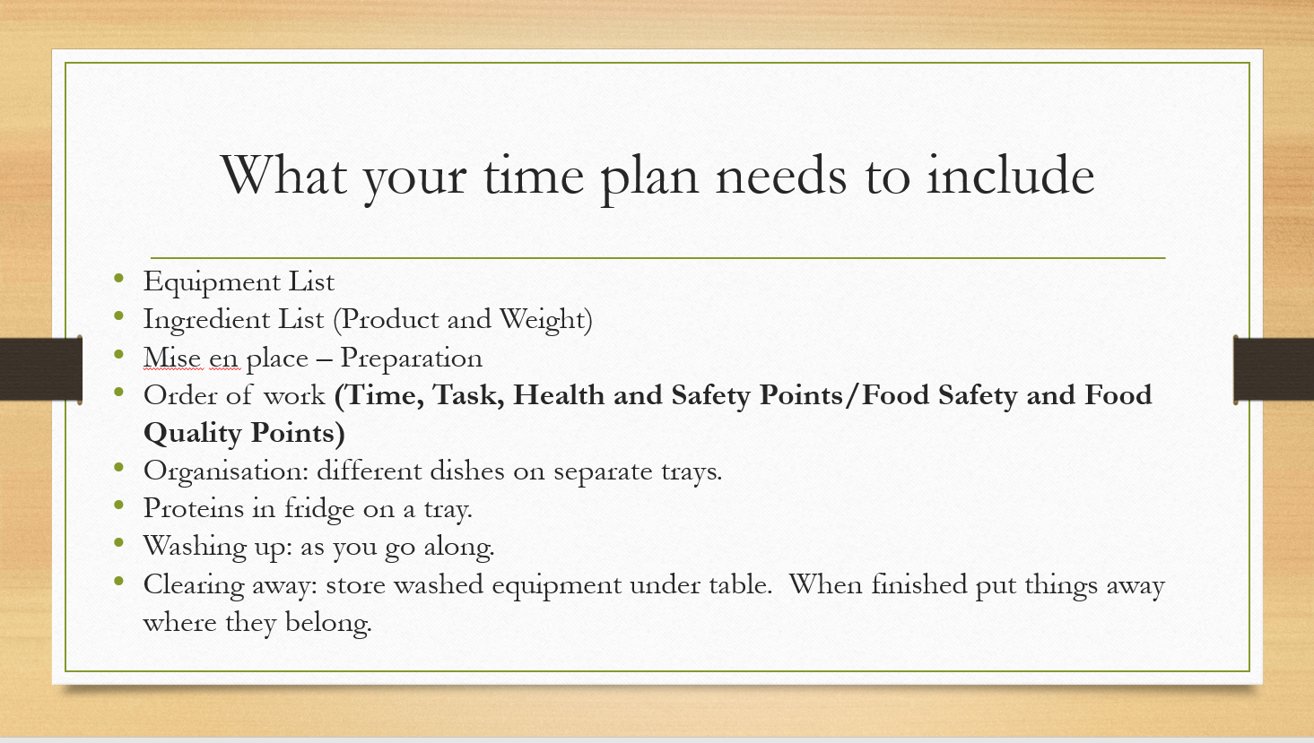
6. Shopping List

- This should be presented as a list in the following sections:
  - Vegetables
  - Fruit
  - Groceries
  - Dairy
  - Meat and / or fish
- You could cost your dishes in this section too (if it’s relevant to your brief) – nutritionprogram.co.uk can help with this

7. Small and large equipment and serving dishes

This is where you list ALL the equipment you will be using, including serving dishes and table settings.

- You should organise all this during your mise en place, so that you are not trying to find things at the moment you need to use them.
- You should list all small equipment – knives, mixing bowls, jugs, spoons etc.
- Also list all the large equipment you’ll need – oven, hob, fridge, blast chiller etc, food processor, electric whisk etc.
- Let us know if you will need any additional timers.
- You may use the serving dishes we have at school, but you can bring them in from home – beg, borrow (but don’t steal) crockery, cutlery, platters, jugs and serving dishes from family and friends. Make sure you list anything you are planning to bring in and state that you will bring it in. AND don’t forget to bring it on the day.
- And finally – it’s up to you whether you want to set a table with flowers, menu holder, napkins etc.

8 Timeplan

This is where you write out in detail your plan for what you will be cooking during your practical assessment.

- Try to make your timeplan so clear that someone else could cook from it and get perfect results.
- Use different colour type for each recipe.
- Dovetail the stages, so that you are not cooking one dish, then another, then the last.
- You could divide it into three separate sections:
  - Mise en place
  - Order of work
  - Completion – including plating up, garnishing, serving, clearing up and switching ovens off.
- Remember your mise en place can include anything but cooking, so – weighing and measuring, greasing and lining tins, fruit and veg prep (remember to plan how you’ll prevent enzymic browning), butchering meat, poultry, rubbing fat into flour, opening cans and laying the table (if there’s one free).
- Include Food safety points (how to avoid food poisoning)
  - Personal hygiene
  - Washing hands after handling foods like raw meat
Food storage | Temperature
Chilled food | 0ºC to -5ºC
Cooked food | 75ºC
Danger zone | 5ºC to -63ºC
Freezing | -18ºC
Reheating | above 63ºC
  - Store food at the correct temperature – especially high-risk foods (meat, poultry, dairy, cooked eggs, shellfish and seafood) in the fridge until needed
  - Test temperatures using a temperature probe
  - Cook food thoroughly (it should reach 75ºC and stay there for 2 minutes)
  - Reheat food properly – reheat to piping hot – above 75ºC
  - Keep food warm at 63ºC or above.
  - Avoid cross-contamination, e.g. by using the correct coloured boards, washing up thoroughly
- Include Health and safety points (how to avoid accidents)
  - Correct handling of knives – correct holds, not left in sinks
  - Cooker safety – hob, oven, grill, use oven gloves
  - Handle machines safely, e.g. pasta machines secured to surfaces
- Include Food quality points (how to make sure the food you serve is the best quality)
  - How will you test for readiness,
  - Specify precise qualities – e.g. size of jardinière carrot batons
  - What oven temperatures you will use to prevent burning and ensure thorough cooking.
  - Explain why you are doing things – e.g. dusting table with flour to prevent dough sticking
  - Cooking times – be ready to change timing if things don’t cook on time – plan to check things
  - Weigh ingredients accurately
  - Make dishes look attractive – clean serving dishes, use garnishes
- Include frequent instructions to wash up – plan to CAYG (clean as you go). You may wash and leave to drip dry in the first clear up session and then dry with a tea towel and put away, wash and leave to drip dry in the second and subsequent sessions, until the final wash and dry and put away.

How to write a timeplan

- List all the dishes and accompaniments you’re making
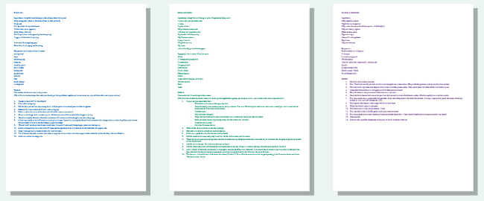
- Get each of your recipes (you may have 5 or 6 depending on how many accompaniments you are making) onto a Word document
- Colour code each recipe
- Read through each recipe to make sure you understand all the processes.
- Jot down a rough order of making – don’t put any detail in yet
- Create tables like the ones below, one for your Mise en place and one for your Order of Work:

Mise en place
Activity | Health and safety points

Order of work
Time | Activity | Health and safety points / Food safety points | Food quality points

- For each task, decide whether they are part of your mise en place or order of work and roughly copy each task from all of your recipes into the activity columns.
- Add in when you are going to do some washing up.
- Once you’re happy with the order add in the detail:
  - Explanations for why you are doing things
  - Health and safety points (how to avoid accidents)
  - Food safety points (how to avoid food poisoning)
  - Food quality points (how to make sure the food you serve is the best quality)
- Add in the timings (use the actual time rather than how long each task takes)
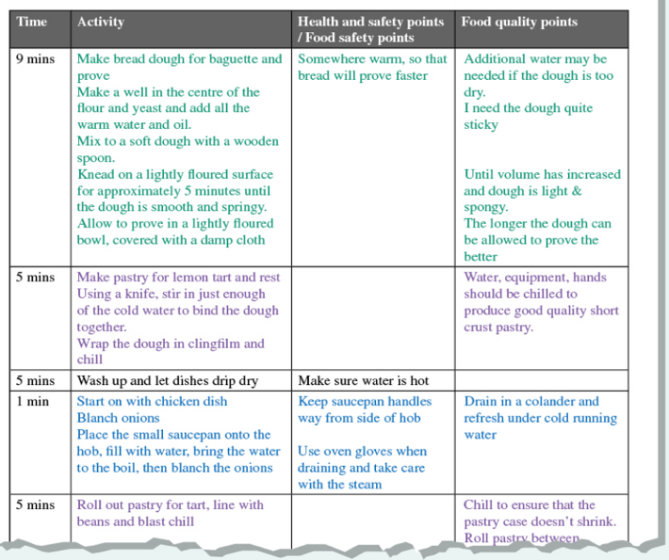
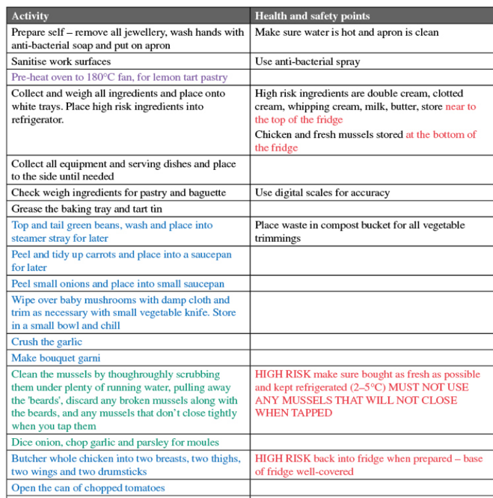

10:15

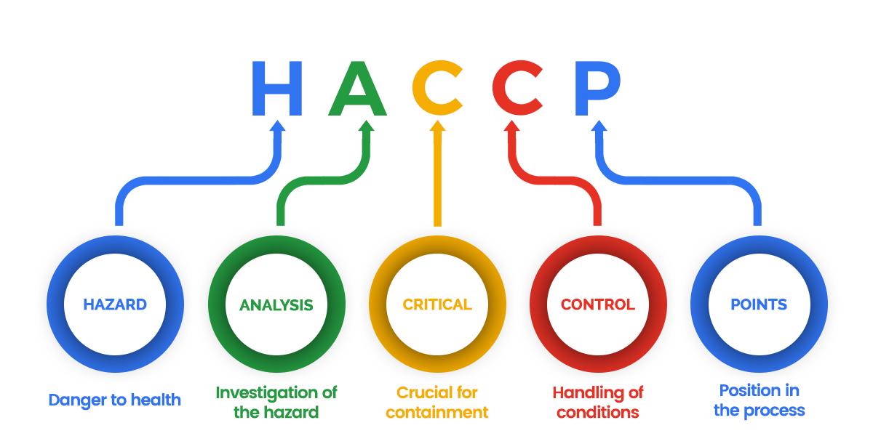

What is HACCP?

………………………………………………………………………………………………………………………………………………………………………

………………………………………………………………………………………………………………………………………………………………………

………………………………………………………………………………………………………………………………………………………………………

TIME PLAN / ORDER OF WORK NAME:
Names of Recipe: Lasagne and Garlic Bread
EQUIPMENT |  | INGREDIENTS
MISE EN PLACE
ACTIVITY – |  |  | HACCP (Health and Safety points)
ORDER OF WORK

Time | Activity |  | H & S / food safety points | Food quality points
 | Taste and evaluate dishes made.

ADDITIONAL NOTES
……………………………………………………………………………………………………………………………………………………………….…
……………………………………………………………………………………………………………………………………………………………….…
……………………………………………………………………………………………………………………………………………………………….…
……………………………………………………………………………………………………………………………………………………………….…
……………………………………………………………………………………………………………………………………………………………….…
……………………………………………………………………………………………………………………………………………………………….…
……………………………………………………………………………………………………………………………………………………………….…
……………………………………………………………………………………………………………………………………………………………….…
……………………………………………………………………………………………………………………………………………………………….…
……………………………………………………………………………………………………………………………………………………………….…
……………………………………………………………………………………………………………………………………………………………….…
……………………………………………………………………………………………………………………………………………………………….…
……………………………………………………………………………………………………………………………………………………………….…
……………………………………………………………………………………………………………………………………………………………….…
……………………………………………………………………………………………………………………………………………………………….…
……………………………………………………………………………………………………………………………………………………………….…
……………………………………………………………………………………………………………………………………………………………….…
……………………………………………………………………………………………………………………………………………………………….…
……………………………………………………………………………………………………………………………………………………………….…
……………………………………………………………………………………………………………………………………………………………….…

THEORY 10: Balanced Diets & Energy Requirements

To describe and explain the importance of energy balance including implications of physical activity and dietary excess to maintenance of a healthy weight.
- To define energy and explain why it is needed.

Energy in: food and drinks
Energy out: activity

- To identify sources of energy in the diet.
- To understand how energy needs change throughout life.
- To understand the energy needs of different levels of physical activity.
- To define energy balance and understand the consequences of imbalance.
Key Works: Descramble
utmacrientsron oteprin drrboatcahye tfa lorieCas
egnery anbalce albas bolmetaic erat ysiphcal ivitacty velel

Energy is essential for life, and is required to fuel many different body processes, growth and activities.
List four point that the body needs energy for:
1)
2)
3)
4)
List four points why different people need different amounts of dietary energy.
1)
2)
3)
4)
Fill in the missing word:
Energy is provided by the carbohydrate , protein and fat in the food and drink we consume. These are known as macronutrients . The amount of energy that each of these macronutrients provides varies.
Energy intake is measured in joules (J) or kilojoules (kJ) but many people are more familiar with Calories (kcal). 1 MJ = 239 kcal
Carbohydrate (starch and sugars) provides ______kcal (17kJ) per gram.
Protein provides ______kcal (17kJ) per gram.
Fat is the most energy dense nutrient, providing ______kcal (37kJ) per gram.
Energy intake can be estimated by applying these figures to the amount of carbohydrate, protein and fat we consume from food and drink
Circle the food do you think contributes the most energy per 100g?
Identify which macronutrient each food is highest in & explain its key role in the body.

Bagel

Ham
Oil

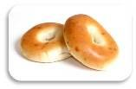

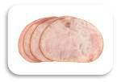

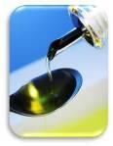

Dietary Reference Values (DRV): Experts have estimated the average requirements for energy for different types of people. These figures are known as Estimated Average Requirements (EAR) for energy.
Experts also recommend that about 50% of our energy intake should come from: C
No more than 35% of our energy intake should come from: F
that means around 15% of our energy intake should come from: P
EARs vary throughout life: Babies, young children and teenagers need more energy. After the age of 18, energy requirements decrease and remain the same until 50. Energy requirements for older adults decrease further as they get older. Explain how EAR for energy changes over the course of your life:
How much energy do we need? Energy requirements vary from person to person, depending on the Basal Metabolic Rate (BMR) and Physical Activity Level (PAL).
Total energy expenditure = BMR x PAL
Basal metabolic rate (BMR) is the rate at which a person uses energy to maintain the basic functions of the body when it is at complete rest. List the three points:
1)
2)
3)
In addition to their BMR, people also use energy for movement of all types, expressed as Physical Activity Level (PAL).
Define this term:
Physical activity should be an important part of our daily energy expenditure. Many different types of activity contribute to our total physical activity, all of which form part of everyday life.
What do you think physical activity includes?
Physical activity: Define moderate intensity exercise is and state how much children and young people are recommended to do a day:

Average physical activity levels in the UK are lower than recommendations. What percentage of adults, older children and teenagers do not meet the targets:
Suggest ways of increasing your physical activity levels throughout the day. Do you think you are doing enough?

What are the consequences of not getting the positive & negative energy balance right?

Energy in: food and drinks
Energy out: activity

Energy out > Energy in = Weight loss

TITLE: Life Stages |  | DATE:
KEY WORDS: | NOTES:  .................................................................................................................................................  .................................................................................................................................................  .................................................................................................................................................  .................................................................................................................................................  ................................................................................................................................................  ................................................................................................................................................  ................................................................................................................................................  ................................................................................................................................................  ................................................................................................................................................  ................................................................................................................................................  ................................................................................................................................................  ................................................................................................................................................  ................................................................................................................................................  ................................................................................................................................................  ................................................................................................................................................  ................................................................................................................................................  ................................................................................................................................................  ................................................................................................................................................  ................................................................................................................................................  ................................................................................................................................................  ................................................................................................................................................  ................................................................................................................................................  .................................................................................................................................................  .................................................................................................................................................  .................................................................................................................................................  .................................................................................................................................................  .................................................................................................................................................  .................................................................................................................................................  .................................................................................................................................................  .................................................................................................................................................
SUMMARY:

Exam Questions: Life Stages

Nutritional needs change during various life stages. Discuss the nutritional needs of the following groups:

(12 Marks)

- Pre-School Children
- Teenagers
- Later Adulthood

- Pre-School Children

…………………………………………………………………………………………………….

…………………………………………………………………………………………………….

…………………………………………………………………………………………………….

…………………………………………………………………………………………………….

- Teenagers

…………………………………………………………………………………………………….

…………………………………………………………………………………………………….

…………………………………………………………………………………………………….

…………………………………………………………………………………………………….

- Later Adulthood

…………………………………………………………………………………………………….

…………………………………………………………………………………………………….

…………………………………………………………………………………………………….

…………………………………………………………………………………………………….

THEORY 11: Food Provenance & Packaging
TITLE: Food Provenance & Packaging |  | DATE:
KEY WORDS: | NOTES:  .................................................................................................................................................  .................................................................................................................................................  .................................................................................................................................................  .................................................................................................................................................  ................................................................................................................................................  ................................................................................................................................................  ................................................................................................................................................  ................................................................................................................................................  ................................................................................................................................................  ................................................................................................................................................  ................................................................................................................................................  ................................................................................................................................................  ................................................................................................................................................  ................................................................................................................................................  ................................................................................................................................................  ................................................................................................................................................  ................................................................................................................................................  ................................................................................................................................................  ................................................................................................................................................  ................................................................................................................................................  ................................................................................................................................................  ................................................................................................................................................  .................................................................................................................................................  .................................................................................................................................................  .................................................................................................................................................  .................................................................................................................................................  .................................................................................................................................................  .................................................................................................................................................  .................................................................................................................................................  .................................................................................................................................................
SUMMARY:

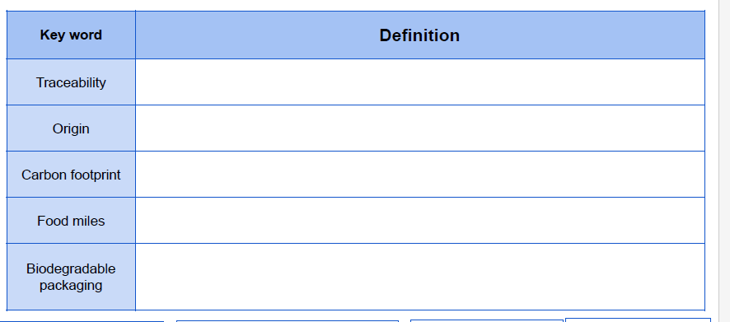

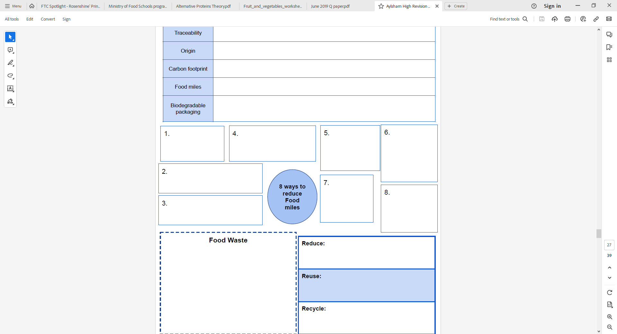
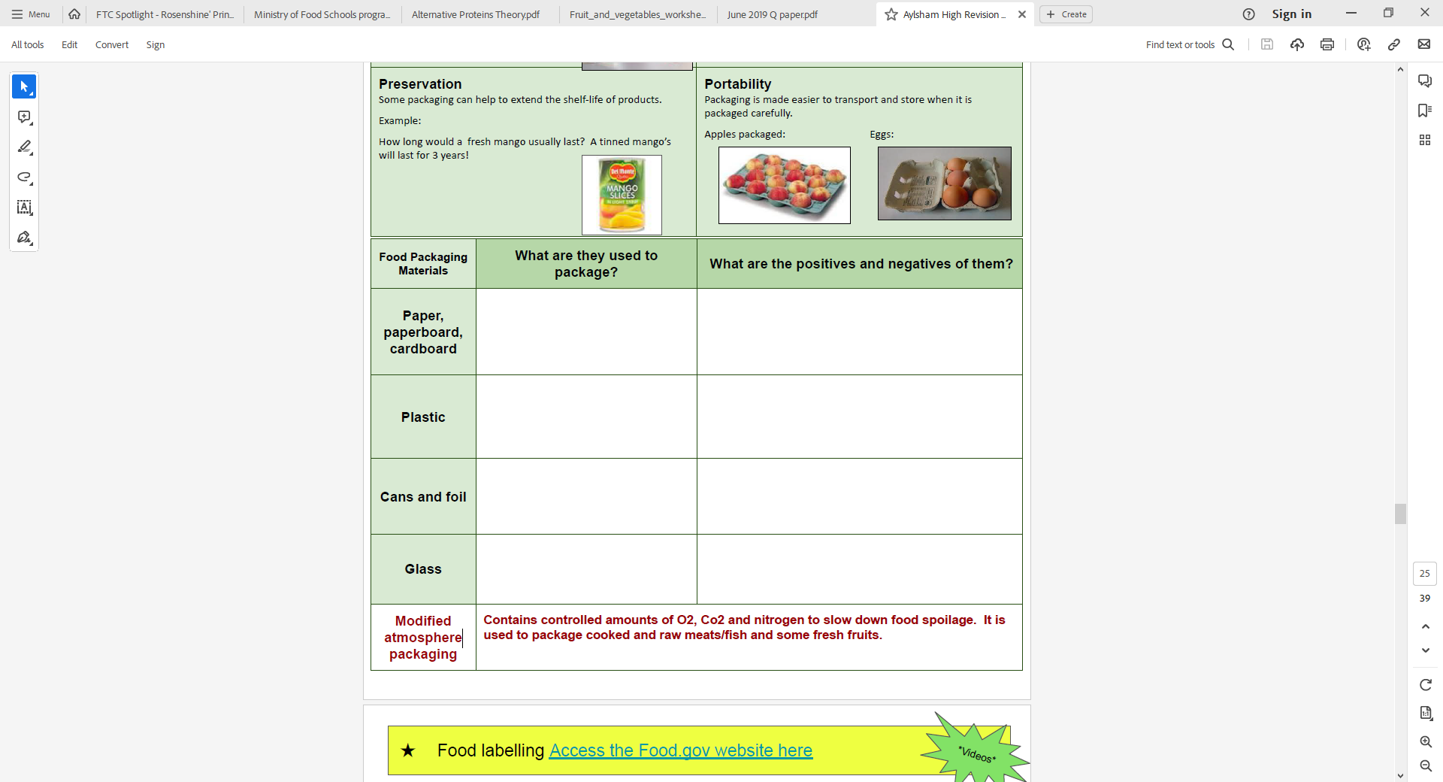

THEORY 12: Factors Affecting Food Choice
TITLE: Factors Affecting Food Choice |  | DATE:
KEY WORDS: | NOTES:  .................................................................................................................................................  .................................................................................................................................................  .................................................................................................................................................  .................................................................................................................................................  ................................................................................................................................................  ................................................................................................................................................  ................................................................................................................................................  ................................................................................................................................................  ................................................................................................................................................  ................................................................................................................................................  ................................................................................................................................................  ................................................................................................................................................  ................................................................................................................................................  ................................................................................................................................................  ................................................................................................................................................  ................................................................................................................................................  ................................................................................................................................................  ................................................................................................................................................  ................................................................................................................................................  ................................................................................................................................................  ................................................................................................................................................  ................................................................................................................................................  .................................................................................................................................................  .................................................................................................................................................  .................................................................................................................................................  .................................................................................................................................................  .................................................................................................................................................  .................................................................................................................................................  .................................................................................................................................................  .................................................................................................................................................
SUMMARY:

TITLE: Factors Affecting Food Choice |  | DATE:
KEY WORDS: | NOTES:  .................................................................................................................................................  .................................................................................................................................................  .................................................................................................................................................  .................................................................................................................................................  ................................................................................................................................................  ................................................................................................................................................  ................................................................................................................................................  ................................................................................................................................................  ................................................................................................................................................  ................................................................................................................................................  ................................................................................................................................................  ................................................................................................................................................  ................................................................................................................................................  ................................................................................................................................................  ................................................................................................................................................  ................................................................................................................................................  ................................................................................................................................................  ................................................................................................................................................  ................................................................................................................................................  ................................................................................................................................................  ................................................................................................................................................  ................................................................................................................................................  .................................................................................................................................................  .................................................................................................................................................  .................................................................................................................................................  .................................................................................................................................................  .................................................................................................................................................  .................................................................................................................................................  .................................................................................................................................................  .................................................................................................................................................
SUMMARY:

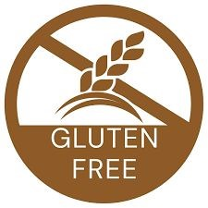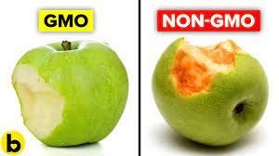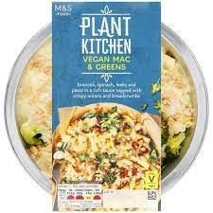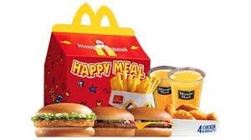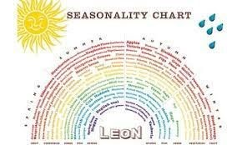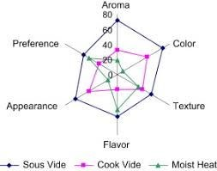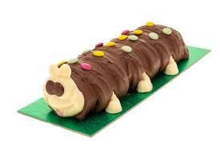
Factors
Affecting
Food
Choice
Availability & Seasonality
Food Costs
Culture & religion
Genetically modified food
(
GMF
)
Ethical Choices
Medical Conditions
Marketing & advertising
Labelling
Sensory analysis

THEORY 13: Baking Methods & Potential Issues
TITLE: Baking Methods & Problem Solving |  | DATE:
KEY WORDS: | NOTES:  .................................................................................................................................................  .................................................................................................................................................  .................................................................................................................................................  .................................................................................................................................................  ................................................................................................................................................  ................................................................................................................................................  ................................................................................................................................................  ................................................................................................................................................  ................................................................................................................................................  ................................................................................................................................................  ................................................................................................................................................  ................................................................................................................................................  ................................................................................................................................................  ................................................................................................................................................  ................................................................................................................................................  ................................................................................................................................................  ................................................................................................................................................  ................................................................................................................................................  ................................................................................................................................................  ................................................................................................................................................  ................................................................................................................................................  ................................................................................................................................................  .................................................................................................................................................  .................................................................................................................................................  .................................................................................................................................................  .................................................................................................................................................  .................................................................................................................................................  .................................................................................................................................................  .................................................................................................................................................  .................................................................................................................................................
SUMMARY:

TITLE: Baking Methods & Problem Solving
KEY WORDS: | NOTES:  .................................................................................................................................................  .................................................................................................................................................  .................................................................................................................................................  .................................................................................................................................................  ................................................................................................................................................  ................................................................................................................................................  ................................................................................................................................................  ................................................................................................................................................  ................................................................................................................................................  ................................................................................................................................................  ................................................................................................................................................  ................................................................................................................................................  ................................................................................................................................................  ................................................................................................................................................  ................................................................................................................................................  ................................................................................................................................................  ................................................................................................................................................  ................................................................................................................................................  ................................................................................................................................................  ................................................................................................................................................  ................................................................................................................................................  ................................................................................................................................................  .................................................................................................................................................  .................................................................................................................................................  .................................................................................................................................................  .................................................................................................................................................  .................................................................................................................................................  .................................................................................................................................................  .................................................................................................................................................  .................................................................................................................................................
SUMMARY:

Revision Questions:
………………………………………………………………………………………………..............…………………………………………………………
………………………………………………………………………………………………..............…………………………………………………………
………………………………………………………………………………………………..............…………………………………………………………
………………………………………………………………………………………………..............…………………………………………………………
………………………………………………………………………………………………..............…………………………………………………………
………………………………………………………………………………………………..............…………………………………………………………
………………………………………………………………………………………………..............…………………………………………………………
………………………………………………………………………………………………..............…………………………………………………………
………………………………………………………………………………………………..............…………………………………………………………
………………………………………………………………………………………………..............…………………………………………………………
………………………………………………………………………………………………..............…………………………………………………………
………………………………………………………………………………………………..............…………………………………………………………
………………………………………………………………………………………………..............…………………………………………………………
………………………………………………………………………………………………..............…………………………………………………………
………………………………………………………………………………………………..............…………………………………………………………
…...…………………………………………………………………………………………..............…………………………………………………………
………………………………………………………………………………………………..............…………………………………………………………
………………………………………………………………………………………………..............…………………………………………………………
………………………………………………………………………………………………..............…………………………………………………………
………………………………………………………………………………………………..............…………………………………………………………
………………………………………………………………………………………………..............…………………………………………………………
………………………………………………………………………………………………..............…………………………………………………………

Revision Questions:
………………………………………………………………………………………………..............…………………………………………………………
………………………………………………………………………………………………..............…………………………………………………………
………………………………………………………………………………………………..............…………………………………………………………
………………………………………………………………………………………………..............…………………………………………………………
………………………………………………………………………………………………..............…………………………………………………………
………………………………………………………………………………………………..............…………………………………………………………
………………………………………………………………………………………………..............…………………………………………………………
………………………………………………………………………………………………..............…………………………………………………………
………………………………………………………………………………………………..............…………………………………………………………
………………………………………………………………………………………………..............…………………………………………………………
………………………………………………………………………………………………..............…………………………………………………………
………………………………………………………………………………………………..............…………………………………………………………
………………………………………………………………………………………………..............…………………………………………………………
………………………………………………………………………………………………..............…………………………………………………………
………………………………………………………………………………………………..............…………………………………………………………
…...…………………………………………………………………………………………..............…………………………………………………………
………………………………………………………………………………………………..............…………………………………………………………
………………………………………………………………………………………………..............…………………………………………………………
………………………………………………………………………………………………..............…………………………………………………………
………………………………………………………………………………………………..............…………………………………………………………
………………………………………………………………………………………………..............…………………………………………………………
………………………………………………………………………………………………..............…………………………………………………………

Revision Questions:
………………………………………………………………………………………………..............…………………………………………………………
………………………………………………………………………………………………..............…………………………………………………………
………………………………………………………………………………………………..............…………………………………………………………
………………………………………………………………………………………………..............…………………………………………………………
………………………………………………………………………………………………..............…………………………………………………………
………………………………………………………………………………………………..............…………………………………………………………
………………………………………………………………………………………………..............…………………………………………………………
………………………………………………………………………………………………..............…………………………………………………………
………………………………………………………………………………………………..............…………………………………………………………
………………………………………………………………………………………………..............…………………………………………………………
………………………………………………………………………………………………..............…………………………………………………………
………………………………………………………………………………………………..............…………………………………………………………
………………………………………………………………………………………………..............…………………………………………………………
………………………………………………………………………………………………..............…………………………………………………………
………………………………………………………………………………………………..............…………………………………………………………
…...…………………………………………………………………………………………..............…………………………………………………………
………………………………………………………………………………………………..............…………………………………………………………
………………………………………………………………………………………………..............…………………………………………………………
………………………………………………………………………………………………..............…………………………………………………………
………………………………………………………………………………………………..............…………………………………………………………
………………………………………………………………………………………………..............…………………………………………………………
………………………………………………………………………………………………..............…………………………………………………………

Revision Questions:
………………………………………………………………………………………………..............…………………………………………………………
………………………………………………………………………………………………..............…………………………………………………………
………………………………………………………………………………………………..............…………………………………………………………
………………………………………………………………………………………………..............…………………………………………………………
………………………………………………………………………………………………..............…………………………………………………………
………………………………………………………………………………………………..............…………………………………………………………
………………………………………………………………………………………………..............…………………………………………………………
………………………………………………………………………………………………..............…………………………………………………………
………………………………………………………………………………………………..............…………………………………………………………
………………………………………………………………………………………………..............…………………………………………………………
………………………………………………………………………………………………..............…………………………………………………………
………………………………………………………………………………………………..............…………………………………………………………
………………………………………………………………………………………………..............…………………………………………………………
………………………………………………………………………………………………..............…………………………………………………………
………………………………………………………………………………………………..............…………………………………………………………
…...…………………………………………………………………………………………..............…………………………………………………………
………………………………………………………………………………………………..............…………………………………………………………
………………………………………………………………………………………………..............…………………………………………………………
………………………………………………………………………………………………..............…………………………………………………………
………………………………………………………………………………………………..............…………………………………………………………
………………………………………………………………………………………………..............…………………………………………………………
………………………………………………………………………………………………..............…………………………………………………………

Revision Questions:
………………………………………………………………………………………………..............…………………………………………………………
………………………………………………………………………………………………..............…………………………………………………………
………………………………………………………………………………………………..............…………………………………………………………
………………………………………………………………………………………………..............…………………………………………………………
………………………………………………………………………………………………..............…………………………………………………………
………………………………………………………………………………………………..............…………………………………………………………
………………………………………………………………………………………………..............…………………………………………………………
………………………………………………………………………………………………..............…………………………………………………………
………………………………………………………………………………………………..............…………………………………………………………
………………………………………………………………………………………………..............…………………………………………………………
………………………………………………………………………………………………..............…………………………………………………………
………………………………………………………………………………………………..............…………………………………………………………
………………………………………………………………………………………………..............…………………………………………………………
………………………………………………………………………………………………..............…………………………………………………………
………………………………………………………………………………………………..............…………………………………………………………
…...…………………………………………………………………………………………..............…………………………………………………………
………………………………………………………………………………………………..............…………………………………………………………
………………………………………………………………………………………………..............…………………………………………………………
………………………………………………………………………………………………..............…………………………………………………………
………………………………………………………………………………………………..............…………………………………………………………
………………………………………………………………………………………………..............…………………………………………………………
………………………………………………………………………………………………..............…………………………………………………………

Revision Questions:
………………………………………………………………………………………………..............…………………………………………………………
………………………………………………………………………………………………..............…………………………………………………………
………………………………………………………………………………………………..............…………………………………………………………
………………………………………………………………………………………………..............…………………………………………………………
………………………………………………………………………………………………..............…………………………………………………………
………………………………………………………………………………………………..............…………………………………………………………
………………………………………………………………………………………………..............…………………………………………………………
………………………………………………………………………………………………..............…………………………………………………………
………………………………………………………………………………………………..............…………………………………………………………
………………………………………………………………………………………………..............…………………………………………………………
………………………………………………………………………………………………..............…………………………………………………………
………………………………………………………………………………………………..............…………………………………………………………
………………………………………………………………………………………………..............…………………………………………………………
………………………………………………………………………………………………..............…………………………………………………………
………………………………………………………………………………………………..............…………………………………………………………
…...…………………………………………………………………………………………..............…………………………………………………………
………………………………………………………………………………………………..............…………………………………………………………
………………………………………………………………………………………………..............…………………………………………………………
………………………………………………………………………………………………..............…………………………………………………………
………………………………………………………………………………………………..............…………………………………………………………
………………………………………………………………………………………………..............…………………………………………………………
………………………………………………………………………………………………..............…………………………………………………………

Revision Questions:
………………………………………………………………………………………………..............…………………………………………………………
………………………………………………………………………………………………..............…………………………………………………………
………………………………………………………………………………………………..............…………………………………………………………
………………………………………………………………………………………………..............…………………………………………………………
………………………………………………………………………………………………..............…………………………………………………………
………………………………………………………………………………………………..............…………………………………………………………
………………………………………………………………………………………………..............…………………………………………………………
………………………………………………………………………………………………..............…………………………………………………………
………………………………………………………………………………………………..............…………………………………………………………
………………………………………………………………………………………………..............…………………………………………………………
………………………………………………………………………………………………..............…………………………………………………………
………………………………………………………………………………………………..............…………………………………………………………
………………………………………………………………………………………………..............…………………………………………………………
………………………………………………………………………………………………..............…………………………………………………………
………………………………………………………………………………………………..............…………………………………………………………
…...…………………………………………………………………………………………..............…………………………………………………………
………………………………………………………………………………………………..............…………………………………………………………
………………………………………………………………………………………………..............…………………………………………………………
………………………………………………………………………………………………..............…………………………………………………………
………………………………………………………………………………………………..............…………………………………………………………
………………………………………………………………………………………………..............…………………………………………………………
………………………………………………………………………………………………..............…………………………………………………………

Revision Questions:
………………………………………………………………………………………………..............…………………………………………………………
………………………………………………………………………………………………..............…………………………………………………………
………………………………………………………………………………………………..............…………………………………………………………
………………………………………………………………………………………………..............…………………………………………………………
………………………………………………………………………………………………..............…………………………………………………………
………………………………………………………………………………………………..............…………………………………………………………
………………………………………………………………………………………………..............…………………………………………………………
………………………………………………………………………………………………..............…………………………………………………………
………………………………………………………………………………………………..............…………………………………………………………
………………………………………………………………………………………………..............…………………………………………………………
………………………………………………………………………………………………..............…………………………………………………………
………………………………………………………………………………………………..............…………………………………………………………
………………………………………………………………………………………………..............…………………………………………………………
………………………………………………………………………………………………..............…………………………………………………………
………………………………………………………………………………………………..............…………………………………………………………
…...…………………………………………………………………………………………..............…………………………………………………………
………………………………………………………………………………………………..............…………………………………………………………
………………………………………………………………………………………………..............…………………………………………………………
………………………………………………………………………………………………..............…………………………………………………………
………………………………………………………………………………………………..............…………………………………………………………
………………………………………………………………………………………………..............…………………………………………………………
………………………………………………………………………………………………..............…………………………………………………………

Revision Questions:
………………………………………………………………………………………………..............…………………………………………………………
………………………………………………………………………………………………..............…………………………………………………………
………………………………………………………………………………………………..............…………………………………………………………
………………………………………………………………………………………………..............…………………………………………………………
………………………………………………………………………………………………..............…………………………………………………………
………………………………………………………………………………………………..............…………………………………………………………
………………………………………………………………………………………………..............…………………………………………………………
………………………………………………………………………………………………..............…………………………………………………………
………………………………………………………………………………………………..............…………………………………………………………
………………………………………………………………………………………………..............…………………………………………………………
………………………………………………………………………………………………..............…………………………………………………………
………………………………………………………………………………………………..............…………………………………………………………
………………………………………………………………………………………………..............…………………………………………………………
………………………………………………………………………………………………..............…………………………………………………………
………………………………………………………………………………………………..............…………………………………………………………
…...…………………………………………………………………………………………..............…………………………………………………………
………………………………………………………………………………………………..............…………………………………………………………
………………………………………………………………………………………………..............…………………………………………………………
………………………………………………………………………………………………..............…………………………………………………………
………………………………………………………………………………………………..............…………………………………………………………
………………………………………………………………………………………………..............…………………………………………………………
………………………………………………………………………………………………..............…………………………………………………………

 | GCSE  FOOD PREPARATION & NUTRITION | USING THE NUTRITION PROGRAM

We can use an online tool, the Nutrition Program by Jenny Ridgewell, to analyse the nutritional content of our food. Nutritional analysis allows us to look at all the nutrients in a dish and helps us to make healthy choices about the food we eat.
Instructions
- Log onto your computer and go to the website www.nutritionprogram.co.uk
- Login using your personal login (on the front of this workbook).
- Go to Create a new Recipe
- Enter the name of the dish
- Enter the number of portions the recipe made in the portions box and click OK

To analyse the nutritional content of a dish:

- Type the name of the first ingredient into the “Find Ingredient” box, select the ingredient which best matches the description and click .
- Next, enter the weight in grams of the ingredient (there may be some hints to help you) and hit return.
- Do this for all the ingredients.

You can then use the different tabs to:
- Change the ingredients,
- Calculate the cost of the dish,
- Look at the nutritional content of the dish,
- Design and print a food label for the dish, and
- Design and print a recipe sheet for the dish.

A food label The nutritional content of the dish
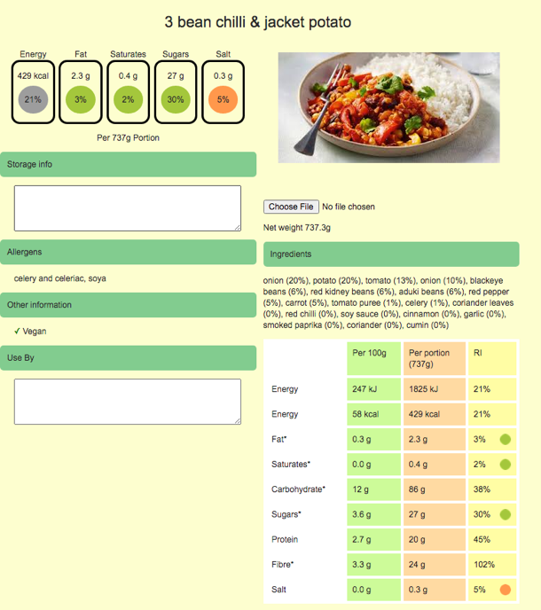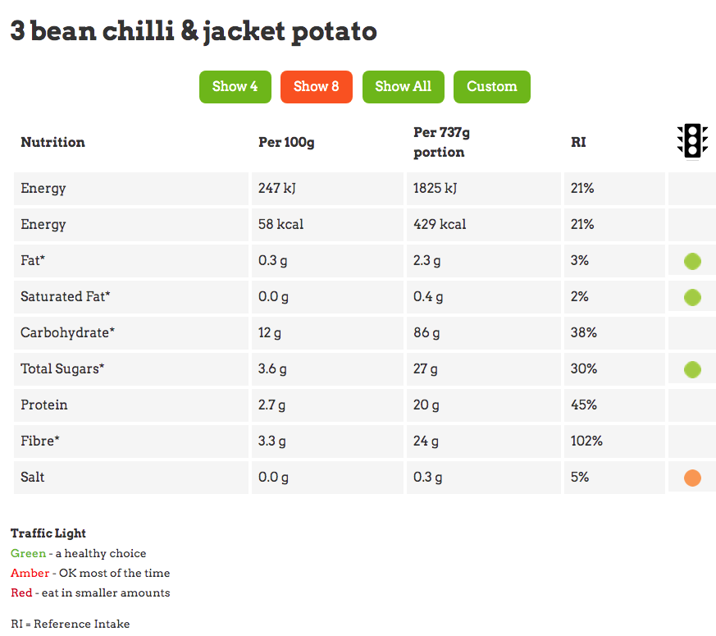

To create a Star Chart to evaluate a dish (really useful in your NEA2)
- Log onto the Nutrition Program, enter the name of the dish and the number of portions. You do not need to enter all the ingredients this time. Click on the Star Profile tab, enter the name of the dish again.
- Click on + Add Descriptor and type in the first of your sensory descriptors and click add. Repeat this for all your sensory descriptors (there must be 3 or more).
- Check the Hide Rating box.
- Click on + Add Taster and type in the name of your first taster, then add their marks out of 5 for each descriptor.
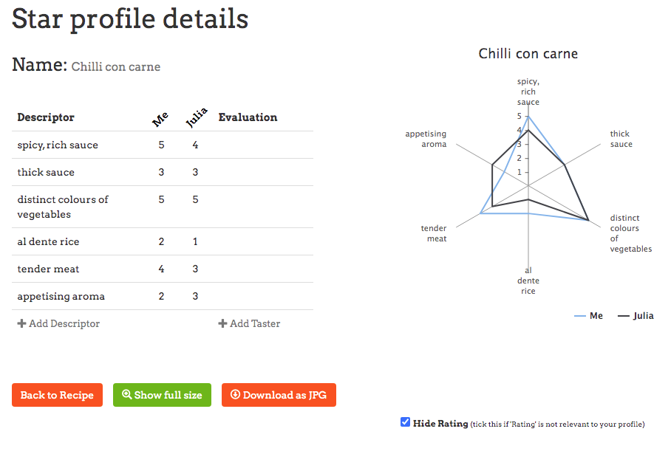

To create a Star Chart to compare variations (really useful in your NEA1)
- Follow the instructions for evaluating a dish, but instead of adding the names of different tasters you can add the names of different variations of a product – e.g. scones with different raising agents in them. Each star on the chart will show how well each variation did on each of the descriptors.
- You can see clearly from the star chart below that the best scones were those made using baking powder as the raising agent.

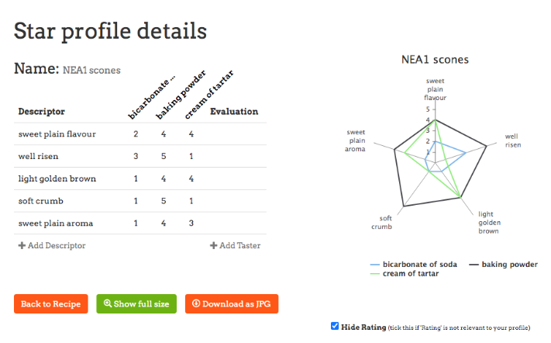

VEGETABLES
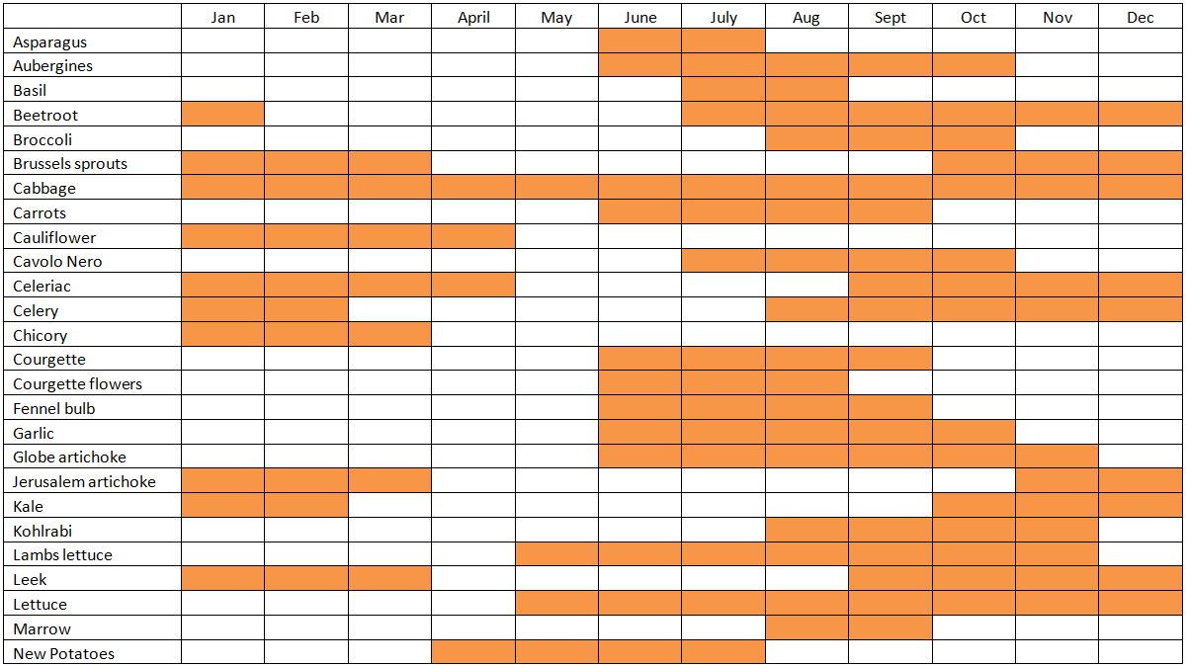
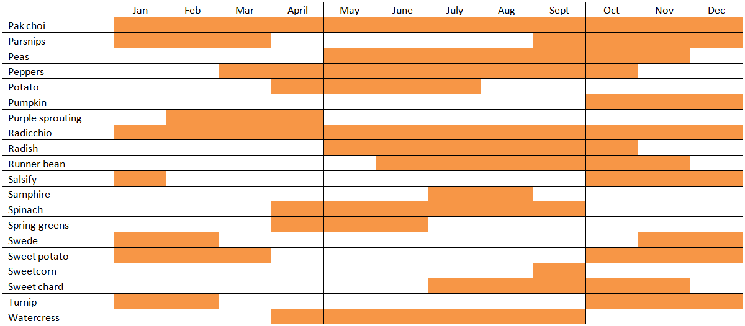
SEASONALITY CHARTS

FRUIT
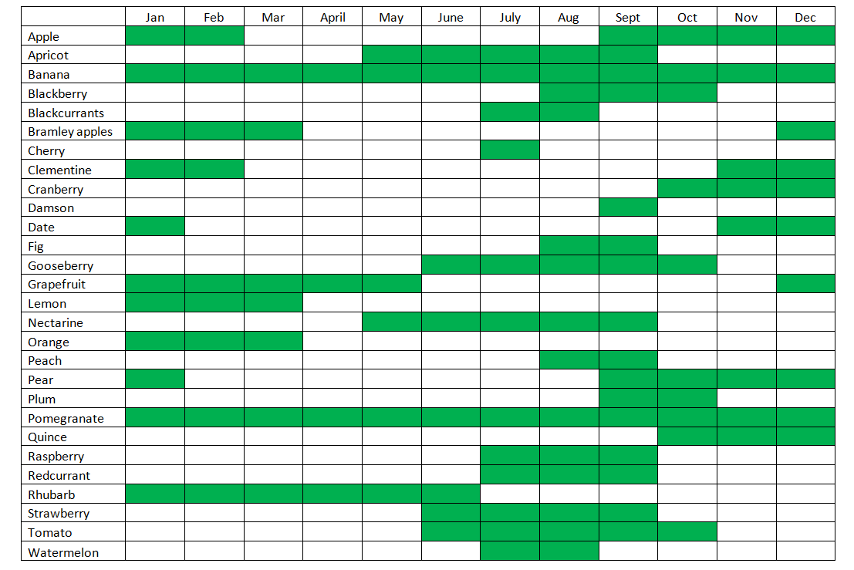
MEAT, GAME AND FISH


