Learner Hub Password Reset
https://learner-hub.ccn.ac.uk/
If you have forgotten your password, please enter your email in the Sign In box and click Go.
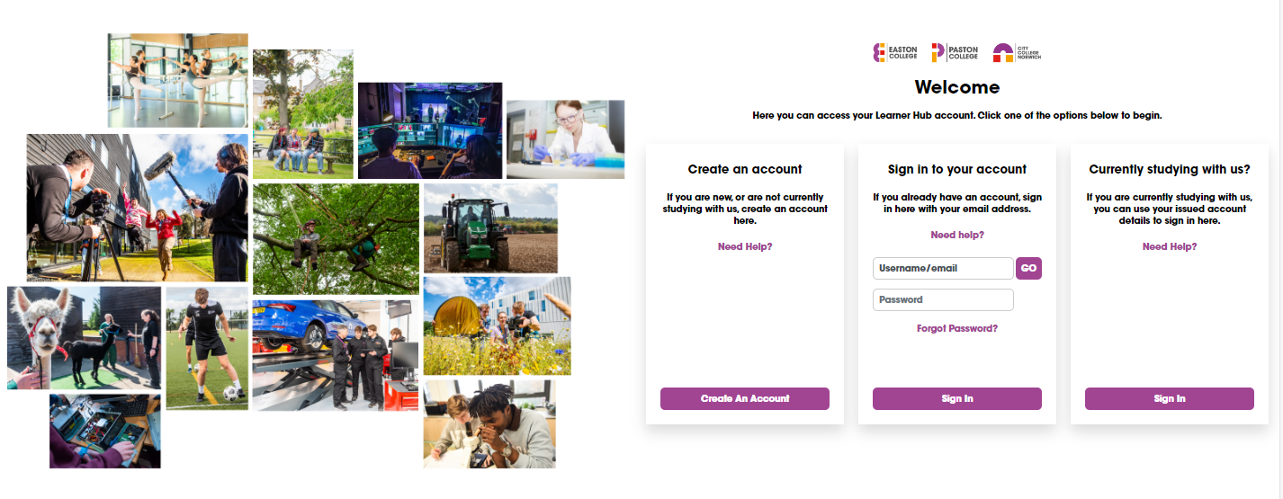
This will show Forgot Password? – click to move on to next stage.

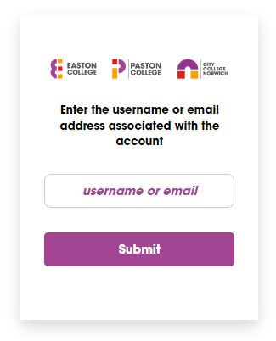
The screen will refresh and you will see this box. Please re-enter your unsername/email and click Submit.

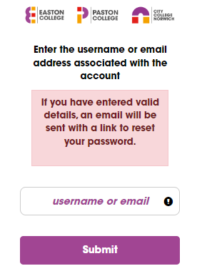

Once submitted you will see this message.
You should then receive your password reset email.
(Remember to check your junk/spam folder just in case)

Once you receive your email click the link you are given to access the password reset screen.

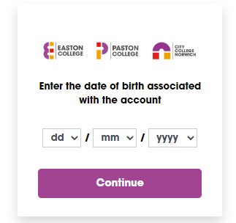

First you will be asked for your date of birth.

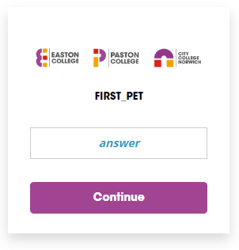

Then you will be asked for the answer to your secruity
question.

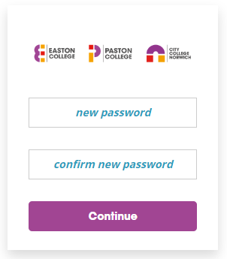

After completing the above, you will be able to
change your password.

