
Applications - Frequently Asked Questions
How does the application process work?
There are four simple stages to our application process.

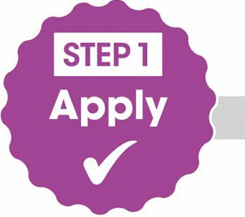
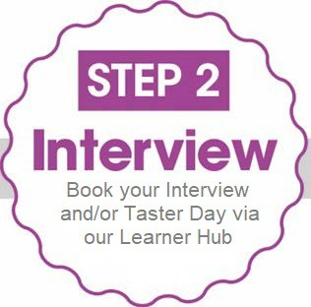

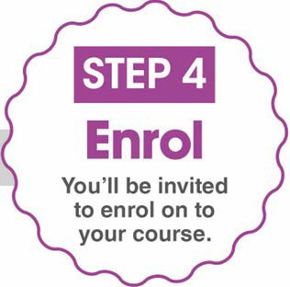

You’ve now completed Step 1!
Step 2
We aim to have Interviews and Taster Days available as soon as possible.
Our Learner Hub will notify you via email when these are available for you to book for your chosen course/s.
(Please note that if you made your application to us either in paper format or via Help You Choose you will need to log in to https://learner-hub.ccn.ac.uk/ and Sign in to the account we have created for you, initially using the ‘Forgot Password?’ option).
Important note about Step 4 (Enrolment)
Please note enrolment is held in the last two weeks of August and it is essential you attend. You are strongly advised to make sure that you are available to come into the college during this period. If that is not possible for any reason, please contact our Admissions Team at the earliest opportunity.
Can I apply for more than one course?
You can apply for more than one course, but please note you will initially be invited in for interview on your 1st choice course. If you don’t have a clear first choice and wish to consider more than one course, please contact our Admissions Team.
I’ve applied for the wrong course. What shall I do?
Contact our Admissions Team to discuss your options. They can look at your application and advise on the best course of action. This may result in applying again or speaking with a member of a Course Advice Team: pastoninfo@ccn.ac.uk

What can I do if I change my mind?
Contact our Admissions Team who will be able to discuss your options and help with any queries you may have regarding your application.
Who do I contact if I have a question about my application?
Get in touch with our Admissions Team -
City College Norwich 01603 773008 or email applications@ccn.ac.uk
Paston College 01692 668175 or email admissions@paston.ac.uk
Easton College 01603 731200 or email admissions@easton.ac.uk

